ERP Products,
EDGE Program,
Global accruals solution
Technical Design Specification
Enhancement

TS_F6_CX_314

Document Version : 18.0

Document Control

Authored By:

Andrei Kyle Hidalgo | Technical SME

Approval

Lubos Adamka | ERP Technical Services

Version History
Revision Date | Version | Author/Company | Description of Change
26th July 2021 | 1.0 | Rakesh Teki /  TATA Consultancy Services Limited | Initial Release
15th September 2021 | 2.0 | Mahesh Guda /  Tata Consultancy Services | CHG0052066  Added the following paragraph:  3.3.64 SAP Web analytics for usage tracking
23rd September 2021 | 3.0 | Rakesh Teki /  TATA Consultancy Services Limited | CHG0052274  Developments related to Wave1  Added the following paragraphs:  3.2.61 Methods: getLinksData  3.2.62 Methods: onSelectPOClosure  3.2.63 Methods: onSelectPOClosureMat  3.2.64 Methods: threPOClosureSelect  3.2.65 Methods: mapThreStr  3.2.66 Methods: onPressSaveThre  3.2.67 Methods: onValueHelpDialogPONum  3.2.68 Methods: onPOSearch  3.2.69 Methods: onPressOkPONum  3.2.70 Methods: onPressCancelPONum  3.2.71 Methods: _poNumFilterSelectionChange  3.2.72 Methods: onValueHelpDialogSupName  3.2.73 Methods: onSupNameSearch  3.2.74 Methods: onPressOkSupName  3.2.75 Methods: onPressCancelSupName  3.2.76 Methods: _itemNumFilterSelectionChange  3.2.77 Methods: onValueHelpDialogSupName  3.2.78 Methods: onSupNameSearch  3.2.79 Methods: onPressOkSupName  3.2.80 Methods: onPressCancelSupName  3.2.81 Methods: _supNameFilterSelectionChange  3.2.82 Methods: onClearFilters  3.2.83 Methods: onClearMatFilters  3.2.84 Methods: onClearThreFilters  3.2.85 Methods: onClearExclFilters  3.2.86 Methods: onPressEmailExcelButton  3.4.2 SDI Replication Task Details  Updated the following paragraphs:  3.4.3 SDI Replication Task details  3.4.4 HANA Database Tables  4.4 Process Logs Details  4.5 Scheduling Considerations
7th February 2022 | 4.0 | Kumari Minakshi /  TATA Consultancy Services Limited | Change Number: CHG0068966  Incident Number: INC1503200  Added 3.5.2 – Begin of CHG0068966  Values are populated incorrectly in Accruals Dashboard and the extract is showing the wrong values.
1st March 2022 | 5.0 | Kumari Minakshi /  TATA Consultancy Services Limited | CHG0070311 - 3.5.3  Bugfix - Notify ADMIN, TBS, FINANCE, POOWNER, POPREPARER jobs did not run in ACCRUALS production system on 15-Feb-2022.
05 Apr 2022 | 6.0 | Alex Aakash A /  TATA Consultancy Services Limited | 3.3.65 CHG0074033  Bugfix – Issue with Mark all as review  button
20 Apr 2022 | 7.0 | Nilamber Pradhan/  TATA Consultancy Services Limited | CHG0052274  3.5.4  Bugfix - Subject of the Email Extract is Wrong  Developments related to Wave2  Added the following paragraphs:  3.2.77 Method: onApproveMarkAsReviewedPress  3.2.78 Method: onApproveMarkAsReviewedPressThre  3.2.79 Method: changeCellColorThr  3.2.80 Method: onClearMatFilter  3.2.81 Method: onBeforeRebindThresholdTable2  3.2.82 Method: onSelectthrePOClosureMater  3.2.83 Method: totalAmountThres  3.2.84 Method: totalPercentThres  3.2.85 Method: onClickCheckBoxThre  3.2.86 Method: getSelectedData2  3.2.87 Method: populateGlobalArrayThre 3.2.88 Method: markAllasReviewed2  3.2.89 Method: onMarkAsReviewedSelect2 3.2.90 Method: onSelection  3.2.91 Method: saveData2  3.2.92 Method: populateReviewedCountThre  3.2.93 Method: onApproveDialogPressThre 3.2.94 Method: savePOChange2  3.2.95 Method: askConfirmation2  3.2.96 Method: edgeSave2  3.2.97 Method: getUserLanguage  Updated the following paragraphs:  3.5.1 XSA Artifacts
29 Apr 2022 | 8.0 | Kanisha Tripathi/ Tata Consultancy Services | 3.3 - 3.3.66: CHG0073691– Release Changes  - Added Logo and Background Image for Accruals Fiori Launchpad
06 May 2022 | 9.0 | Madhusudan Padhi/ Tata Consultancy Services | CHG0071169  3.5.5 Insert records to EDGE table as part of monthly reconciliation process in SAC tool.
18 May 2022 | 10.0 | Kumari Minakshi/ Tata Consultancy Services | CHG0052274  3.4.2 - PRB0011314 -Separate Remote Source creation
20 Oct 2022 | 11.0 | Madhusudan Padhi/ Tata Consultancy Services  Sujith Kumar S/Tata Consultancy Services | CHG0087603/CHG0087759  3.5.6 - Please modify system logic to treat any Material PO that has a Service start and end date populated as a Service PO in DAS. change of logic for Material PO where Service Start and End date are populated - Brazil/China  CHG0087616  3.5.7 - Purchase Orders that are in the 'Exclusion' section do not show any Invoice values, even where invoices exist in ECC.  CHG0085854  3.5.8 - "The update made to the service completed % is not being saved when the application is being refreshed. The updates are being saved after "Mark as Reviewed" is clicked. However, when the user refreshes the screen, the amounts revert back to zero.  Changes are visible in the change log but not on the dashboard.
17 Jan 2023 | 12.0 | Sujith Kumar S/Tata Consultancy Services  Venkata Nimmakayala / TATA Consultancy Services  Madhusudan Padhi/ Tata Consultancy Services  Alex Aakash A /  TATA Consultancy Services Limited | CHG0087840  3.5.9 – Video Links  CHG0080060  3.5.10 - facilitate better 'Committed Spend' reporting, there is a need to create a copy of the 'Eligible for Closure' email report and schedule this to run daily  CHG0092373  3.5.11 - In the main dashboard - summary of all the PO amounts per currency, material PO amounts are not populated.  CHG0092413  3.5.12 - INC2068446 :  Some of the PO lines have misaligned column information.  3.5.13 - RITM1318021 :  Digital Accruals: Fix for the 'Price Unit' issue.  3.5.14 - RITM1342015:  Duplication of PO's due to multiple ASSET id in Single line item of PO .  CHG0093134  3.3.66 - RITM1346368  Update to DAS Dashboard Layout & Text
09 Feb 2023 | 13.0 | Alex Aakash A /  TATA Consultancy Services Limited | 3.3.67- CHG0095742/INC2308469: Some users are having trouble using the DAS tool. getting error msg for cutoff time issue  3.3.68-CHG0094914/RITM1391889: Alignment of Filters/Formatters and Sorters within the Accrual Application  3.3.69-CHG0095265/INC2078352: Authorization issues where mass number of Cost Centers to one user was not possible.  3.5.15 - RITM1391877: Performance Issues - Column Reduction Approach - Reducing the unwanted columns at the SDI level to reduce initial load time and improve performance up to a certain level.  3.5.16 - RITM1324833: Schedule a daily job on the Digital Accruals system to send the ECC Posting Files to a Backup folder in ECC. This job should run at 23:45 CET each day. In addition, the 'Point in Time' file also needs to be sent via email at the same time each day to a predefined email address (to be confirmed). Both these jobs should run daily, except for the final day of the month when the files should be sent to the main AL11 folder in ECC as per normal.  3.5.17 - CHG0095269 - Webservice - establish a direct API connection between Edge and Ariba for PO Eligible for Closure automatic closure.
14 Feb 2023 | 14.0 | Madhusudan Padhi/TATA CONSULTANCY SERVICES | CHG0099561 CHG0097800  3.5.19 INC2383076 :- Reports on Webservice API closure shows items with dates that are before the actual report content structure.  CHG0097800  3.5.20.1 INC2356768 :- Issue with posting files for month-end.  3.5.20.2 INC2356766 :- Issue with Webservice closing POs with NULL Values
21 Mar 2023 | 1.0 | Migration Quality Administrator | Migration of documents from LEADs system to the Takeda Veeva Vault QualityDocs system has altered the numbering sequence. This migration required the restart of version number to 1.0. Previous versions of the document outlined in this Revision History have been created in LEADs and are in scope of archival into Content Manager (CM). Details of the mapping of revisions may be found in the respective Migration Transform Requirements outlined in VAL-0067583 and VAL-0067581.
7 Jun 2023 | 2.0 | Y Vinayak/ TATA CONSULTANCY SERVICES | CHG0104009  3.3.72: Updated Node Js version to 16  CHG0101768-  3.3.70: Matomo integration to track the application  CHG0097438  3.3.71: Japanese reference link description text change  3.3.73: Hungarian text update
16 Jun 2023 | 3.0 | Alex Aakash A/ TATA CONSULTANCY SERVICES | CHG0097800  3.3.74 System performance issue  CHG0099567  3.3.75: CHG0099567: Quick Reference links are updated with mismatch description
12 Jul 2023 | 4.0 | Y Vinayak/ TATA CONSULTANCY SERVICES | CHG0107600  3.3.76: CHG0107600: Smart filter issue and setting button issue  CHG0098341  3.3.77: CHG0098341: Eligible for Closure issue (Scrollbar)  3.5.21: CHG0098341: Eligible for Closure issue (Scrollbar)
20 Jul 2023 | 5.0 | Alex Aakash A/ TATA CONSULTANCY SERVICES | CHG0105586  3.3.78: CHG0105586: UI/UX Improvements & New Column Addition  3.5.22: CHG0105586: New Column Addition.
02 Aug 2023 | 6.0 | Alex Aakash A/ TATA CONSULTANCY SERVICES | CHG0112262  3.3.79: PO review button is missing
18 Dec 2023 | 7.0 | Ben Grampa/ Accenture  Draven Pulinnek/Accenture  Rogerson Culanding / Accenture | CHG0119805  Added the following paragraphs:  3.4.3 SDI Replication Task details  ZMD_POSITN_INFO  ZMD_CONTACT_INFO  ZMD_WORKER_NAME  TB_PO_THRESHOLD  TB_PENDING_PO_DETAILS  Updated the following paragraphs:  3.5.1 XSA Artifacts  3.2.98 _getThresholdValue: Retrieves Threshold value from the HANA table.  3.2.53 onSelectPOClosureMat: Creates Threshold validation.  3.2.82: onSelectthrePOClosureMater: Creates Threshold validation.
10 Jan 2024 | 8.0 | Ben Grampa/Accenture  Delgado, Maria Michelle/Accenture | CHG0119805  3.2.53 onSelectPOClosureMat: Creates Threshold validation.  3.2.82: onSelectthrePOClosureMater: Creates Threshold validation.  3.2.99: _countDecimal: Counts the decimal places of a float amount  3.2.100: _finalMultiplier: Returns the precision multiplier that will be used for variance calculation
11 Sep 2024 | 9.0 | Charlotte Abaya/ Accenture Inc. | CHG0119219  3.3.79 CHG0119219: Missing Video links in  Admin/TBS/Finance tab
11 Sep 2024 | 9.0 | Via Zareena Bulda/Accenture | CHG0123388  3.5.23: Threshold Warning Message English Translation
11 Sep 2024 | 9.0 | Christopher Pajinag/Accenture | CHG0133736  3.5.24: Problem with the VND currency, having zero decimal places when acquired in the DAS application.
11 Sep 2024 | 9.0 | Jan Garperio/Accenture | CHG0132123  3.5.25: RITM2138379 - DAS Email Notification adjustment - for PO Owner/Preparer and TBS/Admin/Finance users from 10, 5, 2 days before Month End Closing to 10, 5, 1 days before Month End Closing.  Update in 3.5.1 (Artifacts : Procedures): Sl. No. 17 – jobschedulerDates
11 Sep 2024 | 9.0 | Angelino Ocampo/Accenture | CHG0135220  3.5.26: RITM2192804 - Decrease improvisation of dialog boxes upon marking as reviewed the POs.
07 January 2025 | 10.0 | Bobby Alfred Cuevas/Accenture | CHG0148052  3.5.27: NJS upgrade for DAS
06 May 2025 | 11.0 | Christopher Pajinag/Accenture | CHG0156477  3.5.28: Bug Fix: to resolve DAS closing issue connection to Ariba
11 July 2025 | 12.0 | Jan Garperio/Accenture | CHG0164446  3.5.29: RITM2701774 - Add a quick filter option to the column settings in the DAS table.
16 Sep 2025 | 13.0 | Christopher Pajinag/Accenture | CD Number: 7000005246  CHG0170932  3.5.30: RITM2855210: Dynamic dates for email notifications in DAS EDGE  4.10: Pull Request Link: Added number 3 - CHG0170932
13 Nov 2025 | 14.0 | Christopher Pajinag/Accenture | CHG0176051  3.5.31: INC3982359: PO lines are not successfully closing even though they have been marked as eligible for closure  4.10: Pull Request Link: Added number 4 - CHG0176051
23 Mar 2026 | 15.0 | Christopher Pajinag/Accenture | CHG0181951  3.5.32: Enhancement - Invoice amount field replace with 'REFWR' field from EKBE instead of 'WRBTR' field.  CHG0181679  3.5.33: Enhancement - Enhancement in DAS - Add the percentage splitting in Dashboard per line item  4.10: Pull Request Link: Added number 5 - CHG0181951, CHG0181679
04 May 2026 | 16.0 | Christopher Pajinag/Accenture | CHG0188041  3.5.34: Enhancement - SAP RISE SFTP and Replication tasks changes  CHG0189963  3.5.35 Enhancement - Removal of POs under Russia Company Codes 1101 and 1105 from DAS  4.10: Pull Request Link: Added number 6 - CHG0188041
15 May 2026 | 17.0 | Christopher Pajinag/Accenture | CHG0191904  3.5.36 Bugfix - Numeric overflow issue in Posting, Monthly Reconciliation, and Monthly Point-in-Time background jobs  4.10: Pull Request Link: Added number 7 - CHG0191904
Date of last approval on Veeva | 18.0 | Andrei Kyle Hidalgo/Accenture | CHG0189716  3.5.37 Enhancement –  DAS – move Synchronous to Asynchronous Job  4.10: Pull Request Link: Added number 8 -  CHG0189716

Reference Global Policies
The documents and templates listed in the table below are Global Standard Operating Procedures and Policies that are directly associated with this document and used to create this document.

Document ID and/or Template ID | Document Title
SOP-218739 | Global System Development Life Cycle (SDLC)
TOOL-213138 | Global Job Aid, Takeda ABAP Development Handbook

Reference Documents
The documents listed in the table below have been directly referenced for the creation of this document.

Doc. ID | Document Title
FS_F6_CX_314 | Global accruals solution
US_F6_CX_056 | Global accruals solution
Contents
1 Document Control 2
1.1 Authored By: 2
1.2 Approval 2
1.3 Version History 3
1.4 Reference Global Policies 9
1.5 Reference Documents 10
2 Overview 17
2.1 Technical Requirement 17
2.2 Purpose of the Document 17
2.3 Development Scope 17
2.4 Best Practices / Technical Solution Options 17
2.5 Assumptions 17
2.6 Constraints and Limitations 18
2.7 Technical Dependencies / Dependent Configuration 18
2.8 Performance Criteria 18
2.9 Applications Affected/Systems Impacted 18
2.10 References 18
3 Detailed Technical Design Specifications 19
3.1 Technical Flow Diagram 19
3.2 Technical Details 19
3.2.1 Technical Details SAP FIORI Application: 19
3.2.2 Method: onInit 19
3.2.3 Method: getUserRoleFlag 20
3.2.4 Method: onInit 20
3.2.5 Method: onBusinessPage 20
3.2.6 Method: onTBSTilePage 20
3.2.7 Method: onInit 24
3.2.8 Method: onObjectMatched 25
3.2.9 Method: geti18nText 25
3.2.10 Method: getCountryConfig 25
3.2.11 Method: dashboardData 25
3.2.12 Method: getTimelineData 25
3.2.13 Method: changeCellColor 25
3.2.14 Method: changeThLinkColor 26
3.2.15 Method: onBeforeExport 26
3.2.16 Method: onBeforeRebindAct1Table 26
3.2.17 Method: getFilterValuesAct1 26
3.2.18 Method: filterValuesSuccess 26
3.2.19 Method: getFilterValuesAct2 26
3.2.20 Method: onBeforeRebindAct2Table 26
3.2.21 Method: getFilterValuesInfo 27
3.2.22 Method: onBeforeRebindInfoTable 27
3.2.23 Method: getFilterValuesThre 27
3.2.24 Method: onBeforeRebindThresholdTable 27
3.2.25 Method: totalAmount 27
3.2.26 Method: totalPercent 27
3.2.27 Method: onClickCheckBox 28
3.2.28 Method: getAuditLogData 28
3.2.29 Method: detDialog1 28
3.2.30 Method: onDetCancel1 28
3.2.31 Method: getAribaLink 28
3.2.32 Method: onPressAribaLink 29
3.2.33 Method: detDialog 29
3.2.34 Method: onLinkPress 29
3.2.35 Method: getChart 29
3.2.36 Method: onDetCancel 29
3.2.37 Method: mapStr 29
3.2.38 Method: getSelectedData 29
3.2.39 Method: populateGlobalArray 30
3.2.40 Method: onMarkAsReviewedSelect 30
3.2.41 Method: markAllasReviewed 30
3.2.42 Method: onSelectReview 30
3.2.43 Method: rebindTables 30
3.2.44 Method: saveData 30
3.2.45 Method: populateReviewedCount 30
3.2.46 Method: onApproveDialogPress 30
3.2.47 Method: savePOChange 31
3.2.48 Method: askConfirmation 31
3.2.49 Method: createColumnConfig 31
3.2.50 Method: auditExportxls 31
3.2.51 Method: getLinksData 31
3.2.52 Method: onSelectPOClosure 31
3.2.53 Method: onSelectPOClosureMat 31
3.2.54 Method: threPOClosureSelect 32
3.2.55 Method: mapThreStr 32
3.2.56 Method: onPressSaveThre 32
3.2.57 Method: onValueHelpDialogPONum 32
3.2.58 Method: onPOSearch 32
3.2.59 Method: onPressOkPONum 32
3.2.60 Method: onPressCancelPONum 32
3.2.61 Method: _poNumFilterSelectionChange 33
3.2.62 Method: onValueHelpDialogItemNum 33
3.2.63 Method: onLineItemSearch 33
3.2.64 Method: onPressOkLineItem 33
3.2.65 Method: onPressCancelLineItem 33
3.2.66 Method: _itemNumFilterSelectionChange 33
3.2.67 Method: onValueHelpDialogSupName 33
3.2.68 Method: onSupNameSearch 33
3.2.69 Method: onPressOkSupName 34
3.2.70 Method: onPressCancelSupName 34
3.2.71 Method: _supNameFilterSelectionChange 34
3.2.72 Method: onClearFilters 34
3.2.73 Method: onClearMatFilters 34
3.2.74 Method: onClearThreFilters 34
3.2.75 Method: onClearExclFilters 34
3.2.76 Method: onPressEmailExcelButton 34
3.2.77 Method: onApproveMarkAsReviewedPress() 35
3.2.78 Method: onApproveMarkAsReviewedPressThre() 35
3.2.79 Method: changeCellColorThr 35
3.2.80 Method: onClearMatFilter 35
3.2.81 Method: onBeforeRebindThresholdTable2 35
3.2.82 Method: onSelectthrePOClosureMater 35
3.2.83 Method: totalAmountThres 36
3.2.84 Method: totalPercentThres 36
3.2.85 Method: onClickCheckBoxThre 36
3.2.86 Method: getSelectedData2 36
3.2.87 Method: populateGlobalArrayThre 37
3.2.88 Method: markAllasReviewed2 37
3.2.89 Method: onMarkAsReviewedSelect2 37
3.2.90 Method: onSelection 37
3.2.91 Method: saveData2 37
3.2.92 Method: populateReviewedCountThre 37
3.2.93 Method: onApproveDialogPressThre 37
3.2.94 Method: savePOChange2 38
3.2.95 Method: askConfirmation2 38
3.2.96 Method: edgeSave2 38
3.2.97 Method: getUserLanguage 38
3.2.98 Method: _getThresholdValue 38
3.2.99 Method: _countDecimal 38
3.2.100 Method: _finalMultiplier 38
3.3 Technical Details – Accruals Configuration 38
3.3.1 Technical Details SAP FIORI Application Accruals Configuration 38
3.3.0 Method: onInit(): 40
3.3.1 Method: onItemSelect(): 41
3.3.2 Method: getThreshold(): 41
3.3.3 Method: getEmailTemplates(): 41
3.3.4 Method: getLanguages(): 41
3.3.5 Method: getUserRoles(): 41
3.3.6 Method: getConfig(): 41
3.3.7 Method: getcountryConfig(): 41
3.3.8 Method: onSearchCountryConfig(): 42
3.3.9 Method: onPressConfigCreate(): 42
3.3.10 Method: onPressThresholdCreate(): 42
3.3.11 Method: onPressEmailTemplateCreate(): 42
3.3.12 Method: onPressUserRoleCreate(): 42
3.3.13 Method: onPressConfigChange(): 42
3.3.14 Method: onPressCreate(): 42
3.3.15 Method: onPressLangCreate(): 42
3.3.16 Method: onPressChange(): 42
3.3.17 Method: onPressThresholdChange (): 43
3.3.18 Method: onPressUserRoleChange(): 43
3.3.19 Method: onPressEmailTemplateChange(): 43
3.3.20 Method: onConfigCancelUpdate(): 43
3.3.21 Method: onThresholdCancelUpdate(): 43
3.3.22 Method: onUserRoleUpdateCancel(): 43
3.3.23 Method: onCancelEmailTempl(): 43
3.3.24 Method: onCancelUpdate(): 43
3.3.25 Method: onCancel(): 43
3.3.26 Method: updateConfigValue (): 44
3.3.27 Method: updateValue (): 44
3.3.28 Method: updateThresholdRole (): 44
3.3.29 Method: updateUserRole (): 44
3.3.30 Method: updateEmailTemplate (): 44
3.3.31 Method: onThresholdSaveUpdate (): 44
3.3.32 Method: onchangeEmailTemplSave (): 44
3.3.33 Method: onConfigSaveUpdate (): 44
3.3.34 Method: onUserRoleUpdateSave (): 44
3.3.35 Method: onUserRoleUpdate (): 45
3.3.36 Method: onSaveUpdate (): 45
3.3.37 Method: onConfigSave (): 45
3.3.38 Method: onThresholdSave (): 45
3.3.39 Method: onLangSave (): 45
3.3.40 Method: onUserRoleSave (): 45
3.3.41 Method: onCreateEmailTemplSave (): 45
3.3.42 Method: onSave (): 45
3.3.43 Method: saveThresholdData (): 45
3.3.44 Method: saveLanguageData (): 45
3.3.45 Method: saveEmailTemplateData (): 46
3.3.46 Method: saveUserRoleData (): 46
3.3.47 Method: saveConfigData (): 46
3.3.48 Method: saveData (): 46
3.3.49 Method: onPressThresholdDelete (): 46
3.3.50 Method: onPressConfigDelete (): 46
3.3.51 Method: onPressLangDelete (): 46
3.3.52 Method: onPressUserRoleDelete (): 46
3.3.53 Method: onPressDelete (): 46
3.3.54 Method: onPressEmailTemplateDelete (): 46
3.3.55 Method: action (): 47
3.3.56 Method: actionConfig (): 47
3.3.57 Method: actionUserRole (): 47
3.3.58 Method: actionThreshold (): 47
3.3.59 Method: actionEmailTempl (): 47
3.3.60 Method: actionLang (): 47
3.3.61 Method:OData Configuration 47
3.3.62 Fiori Launchpad Configuration 49
3.3.63 SAP Web Analytics for usage tracking 50
3.3.64 CHG0074033: Bugfix- Issue with Mark all as reviewed button 52
3.3.66 Background Image for ACCRUALS Fiori Launchpad and UI Theme Designer 52
3.3.65 CHG0093134: Update to DAS Dashboard Layout & Text 53
3.3.66 CHG0095742/INC2308469: Some users are having trouble using the DAS tool. getting error msg for cutoff time issue. 53
3.3.67 CHG0094914/RITM1391889: Alignment of Filters/Formatters and Sorters within the Accrual Application 53
3.3.68 CHG0095265/INC2078352: Authorization issues where mass number of Cost Centers to one user was not possible. 54
3.3.69 CHG0101768: Matomo integration for tracking the application 54
3.3.70 CHG0097438: Reference link description text change for Japanese Language 54
3.3.71 CHG0104009: Update Node JS version to 16 55
3.3.72 CHG0097438: Hungarian text update 55
3.3.73 CHG0097800: System performance issues 55
3.3.74 CHG0099567: Quick Reference links are updated with mismatch description and taking long time to load the data 56
3.3.75 CHG0107600: Smart filter issue and setting button issue 56
3.3.76 CHG0098341: Eligible for Closure issue (Scrollbar) 57
3.3.77 CHG0105586: UI/UX Improvements & New Column Addition 58
3.3.78 CHG0112262: PO review button is missing 60
3.3.79 CHG0119219: Missing Video links in Admin/TBS/Finance tab and Addition of IVT And PO Depletion Report 60
3.4 Technical Details in SAP HANA Database: 62
3.4.1 SDI Configuration 62
3.4.2 SDI Configuration for ECC 62
3.4.3 SDI Replication Task details 62
3.4.4 HANA Data Base Tables: 63
3.5 Technical Details in SAP XSA 64
3.5.1 XSA Artifacts 64
3.5.2 CHG0068966: Values are populated incorrectly in Accruals Dashboard and the extract also is showing the wrong values 75
3.5.3 CHG0070311: Bugfix - Notify ADMIN, TBS, FINANCE, POOWNER, POPREPARER jobs did not run in ACCRUALS production system on 15-Feb-2022. 76
3.5.4 Bugfix - Subject of the Email Extract is Wrong. 76
3.5.5 CHG0071169: Enable download of DAS reconcile data to HANA DB on monthly basis. 76
3.5.6 Please modify system logic to treat any Material PO that has a Service start and end date populated as a Service PO in DAS. change of logic for Material PO where Service Start and End date are populated - Brazil/China. 77
3.5.7 Purchase Orders that are in the 'Exclusion' section do not show any Invoice values, even where invoices exist in ECC. 78
3.5.8 "The update made to the service completed % is not being saved when the application is being refreshed. The updates are being saved after "Mark as Reviewed" is clicked. However, when the user refreshes the screen, the amounts revert back to zero. 79
3.5.9 Video Links 79
3.5.10 CHG0080060 - facilitate better 'Committed Spend' reporting, there is a need to create a copy of the 'Eligible for Closure' email report and schedule this to run daily 80
3.5.11 CHG0092373 - In the main dashboard - summary of all the PO amounts per currency, material PO amounts are not populated. 80
3.5.12 INC2068446 :Some of the PO lines have misaligned column information. 80
3.5.13 RITM1318021 : Digital Accruals: Fix for the 'Price Unit' issue. 80
3.5.14 RITM1342015: Duplication of PO's due to multiple ASSET id in Single line item of PO . 81
3.5.15 : RITM1391877 : Performance Issues - Column Reduction Approach - Reducing the unwanted columns at the SDI level to reduce initial load time and improve performance up to a certain level. 81
3.5.16 RITM1324833 : Schedule a daily job on the Digital Accruals system to send the ECC Posting Files to a Backup folder in ECC. This job should run at 23:45 CET each day. In addition the 'Point in Time' file also needs to be sent via email at the same time each day to a predefined email address (to be confirmed). Both these jobs should run daily, except for the final day of the month when the files should be sent to the main AL11 folder in ECC as per normal. 81
3.5.17 CHG0095269 - Webservice - establish a direct API connection between Edge and Ariba for PO Eligible for Closure automatic closure. 82
3.5.18 INC2078352 : Authorization issues where mass number of Cost Centers to one user was not possible. 82
3.5.19 CHG0099561 : INC2383076 :- Reports on Webservice API closure shows items with dates that are before the actual report content structure. 83
3.5.20 CHG0097800 : System Performance Issue. 83
3.5.21 CHG0098341: Eligible for Closure issue (Scrollbar) 84
3.5.22 CHG0105586 : New Column Addition 84
3.5.23 CHG0123388: Threshold Warning Message English Translation 86
3.5.24 CHG0133736 – INC3139113: Problem with the VND currency, having zero decimal places when acquired in the DAS application. 88
3.5.25 CHG01312123 – RITM2138379: Business request to adjust DAS Email Notification for PO Owner/Preparer and TBS/Admin/Finance users from 10, 5, 2 days before Month End Closing to 10, 5, 1 days before Month End Closing. 89
3.5.26 CHG0135220 - RITM2192804: Decrease improvisation of dialog boxes upon marking as reviewed the POs. 89
3.5.27 CHG0148052 - Upgrade nodejs version and convert xsjs files into async for DAS. 90
3.5.28 CHG0156477- Bug Fix: to resolve DAS closing issue connection to Ariba 91
3.5.29 CHG0164446 - Add a quick filter option to the column settings in the DAS table. 92
3.5.30 CHG0170932 - Dynamic dates for email notifications in DAS EDGE 92
3.5.31 CHG0176051- PO lines are not successfully closing even though they have been marked as eligible for closure 93
3.5.32 CHG0181951- Enhancement - Invoice amount field replace with 'REFWR' field from EKBE instead of 'WRBTR' field. 93
3.5.33 CHG0181679- Enhancement - Add the percentage splitting in Dashboard per line item 94
3.5.34 CHG0188041- Enhancement - SAP RISE SFTP and Replication tasks changes 95
3.5.35 CHG0189963- Enhancement - Removal of POs under Russia Company Codes 1101 and 1105 from DAS 96
3.5.36 CHG0191904- Bugfix - Numeric overflow issue in Posting, Monthly Reconciliation, and Monthly Point-in-Time background jobs 96
3.6 Detailed Enhancement Design Specifications 97
3.6.1 Enhancement Framework 98
3.6.2 BADI Information 98
3.6.3 User Exit Information 99
3.6.4 Routine / Formulas 99
3.6.5 Search Help Exit 99
3.6.6 Screen Exit 99
3.6.7 Table/Structure Enhancement 99
3.6.8 Any Additional Enhancement 100
3.6.9 Detailed Form Design Specifications 100
3.6.10 Windows Attributes 103
3.6.11 Form Output Layout 103
4 Additional Information 109
4.1 Parallel Processing 109
4.2 Error /Exception Handling Method 109
4.3 Post Execution Notification Details: 109
4.4 Process Log Details: 109
4.5 Scheduling Considerations 109
4.6 Backup / Recovery 110
4.7 Security Profile & Authorization 110
4.8 Considerations for Informal Testing 110
4.9 Transport Request List 110
4.10 Pull Request Link 112
5 Glossary 113
6 Appendices / Attachments 114
6.1 Appendix A 114

Overview

Technical Requirement
This application, Digital accruals solution, is an online intuitive tool for PO users to review and update work completed for open Purchase Orders in a timely manner for accurate accrual reporting and automated posting to ECC (SAP).
This tool also supports TBS/Admin/Finance team with reports to review past and current accruals data for accuracy and to determine actions where needed.
The solution is developed on EDGE standard solution architecture utilizing the SAP Cloud platform.

Purpose of the Document
The purpose of this technical document for Digital accruals solution, is to describe how the technical design will address the functional requirement

Development Scope
The application will provide a dashboard with Open Purchase orders for review for the current month. Scope will include -
- Different access roles for reviewing and updating data
- View worklist with all open POs with calculated work to date, work prior month and work performed to date current month
- View exclusion POs where user can't change any data
- Automatic data updated between ECC and Edge
- Automatic process to interface accruals data for ECC to process GL posting
- SOX controls in updating and executing data, Audit/change history
- Automatic accruals calculations based on work completed
- Notification for any open POs to review by email
.

Best Practices / Technical Solution Options
The Technical solution approach followed is using SAP HANA Native Development using XSA services.
Smart Data Integration will be used to integrate and replicate the date between ECC and SAP HANA (On Premise) on real time.

Assumptions
- PO Owners will be responsible for review and update of the POs
- Existing POs will be cleaned up by business
- Service start and end dates for active POs will be migrated from Ariba to ECC
- Digital accruals solution will replicate the data based on ECC for active POs for the ones which needs review and excluded POs
- Accruals data file will be sent at the time of cut off every month to ECC for posting
- ECC will post the accruals and reversals based on Edge file
- Notifications for posting will be handled in ECC

Constraints and Limitations
- The application is designed to work for Desktop and works best on latest Google chrome browser.

Technical Dependencies / Dependent Configuration
- SDI configuration must be setup for ECC system
- Technical user needs to be created to access remote sources data
- Deployment to SAP Hana Cloud Platform
- Testing in defined browsers (desktop and tablet)

Performance Criteria
N/A

Applications Affected/Systems Impacted
ECC System is impacted as the data is retrieved from the source systems and custom fields in the EKPO table is updated back via SAP Gateway system.
SAP System | SAP Module | Impact/Change Description
ECC | MM | Purchase Order EKPO table; ZSERV_AMT and ZSERV_PERC fields are updated.
NON-SAP System | Impact/Change Description
N/A | N/A

References

Document Title | Author | Attachment / Links
FS_F6_CX_314 | Global accruals solution | N/A
US_F6_CX_056 | Global accruals solution | N/A

Detailed Technical Design Specifications

Technical Flow Diagram
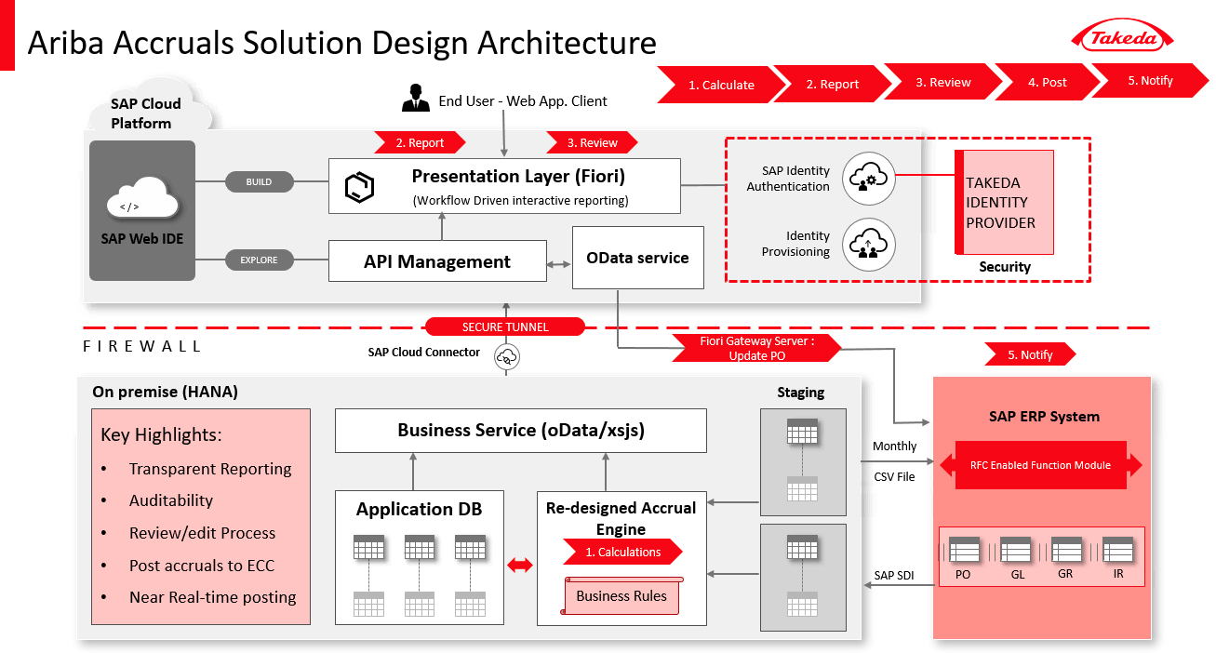

Figure 1 Technical Flow
The figure illustrates the technical flow of how the HANA database retrieves the data from ECC, Using HANA XSA, ODATA services will be created accordingly. The data present in the services will be consumed by UI and will display the same in the dashboard.
ECC source system data load is near real time.

Technical Details

Technical Details SAP FIORI Application:
View: App
Controller: App.controller
Methods involved in controller:
File Name | Methods Involved
App.controller.js | onInit()  getUserRoleFlag()

Method: onInit
- Function to read the Email Id of logged on user.
- Calling the getUserRoleFlag method.

Method: getUserRoleFlag
- Function to fetch the user role and display the PO Owner and TBS tiles based on roles.
- If the user is not assigned to TBS/Admin/Finance role (it is assumed that the user is a PO Owner) then directly it navigates to the PO Owner dashboard view.
- If the user is assigned to TBS/Admin/Finance role, then the application navigates to a view where it displays both PO Owner and TBS tiles. User can choose one.
View: Main
Controller: Main.controller
Methods involved in controller:
File Name | Methods Involved
Main.controller.js | onInit ()  onBusinessPage ()  onTBSTilePage ()

Method: onInit
- This function is called to Initialize the Router.

Method: onBusinessPage
- The function is called to navigate from Main screen to Business screen.

Method: onTBSTilePage
- The function is called to navigate from Main screen to TBS screen.

View: Business
Controller: Business.controller
Methods involved in controller:
File Name | Methods Involved
Business.controller.js | onInit ()  onObjectMatched()  geti18nText ()  getConfigValues ()  getCountryConfig ()  getUserRole ()  getUserDetails ()  dashboardData ()  getTimelineData ()  changeCellColor ()  changeThLinkColor ()  onBeforeExport ()  onBeforeRebindAct1Table ()  getFilterValuesAct1 ()  filterValuesSuccess ()  getFilterValuesAct2 ()  onBeforeRebindAct2Table ()  getFilterValuesInfo ()  onBeforeRebindInfoTable ()  getFilterValuesThre ()  onBeforeRebindThresholdTable ()  totalAmount ()  totalPercent ()  onClickCheckBox ()  getAuditLogData ()  detDialog1 ()  onDetCancel1 ()  getAribaLink ()  onPressAribaLink ()  detDialog ()  onLinkPress ()  getChart ()  onDetCancel ()  mapStr ()  getSelectedData ()  populateGlobalArray ()  markAllasReviewed ()  onMarkAsReviewedSelect ()  onSelectReview ()  rebindTables ()  saveData ()  populateReviewedCount ()  onApproveDialogPress ()  savePOChange ()  getLinksData()
askConfirmation ()
createColumnConfig()
auditExportxls()
onSelectPOClosure()
onSelectPOClosureMat()
threPOClosureSelect()
mapThreStr()
onPressSaveThre()
onValueHelpDialogPONum()
onPOSearch()
onPressOkPONum()
onPressCancelPONum()
_poNumFilterSelectionChange()
onValueHelpDialogItemNum()
onLineItemSearch()
onPressOkLineItem()
onPressCancelLineItem()
_itemNumFilterSelectionChange()
onValueHelpDialogSupName()
onSupNameSearch()
onPressOkSupName()
onPressCancelSupName()
_supNameFilterSelectionChange()
onClearFilters()
onClearMatFilters()
onClearThreFilters()
onClearExclFilters()
onApproveMarkAsReviewedPress()
onApproveMarkAsReviewedPressThre()
onSelection()
onClearMatFilter()
onBeforeRebindThresholdTable2()
totalPercentThres()
totalAmountThres()
onClickCheckBoxThre()
onSelectthrePOClosureMater()
onMarkAsReviewedSelect2()
markAllasReviewed2()
getSelectedData2()
askConfirmation2()
saveData2()
savePOChange2()
onApproveDialogPressThre()
populateReviewedCountThre()
onApproveMarkAsReviewedPressThre()
edgeSave2()
_getThresholdValue()
_counteDecimal()
_finalMultiplier()

TBS.controller.js | onInit ()  geti18nText ()  getConfigValues ()  getCountryConfig ()  getUserRole ()  getUserDetails ()  dashboardData ()  getTimelineData ()  changeCellColor ()  changeThLinkColor ()  onBeforeExport ()  onBeforeRebindAct1Table ()  getFilterValuesAct1 ()  filterValuesSuccess ()  getFilterValuesAct2 ()  onBeforeRebindAct2Table ()  getFilterValuesInfo ()  onBeforeRebindInfoTable ()  getFilterValuesThre ()  onBeforeRebindThresholdTable ()  totalAmount ()  totalPercent ()  onClickCheckBox ()  getAuditLogData ()  detDialog1 ()  onDetCancel1 ()  onPresscreatePOLink ()  getAribaLink ()  onPressAribaLink ()  detDialog ()  onLinkPress ()  getChart ()  onDetCancel ()  mapStr ()  getSelectedData ()  populateGlobalArray ()  markAllasReviewed ()  onMarkAsReviewedSelect ()  onSelectReview ()  rebindTables ()  saveData ()  populateReviewedCount ()  onApproveDialogPress ()  savePOChange ()  getLinksData()  onSelectPOClosure()  onSelectPOClosureMat()  threPOClosureSelect()
mapThreStr()
onPressSaveThre()
onValueHelpDialogPONum()
onPOSearch()
onPressOkPONum()
onPressCancelPONum()
_poNumFilterSelectionChange()
onValueHelpDialogItemNum()
onLineItemSearch()
onPressOkLineItem()
onPressCancelLineItem()
_itemNumFilterSelectionChange()
onValueHelpDialogSupName()
onSupNameSearch()
onPressOkSupName()
onPressCancelSupName()
_supNameFilterSelectionChange()
onClearTBSFilters()
onClearMatTBSFilters()
onClearThreFilters()
onClearExclFilters()
askConfirmation ()
createColumnConfig()
auditExportxls()
onApproveMarkAsReviewedPress()
onApproveMarkAsReviewedPressThre()
onSelection()
onClearMatFilter()
onBeforeRebindThresholdTable2()
totalPercentThres()
totalAmountThres()
onClickCheckBoxThre()
onSelectthrePOClosureMater()
onMarkAsReviewedSelect2()
markAllasReviewed2()
getSelectedData2()
askConfirmation2()
saveData2()
savePOChange2()
onApproveDialogPressThre()
populateReviewedCountThre()
onApproveMarkAsReviewedPressThre()
edgeSave2()
_getThresholdValue()

Method: onInit
- This function is to Initialize the Router and calling the onObjectMatched function.

Method: onObjectMatched
- The function is called in onInit method.
- It is triggered on click of PO Owner tile in the main screen or the user who has PO Owner access will navigate to this screen directly.
- Retrieve the Email Id of the login user, setting the Mark as Reviewed button is initially disabled to be and calling the below functions.
- Further the mentioned methods are called in sequence: getPDF, getUserRole, getUserDetails, getConfigValues, getCountryConfig, dashboardData, getTimelineData, changeCellColor, changeThLinkColor, getFilterValuesAct1, getFilterValuesAct2, getFilterValuesInfo, getFilterValuesThre.

Method: geti18nText
- The function is used to get the i18 text. This file (i18N Properties) stores all the static text to be displayed.

Method: getCountryConfig
- The function is used to fetch the Country Configuration data from the model and binding the data to a local JSON model.
- The data is stored in the below table
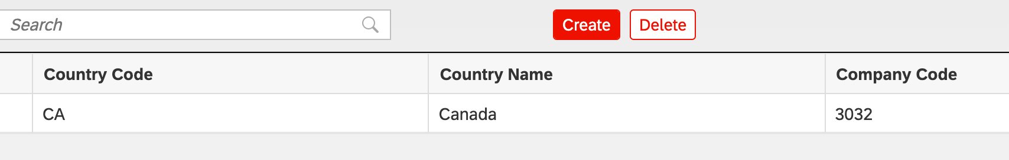

Method: dashboardData
- The function is used to fetch the data for Dashboard table.
- Extract the Dashboard Data from the Dashboard Model and bind it to the table.

Method: getTimelineData
- The function is used to set the data to the Timeline.
- Fetching the first day,6th day and last day of present Month and setting it to the Bullet Micro Chart.
- Bullet Micro chart is used to show the timeline information

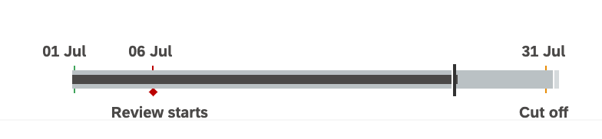

Method: changeCellColor
- The function is used to change the background color of edited columns.
- Fetching the column cells using Id and changing the background color.
- Changing the PO Number link color if the Service Start Date and Service End Date is not available for that PO for Indirect Services Table for PO Owners.

Method: changeThLinkColor
- The function is used to change the PO Number link color if the Service Start Date and Service End Date is not available for that particular PO for Below Threshold Table.

Method: onBeforeExport
- The function is triggered before exporting the excel.
- Changing the date format as dd/mmm/yyyy .
- SAP JS "sap/ui/export/Spreadsheet" is used for the export of the excel sheet.

Method: onBeforeRebindAct1Table
- The function is triggered before binding the data to the Indirect Services Smart table.
- Adding filter parameters PO Number, Item Number and Supplier Name.
- Binding the path to the Smart table.

Method: getFilterValuesAct1
- The function is used to get the filters dropdown values of Indirect Services.
- Reading the data from the Indirect Services table model.
- Method filterValuesSuccess() function is called after getting the data to bind it to the filters dropdown.

Method: filterValuesSuccess
- The function is used to sort the data and bind it to the filter’s dropdown.

Method: getFilterValuesAct2
- The function is used to get the filters dropdown values of Indirect Materials.
- Reading the data from the Indirect Materials table model.
- Method filterValuesSuccess() is called after getting the data to bind it to the filters dropdown.

Method: onBeforeRebindAct2Table
- The function is called before binding the data to the Indirect Materials Smart table.
- Adding filter parameters PO Number, Item Number and Supplier Name.
- Binding the path to the Smart table.

Method: getFilterValuesInfo
- The function is used to get the filters dropdown values of Exclusion POs.
- Reading the data from the Exclusion POs table model.
- Method filterValuesSuccess() is called after getting the data to bind it to the filters dropdown.

Method: onBeforeRebindInfoTable
- The function is called before binding the data to the Exclusion POs Smart table.
- Adding filter parameters PO Number, Item Number and Supplier Name.
- Binding the path to the Smart table.

Method: getFilterValuesThre
- The function is used to get the filters dropdown values of Below Threshold.
- Reading the data from the Below Threshold table model.
- Method filterValuesSuccess() is called after getting the data to bind it to the filters dropdown.

Method: onBeforeRebindThresholdTable
- The function is called before binding the data to the Below Threshold Smart table.
- Adding filter parameters PO Number, Item Number and Supplier Name.
- Binding the path to the Smart table.

Method: totalAmount
- The function is called when user changes the Services Completed Amount.
- Get the user edited amount and checking whether it is in the correct format based on the User’s format set in SAP ( SU3 transaction code ).
- The following conditions are checked:
  - Amount should not be more than PO value
  - Service completed amount should not be in negative.
- Calculate the % of Services Completed and Amount to be Accrued.
- % of Services Completed = (Services Completed Amount / PO value) *100
- If the Invoice Amount is negative, then marking it as zero.
- Amount to be Accrued = Services Completed Amount – Invoice Amount.
- Set the result values to the fields and changing the Accrual Method ‘Straight line’ to ‘Work to Date’.
- Mark the edited row as selected.

Method: totalPercent
- This method is triggered when user changes the % of Services Completed.
- Get the edited percentage and checking whether it is in the correct format.
- The following conditions are checked:
  - Percentage should not be more than 100.
  - Service completed amount should not be in negative.
- Calculating the Services Completed Amount and Amount to be Accrued.
- Services Completed Amount = (% of Services Completed * PO value) / 100
- If the Invoice Amount is negative then marking it as zero.
- Amount to be Accrued = Services Completed Amount – Invoice Amount.
- Setting the result values to the fields and changing the Accrual Method ‘Straight line’ to ‘Work to Date’.
- Mark the edited row as selected.

Method: onClickCheckBox
- The function is called when user clicks the checkbox of “Straight Line” method i.e., when user changes the ‘Work to Date’ to ‘Straight Line’.
- HANA xsodata service (/methodParameters) is called by passing the required row parameters to the url.
- Setting the result values to the fields and changing the Accrual Method ‘Work to Date’’ to ‘Straight Line’.
- Making the edited row as selected.

Method: getAuditLogData
- The function is used to fetch the Data for Audit log table for PO Owner tile.
- HANA xsodata service : /auditParameters is called by passing the required URL.
- Reading the Audit log data from the Audit Model and binding it to the table.

Method: detDialog1
- This method is triggered when user clicks on the Audit log icon in the Smart Table.
- The function is used to open the dialog for the Audit log table.
- Fragment: Audit.fragment.xml is related XML file.

Method: onDetCancel1
- The function is triggered to close the dialog for the Audit log table.

Method: getAribaLink
- The function is used to get the Ariba Link from the Configuration table model by passing the EP Number to it.
- The URL is maintained in configuration table:
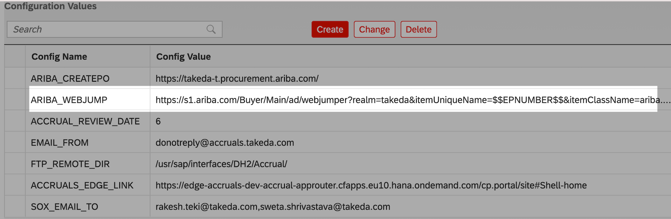

Method: onPressAribaLink
- This method getAribaLink() is triggered on press of the PO number from the table.

Method: detDialog
- The function is used to open the dialog for the Details of that particular record.

Method: onLinkPress
- The function is called when user clicks on the PO Details Link in the Smart Table.
- The method detDialog() is triggered to open the dialog which opens the details.fragment.xml file.
- Binding the edited row data to pass the fields of Details Screen.
- Method getChart() function to get the chart data and bind it to the line chart.

Method: getChart
- The function is used to get the data for the line chart.
- Calculating the Straight line values and fetching the current month invoiced Amount and Services completed Amount.
- Bind the result values to the chart.

Method: onDetCancel
- The function is used to close the dialog for the Details screen.

Method: mapStr
- The function is used to fetch the details of the row and map it to variable.
- This method is called from multiple methods to map the PO fields to the array.

Method: getSelectedData
- The function is used to get the selected row details.
- Fetching the row details and Calling the mapStr() function to map the details to variable Str.

Method: populateGlobalArray
- The function is used to push the Str values to jsonArray.

Method: onMarkAsReviewedSelect
- The function is called when user clicks on select All.
- Method markAllasReviewed() is called by passing the row details as parameters.

Method: markAllasReviewed
- The function mapStr() is called to map the values.
- The function populateGlobalArray() is called to push the values to the jsonArray.

Method: onSelectReview
- This function will be triggered when a row is selected.
- Based on conditions if user clicks on select all check box then calling onMarkAsReviewedSelect() function else calling getSelectedData() function and populateGlobalArray() function.
- If the user unselect the record, then the record will be deleted from the jsonArray.

Method: rebindTables
- This function is used to rebind the Smart tables of Indirect Services and Indirect Materials.

Method: saveData
- This function is used to call the updateServPOStatus xsjs service to post the data to the db.

Method: populateReviewedCount
- This function is used get the count of the pending and reviewed POs count.

Method: onApproveDialogPress
- This function is triggered when user clicks on the Mark as Reviewed button.
- The function populateReviewedCount() is called to get the count of the pending and reviewed POs count.
- Showing pop up with the count.
- On press of Mark only updated as reviewed button in the pop up, calling askConfirmation() function with the same jsonArray.
- On press of Mark all as reviewed button in the pop up, calling askConfirmation() function with all the POs.

Method: savePOChange
- This function is used to call the ECC xsodata service to post the data to the ECC.
- On success, calling the saveData() function().

Method: askConfirmation
- This function is used to open the confirmation pop up.
- On press of Submit button in the pop up, calling the savePOChange() function.
- On press of Cancel button in the pop up, it will close the pop up.

Method: createColumnConfig
- This function is used to create custom columns for export of Audit Table.

Method: auditExportxls
- This function is used to export the audit log data.
- Fetch the data from the Audit log Model.
- The function createColumnConfig() is called to get the custom columns.
- Binding the columns and data to spreadsheet.
Begin of version 3.0

Method: getLinksData

- This function is used to get the links from the backend.
- Calling the helpLinks.xsodata service and binding the data to the table.

Method: onSelectPOClosure
- This function triggers when user clicks on the check box of Eligible for Closure for Indirect Service table.
- Fetches the value of a check box whether it is checked or not.
- Fetching the particular row index and making the row as selected.

Method: onSelectPOClosureMat
- This function triggers when user clicks on the check box of Eligible for Closure for Indirect Material table.
- Fetches the value of a check box whether it is checked or not.
Begin of version 8.0 (CHG0119805)
- Validates particular row on its eligibility for closure based on the threshold value set.
  - Adjust the float precision of the Goods Receipt and Invoice Amount.
  - If (GR_AMT > INV_AMT), then threshold validation follows (((GR_AMT- INV_AMT) / GR_AMT) *100) > 10, If the row satisfies both conditions then PO is not eligible for closure.
End of version 8.0 (CHG0119805)
- Fetching the particular row index and making the row as selected.

Method: threPOClosureSelect
- This function triggers when user clicks on the check box of Eligible for Closure for Threshold PO table.
- Fetches the value of a check box whether it is checked or not.
- Fetching the particular row index and making the row as selected.

Method: mapThreStr
- The function is used to fetch the details of the row and map it to variable.
- This method is called from mapThreStr method to map the fields to the array

Method: onPressSaveThre
- This function is used to call the updateThresholdPOClosure.xsjs service to post the data to the db

Method: onValueHelpDialogPONum
- In this Function calling the valueHelpDialogPONum from the poValueHelp.js file by passing the search token.
- Adding three custom columns PO Number.Line Item and PO Line Description.
- Calling the poValueHelp fragment,creating a table for value help and opening it.

Method: onPOSearch
- This Method will trigger if user searches from the search bar.
- Passing the searched value as filters to the service to get the searched POs in the value help table.

Method: onPressOkPONum
- This Method will trigger if user clicks on OK button of value help dialog.
- Fetching the selected tokens and setting it to particular value help after closing the value help dialog.

Method: onPressCancelPONum
- This Method will trigger if user clicks on Cancel button of value help dialog.
- This Method is used to close the value help dialog.

Method: _poNumFilterSelectionChange
- This Method will trigger if user selects any row from the value help dialog.
- Get the selected indices and setting the tokens to particular value help dialog.

Method: onValueHelpDialogItemNum
- In this Function calling the valueHelpDialogItemNum from the lineItemHelpValue.js file by passing the search token.
- Adding custom column Line Item.
- Calling the itemValueHelpfragment,creating a table for value help and opening it.

Method: onLineItemSearch
- This Method will trigger if user searches from the search bar.
- Passing the searched value as filters to the service to get the searched line item in the value help table.

Method: onPressOkLineItem
- This Method will trigger if user clicks on OK button of value help dialog.
- Fetching the selected tokens and setting it to particular value help after closing the value help dialog.

Method: onPressCancelLineItem
- Method will trigger if user clicks on Cancel button of value help dialog.
- This Method is used to close the value help dialog.

Method: _itemNumFilterSelectionChange
- Method will trigger if user selects any row from the value help dialog.
- Get the selected indices and setting the tokens to particular value help dialog.

Method: onValueHelpDialogSupName
- In this Function calling the valueHelpDialogSupName from the supplierValueHelp.js file by passing the search token.
- Adding two custom columns Supplier Id and Supplier Name.
- Calling the supplierValueHelp,creating a table for value help and opening it.

Method: onSupNameSearch
- Method will trigger if user searches from the search bar.
- Passing the searched value as filters to the service to get the searched Supplier in the value help table.

Method: onPressOkSupName
- Method will trigger if user clicks on OK button of value help dialog.
- Fetching the selected tokens and setting it to particular value help after closing the value help dialog.

Method: onPressCancelSupName

- Method will trigger if user clicks on Cancel button of value help dialog.
- This Method is used to close the value help dialog.

Method: _supNameFilterSelectionChange
- Method will trigger if user selects any row from the value help dialog.
- Get the selected indices and setting the tokens to particular value help dialog.

Method: onClearFilters
- Method to clear the filters of Indirect Services Table.

Method: onClearMatFilters
- Method to clear the filters of Indirect Materials Table.

Method: onClearThreFilters
- Method to clear the filters of Below Threshold Table.

Method: onClearExclFilters
- Method to clear the filters of Exclusion Table.

Method: onPressEmailExcelButton
- This function is used to send all the data into an excel sheet through mail.
- The function getAllOpenPOs xsjs service is called to trigger the mail by passing the login user email id and role.
End of version 3.0
Begin of version 7.0 (CHG0052274)

Method: onApproveMarkAsReviewedPress()
- This function is called when user clicks on mark as reviewed button. If atleast one PO is marked for closure, a confirmation fragment pops up.
- On click of cancel, pop up will close.
- On click of proceed for review, onApproveDialogPress () function is being called.
- If No POs are marked for closure, when user clicks on mark for reviewed, Pop up wont appear and onApproveDialogPress() is being called.

Method: onApproveMarkAsReviewedPressThre()
- When user is in threshold tab, This function is called when user clicks on mark as reviewed button. If atleast one PO is marked for closure, a confirmation fragment pops up.
- On click of cancel, pop up will close.
- On click of proceed for review, onApproveDialogPressThre () function is being called.
- If No POs are marked for closure, when user clicks on mark for reviewed, Pop up wont appear and onApproveDialogPressThre () is being called.

Method: changeCellColorThr
1. The function is used to change the background color of edited columns.
2. Fetching the column cells using Id and changing the background color.
3. Changing the PO Number link color if the Service Start Date and Service End Date is not available for that PO for Indirect Services Table for PO Owners.

Method: onClearMatFilter
- Method to clear the filters of Indirect Materials Table.

Method: onBeforeRebindThresholdTable2
- The function is called before binding the data to the Below Threshold Smart table.
- Adding filter parameters PO Number, Item Number and Supplier Name.
- Binding the path to the Smart table.

Method: onSelectthrePOClosureMater
- This function triggers when user clicks on the check box of Eligible for Closure for Indirect Material table.
- Fetches the value of a check box whether it is checked or not.
Begin of version 8.0 (CHG0119805)
- Validates particular row on its eligibility for closure based on the threshold value set.
  - Adjust the float precision of the Good Receipts and Invoice Amount.
  - If (GR_AMT > INV_AMT), then threshold validation follows (((GR_AMT- INV_AMT) / GR_AMT) *100) > 10, If the row satisfies both conditions then PO is not eligible for closure.
End of version 8.0 (CHG0119805)
- Fetching the particular row index and making the row as selected.

Method: totalAmountThres
- The function is called when user changes the Services Completed Amount.
- Get the user edited amount and checking whether it is in the correct format based on the User’s format set in SAP ( SU3 transaction code ).
- The following conditions are checked:
  - Amount should not be more than PO value
  - Service completed amount should not be in negative.
- Calculate the % of Services Completed and Amount to be Accrued.
- % of Services Completed = (Services Completed Amount / PO value) *100
- If the Invoice Amount is negative, then marking it as zero.
- Amount to be Accrued = Services Completed Amount – Invoice Amount.
- Set the result values to the fields and changing the Accrual Method ‘Straight line’ to ‘Work to Date’.
- Mark the edited row as selected.

Method: totalPercentThres
- This method is triggered when user changes the % of Services Completed.
- Get the edited percentage and checking whether it is in the correct format.
- The following conditions are checked:
  - Percentage should not be more than 100.
  - Service completed amount should not be in negative.
- Calculating the Services Completed Amount and Amount to be Accrued.
- Services Completed Amount = (% of Services Completed * PO value) / 100
- If the Invoice Amount is negative then marking it as zero.
- Amount to be Accrued = Services Completed Amount – Invoice Amount.
- Setting the result values to the fields and changing the Accrual Method ‘Straight line’ to ‘Work to Date’.
- Mark the edited row as selected.

Method: onClickCheckBoxThre
- The function is called when user clicks the checkbox of “Straight Line” method i.e., when user changes the ‘Work to Date’ to ‘Straight Line’.
- HANA xsodata service (/methodParameters) is called by passing the required row parameters to the url.
- Setting the result values to the fields and changing the Accrual Method ‘Work to Date’’ to ‘Straight Line’.
- Making the edited row as selected.

Method: getSelectedData2
- The function is used to get the selected row details.
- Fetching the row details and Calling the mapThreStr() function to map the details to variable Str.

Method: populateGlobalArrayThre
- The function is used to push the Str values to jsonArrayfinal2.

Method: markAllasReviewed2
- The function mapThreStr() is called to map the values.
- The function populateGlobalArrayThre() is called to push the values to the jsonArrayfinal2.

Method: onMarkAsReviewedSelect2
- The function is called when user clicks on select All.
- Method markAllasReviewed2() is called by passing the row details as parameters.

Method: onSelection
- This function will be triggered when a row is selected.
- Based on conditions if user clicks on select all check box then calling onMarkAsReviewedSelect2() function else calling getSelectedData2() function and populateGlobalArrayThre() function.
- If the user unselect the record, then the record will be deleted from the jsonArrayfinal2.

Method: saveData2
- This function is used to call the updateServPOStatus.xsjs service to post the data to the db.

Method: populateReviewedCountThre
- This function is used get the count of the pending and reviewed POs count.

Method: onApproveDialogPressThre
- This function is triggered when user clicks on the Mark as Reviewed button.
- The function populateReviewedCountThre() is called to get the count of the pending and reviewed POs count.
- Showing pop up with the count.
- On press of Mark only updated as reviewed button in the pop up, calling askConfirmation2() function with the same jsonArrayfinal2.
- On press of Mark all as reviewed button in the pop up, calling askConfirmation2() function with all the POs.

Method: savePOChange2
- This function is used to call the ECC xsodata service to post the data to the ECC.
- On success, calling the saveData2() function().

Method: askConfirmation2
- This function is used to open the confirmation pop up.
- On press of Submit button in the pop up, calling the savePOChange2() function.
- On press of Cancel button in the pop up, it will close the pop up.

Method: edgeSave2
- This function is used to save the data in EDGE.

Method: getUserLanguage
- This function is used to get the browser language of the user.

End of version 7.0 (CHG0052274)
Begin of version 8.0 (CHG0119805)

Method: _getThresholdValue
- This function is used to retrieve the threshold value property (THRESHOLDVALUE), initially set to 10 from the entity set RoundingThreshold of the HANA table.

Method: _countDecimal
- Counts the decimal places of a float amount

Method: _finalMultiplier
- Returns the precision multiplier that will be used for variance calculation

End of version 8.0 (CHG0119805)

Technical Details – Accruals Configuration

Technical Details SAP FIORI Application Accruals Configuration
View: CountryConfig
Controller: CountryConfig.controller
Methods involved in controller:

File Name | Methods Involved
CountryConfig.controller.js | onInit()  onItemSelect()  getThreshold()  getEmailTemplates()  getLanguages()  getUserRoles()  getConfig()  getcountryConfig()  onSearchCountryConfig()  onPressConfigCreate()  onPressThresholdCreate()  onPressEmailTemplateCreate()  onPressUserRoleCreate ()  onPressConfigChange ()  onPressCreate ()
onPressLangCreate()
onPressChange()
onPressThresholdChange()
onPressUserRoleChange()
onPressEmailTemplateChange()
onConfigCancelUpdate()
onThresholdCancelUpdate()
onUserRoleUpdateCancel()
onCancelEmailTempl()
onCancelUpdate()
onCancel()
updateConfigValue()
updateValue()
updateThresholdRole()
updateUserRole()
updateEmailTemplate()
onThresholdSaveUpdate()
onchangeEmailTemplSave()
onConfigSaveUpdate()
onUserRoleUpdateSave()
onUserRoleUpdate()
onSaveUpdate()
onConfigSave()
onThresholdSave()
onLangSave()
onUserRoleSave()
onCreateEmailTemplSave()
onSave()
saveThresholdData()
saveLanguageData()
saveEmailTemplateData()
saveUserRoleData()
saveConfigData()
saveData()
onPressThresholdDelete()
onPressConfigDelete()
onPressLangDelete()
onPressUserRoleDelete()
onPressDelete()
onPressEmailTemplateDelete()
action()
actionConfig()
actionUserRole()
actionThreshold()
actionEmailTempl()
actionLang()

Method: onInit():
- Fetch the data from the Roles.json and Access.json.
- The functions getcountryConfig(), getThreshold(), getConfig(), getUserRoles(), getEmailTemplates(), getLanguages() are called to get the data.

Method: onItemSelect():
- This function is called on selection of tab.
- Fetch the key and if the key is page2 then calling the getConfig() to get the data.

Method: getThreshold():
- This function is used to get the data from the threshold model to get the threshold values.
- Reading the data from the threshold model, setting the data to the local json model and binding it to the table.

Method: getEmailTemplates():
- This function is used to get the data from the config model to get the email template.
- Reading the data from the config model, setting the data to the local json model and binding it to the table.

Method: getLanguages():
- This function is used to get the data from the config model to get the languages.
- Reading the data from the config model, setting the data to the local json model and binding it to the table.

Method: getUserRoles():
- This function is used to get the data from the user role model to get the user roles.
- Reading the data from the user role model, setting the data to the local json model and binding it to the table.

Method: getConfig():
- This function is used to get the data from the config model to get the user roles.
- Reading the data from the config model, setting the data to the local json model and binding it to the table.

Method: getcountryConfig():
- This function is used to get the data from the ctryConfig model to get the user roles.
- Reading the data from the ctryConfig model, setting the data to the local json model and binding it to the table.

Method: onSearchCountryConfig():
- This Function is used to filter the Country Name, Country Code and Bukrs from the Country Configuration Table.
- Fetching the value which is entered by the user to search and filtering out the data from the Country Configuration Table.

Method: onPressConfigCreate():
- This function is called to open the dialog popup to create a new configuration.

Method: onPressThresholdCreate():
- This function is called to open the dialog popup to create a new threshold value.

Method: onPressEmailTemplateCreate():
- This function is called to open the dialog popup.
- Fetching the data from the langConfigTable model and setting the data to it before opening the pop up.

Method: onPressUserRoleCreate():
- This function is called to open the dialog popup to create a new user role.

Method: onPressConfigChange():
- This function is called to open the dialog pop up to change an existing configuration.
- Calling updateConfigValue() function to fetch the data of that particular record.

Method: onPressCreate():
- This function is called to open the dialog popup to create a new country configuration.

Method: onPressLangCreate():
- This function is called to open the dialog popup to create a new language to the configuration Table.

Method: onPressChange():
- This function is called to open the dialog pop up to change an existing country configuration.
- Calling updateValue() function to fetch the data of that particular record.

Method: onPressThresholdChange ():
- This function is called to open the dialog pop up to change an existing threshold configuration.
- Calling updateThresholdRole() function to fetch the data of that particular record.

Method: onPressUserRoleChange():
- This function is called to open the dialog pop up to change an existing user role configuration.
- Calling updateUserRole() function to fetch the data of that particular record.

Method: onPressEmailTemplateChange():
- This function is called to open the dialog pop up to change an existing country configuration.
- Calling updateEmailTemplate() function to fetch the data of that particular record.
- Fetching the data from the langConfigTable model and setting the data to it before opening the pop up.

Method: onConfigCancelUpdate():
- This function is called to close and destroy the dialog pop up of an existing configuration.

Method: onThresholdCancelUpdate():
- This function is called to close and destroy the dialog pop up of an existing threshold configuration.

Method: onUserRoleUpdateCancel():
- This function is called to close and destroy the dialog pop up of an existing user role configuration.

Method: onCancelEmailTempl():
- This function is called to close and destroy the dialog pop up of an existing email template configuration.

Method: onCancelUpdate():
- This function is called to close and destroy the dialog pop up of an existing country configuration.

Method: onCancel():
- This function is called to close and destroy the dialog pop.

Method: updateConfigValue ():
- This function is used to fetch the selected row values and setting it to the configuration change dialog pop.

Method: updateValue ():
- This function is used to fetch the selected row values and setting it to the country configuration change dialog pop.

Method: updateThresholdRole ():
- This function is used to fetch the selected row values and setting it to the threshold configuration change dialog pop.

Method: updateUserRole ():
- This function is used to fetch the selected row values and setting it to the user role configuration change dialog pop.

Method: updateEmailTemplate ():
- This function is used to fetch the selected row values and setting it to the email template configuration change dialog pop.

Method: onThresholdSaveUpdate ():
- This function is used to fetch the new edited values of threshold.
- Calling the saveThresholdData() to save the data in the db.

Method: onchangeEmailTemplSave ():
- This function is used to fetch the new edited values of email template.
- Calling the saveEmailTemplateData () to save the data in the db.

Method: onConfigSaveUpdate ():
- This function is used to fetch the new edited values of configuration.
- Calling the saveConfigData() function to save the data in the db.

Method: onUserRoleUpdateSave ():
- This function is used to fetch the new edited values of user role.
- Calling the saveUserRoleData() function to save the data in the db.

Method: onUserRoleUpdate ():
- This function is used to fetch the new edited values of user role.
- Calling the saveConfigData() function to save the data in the db.

Method: onSaveUpdate ():
- This function is used to fetch the new edited values of configuration.
- Calling the saveData () function to save the data in the db.

Method: onConfigSave ():
- This function is used to fetch the values of configuration.
- Calling the saveConfigData() function to save the data in the db.

Method: onThresholdSave ():
- This function is used to fetch the values of threshold.
- Calling the saveThresholdData() function to save the data in the db.

Method: onLangSave ():
- This function is used to fetch the values of language configuration.
- Calling the saveLanguageData() function to save the data in the db.

Method: onUserRoleSave ():
- This function is used to fetch the values of user role.
- Calling the saveUserRoleData() function to save the data in the db.

Method: onCreateEmailTemplSave ():
- This function is used to fetch the values of email template.
- Calling the saveEmailTemplateData() function to save the data in the db.

Method: onSave ():
- This function is used to fetch the values of country.
- Calling the saveData() function to save the data in the db.

Method: saveThresholdData ():
- Calling insertThreshold xsjs service to save the threshold data.

Method: saveLanguageData ():
- Calling insertLanguage xsjs service to save the language data.

Method: saveEmailTemplateData ():
- Calling insertEmailTemplate xsjs service to save the email template data.

Method: saveUserRoleData ():
- Calling insertUserRole xsjs service to save the user role data.

Method: saveConfigData ():
- Calling insertConfigValues xsjs service to save the configuration data.

Method: saveData ():
- Calling insertCountry xsjs service to save the country data.

Method: onPressThresholdDelete ():
1. Fetching the selected row details and calling confirmation pop up.
- Calling deleteThreshold xsjs service to delete the threshold data from the db.

Method: onPressConfigDelete ():
1. Fetching the selected row details and calling confirmation pop up.
- Calling deleteConfigValues xsjs service to delete the config data from the db.

Method: onPressLangDelete ():
1. Fetching the selected row details and calling confirmation pop up.
2. Calling deleteLanguages xsjs service to delete the languages data from the db.

Method: onPressUserRoleDelete ():
- Fetching the selected row details and calling confirmation pop up.
- Calling deleteUserRole xsjs service to delete the user role data from the db.

Method: onPressDelete ():
- Fetching the selected row details and calling confirmation pop up.
- Calling deleteCountry xsjs service to delete the country data from the db.

Method: onPressEmailTemplateDelete ():
- Fetching the selected row details and calling confirmation pop up.
- Calling deleteEmailTemplate xsjs service to delete the email template data from the db.

Method: action ():
- This function is called when user selects a record from the country table.
- Fetching the edited row details.

Method: actionConfig ():
- This function is called when user selects a record from the config table.
- Fetching the edited row details.

Method: actionUserRole ():
- This function is called when user selects a record from the user role table.
- Fetching the edited row details.

Method: actionThreshold ():
- This function is called when user selects a record from the threshold table.
- Fetching the edited row details.

Method: actionEmailTempl ():
- This function is called when user selects a record from the email template table.
- Fetching the edited row details.

Method: actionLang ():
- This function is called when user selects a record from the language table.
- Fetching the edited row details.

Method:OData Configuration

The following steps are mentioned for OData configuration.
- Step 1: Go to Manifest.Json and select Data source 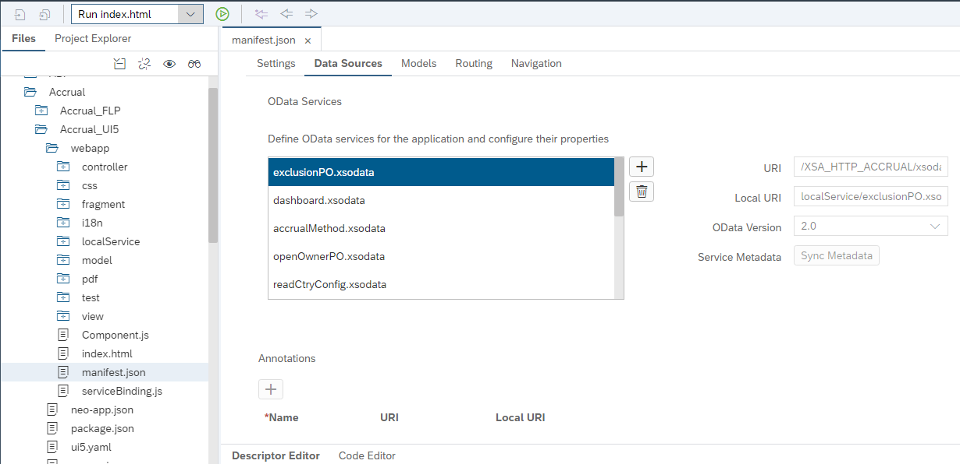
Figure 2: Manifest-Odata Configuration

- Step 2: Add New Service

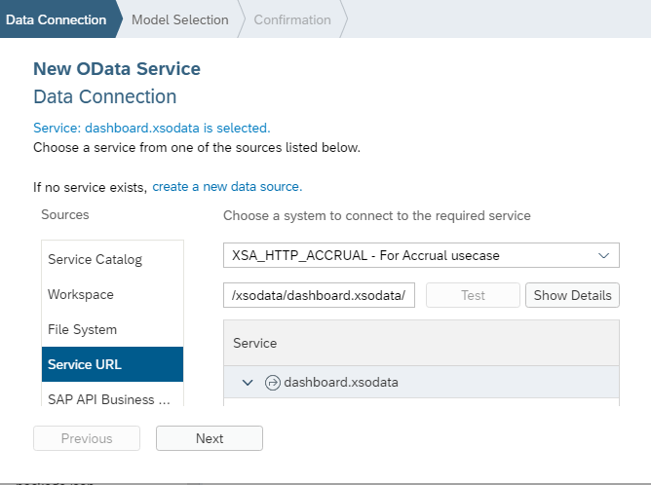

Figure 3: Add new service

- Step 3: Create new model for the service
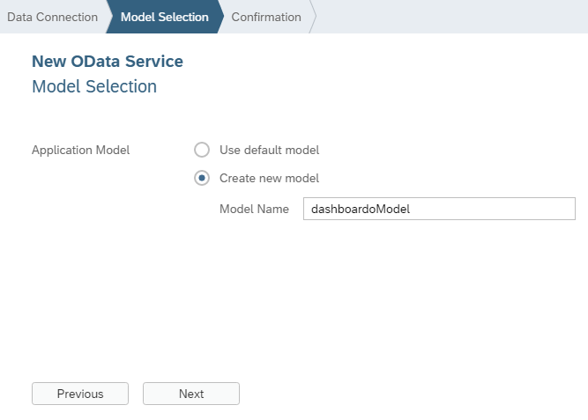

Figure 4: Adding Model
- Step 4: Confirm the service
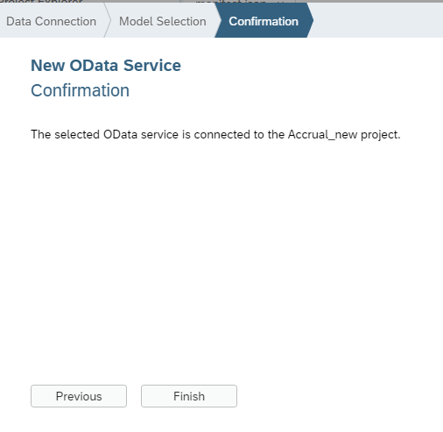
Figure 5: Confirmation

Fiori Launchpad Configuration
- Step 1: Create Fiori Launchpad

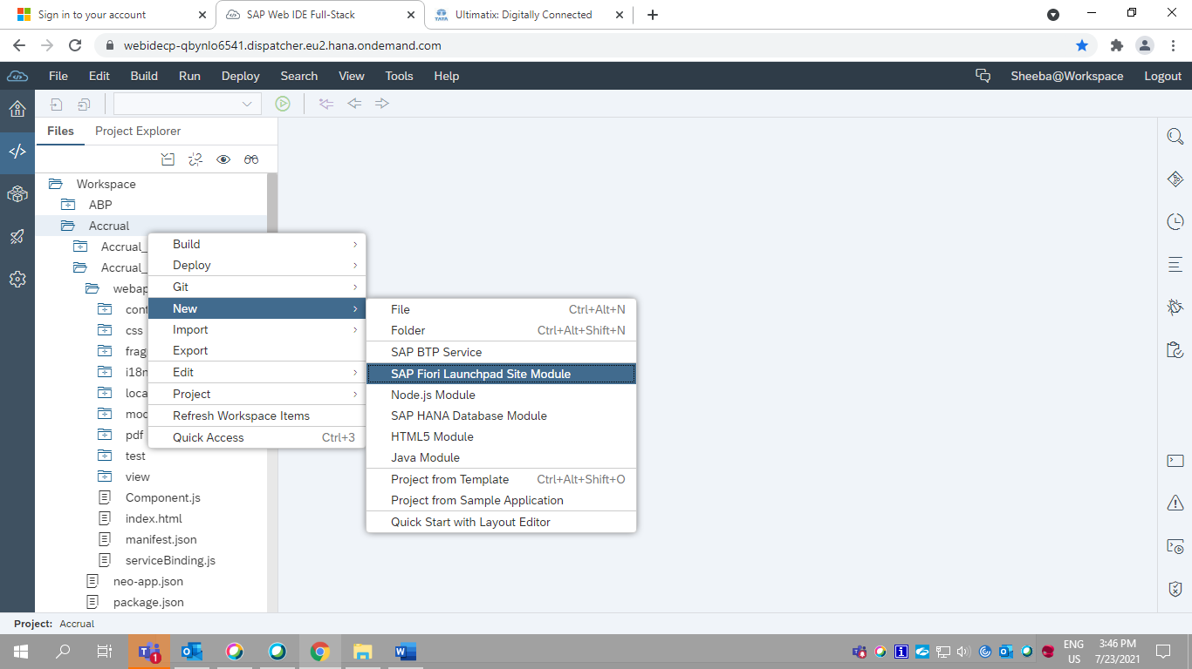
Figure 6: Fiori Launchpad Creation
- Step 2: Create Tiles
- Step 3: Adding Tiles
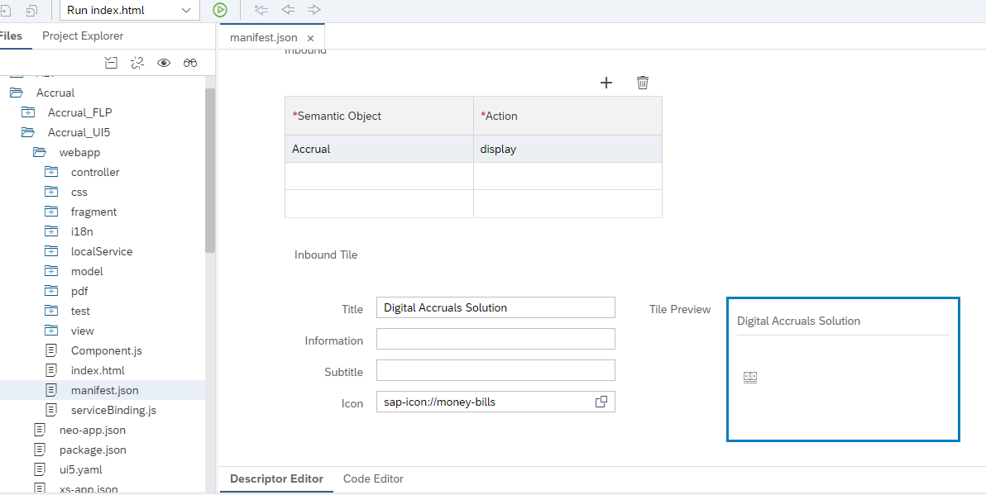

Figure 7: Adding Tile

SAP Web Analytics for usage tracking

Implement SAP Web Analytics for tracking the usage in Fiori Launchpad application. The solution will be implemented as Shell Plug-in in Fiori Launchpad. The tracking service is enabled in SAP Cloud platform to check the usage of application Cloud Administrator will be able to generate the report. There is no additional development requirement except creating new Shell Plugin application.

SAPUI5 Shell Plugin application:
A new HTML5 module with Shell Plugin added to the project
- Once logged in to Fiori Launchpad the events will be triggered to SAP Cloud platform. The script will be generated in SAP Cloud platform. Below is the script information embedded in plugin module.

<script>
var swa = {
pubToken: ‘0ee7e8d3-d04a-41a3-ab3e-28bd9af8a16d’,
baseUrl: 'https://events.wa.cfapps.eu10.hana.ondemand.com/tracker/',
owner: null,
//set this to a function that returns the identifier of the tracked user
};
(function(){
var d=document, g=d.createElement('script'), s=d.getElementsByTagName('script')[0];
g.type='text/javascript'; g.defer=true; g.async=true; g.src=swa.baseUrl+'js/track.js';
s.parentNode.insertBefore(g,s);
})();
</script>
- Application controller logic implemented in “Component.js” .
Controller Path: com.takeda.ACCRUAL_ShellPlugin

Version 6.0 Begins (CHG0074033)

CHG0074033: Bugfix- Issue with Mark all as reviewed button
- Requirement: Removal of "Mark all as reviewed" button in PO Owner / Preparer tile. As it did not capture the changes in audit log and status of the PO's not changing.
- Solution Implemented:
Removed the “Mark all as reviewed” button form the pop-up when the user clicks on Mark as reviewed button from the PO Owner / Preparer tile.
Instead, user can use select all option from the table, which is working fine, hence proposed fix is to remove the button from the pop-up in PO Owner/Preparer tile.
File modified under repositories in eclipse:
Accruals -> Accruals_UI5 -> webapp -> controller -> Business.controller.js
Version 6.0 Ends (CHG0074033)
Version 8.0 Starts(CHG0073691)

3.3.66 Background Image for ACCRUALS Fiori Launchpad and UI Theme Designer

UI Theme Designer has been used to publish Standard Takeda Theme as per the Takeda Design Guidelines. Background Image for Accruals Launchpad has been uploaded and theme has been published. Relevant CSS Changes have been done in the UI Theme Designer for Accruals.
Theme ID – edge_accruals
File modified in edge-accurals-ui code:
edge-accurals-ui -> Accrual_FLP->portal-site ->CommonDataModel.json
Accruals UI Launchpad Background Image :-
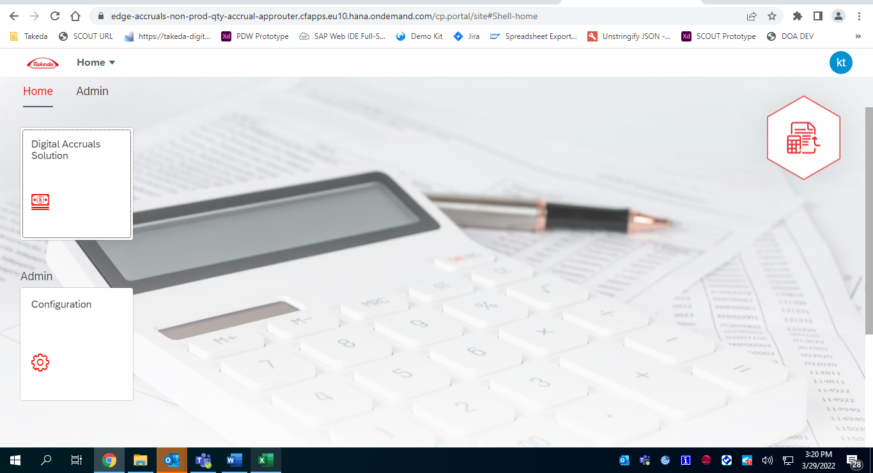

Version 8.0 Ends(CHG0073691)
Version 12.0 Starts(CHG0073691)

CHG0093134: Update to DAS Dashboard Layout & Text
- Requirement:
- Change "To act upon" to read: To Act Upon: POs Over $50k
- Change "POs under $50k" to read: To Act Upon: POs Under $50k
- Move the below $50k POs to the right of the above 50k tab
- Capitalize "For Information Only".
- Change the font color of "For information only" to green or another color that differentiates it from the to act upon tabs.
- Solution Implemented:
The text has been updated in all the given languages.
For Information Only tab has been moved to the right side and the text color.
File modified under repositories in eclipse:
Accruals -> Accruals_UI5 -> webapp -> dashboard.fragment.xml
Accruals -> Accruals_UI5 -> webapp -> dashboardTBS.fragment.xml
Accruals -> Accruals_UI5 -> webapp -> css -> style.css
Accruals -> Accruals_UI5 -> webapp -> i18n
Version 12.0 Ends(CHG0073691)

Version 13.0 Starts

CHG0095742/INC2308469: Some users are having trouble using the DAS tool. getting error msg for cutoff time issue.
Requirement: The PO Under $50k tab on DAS application is in freeze mode (cutoff time issue).
Solution Implemented: The code is updated and the issue is fixed now the application is working fine as excepted.
File modified under repositories in webide:
Accruals -> Accruals_UI5 -> webapp -> controller -> Business.controller.js
Accruals -> Accruals_UI5 -> webapp -> controller -> TBS.controller.js

CHG0094914/RITM1391889: Alignment of Filters/Formatters and Sorters within the Accrual Application
Requirement: Alignment of Filters/Formatters and Sorters within the Accrual Application
Solution Implemented: The Filter/Formatters and Sorters were fixed in the Dashboard table and in the PO table. Filter and Sort property name was updated in the below files.
File modified under repositories in webide:
Accruals -> Accruals_UI5 -> webapp -> controller -> Business.controller.js
Accruals -> Accruals_UI5 -> webapp -> controller -> TBS.controller.js
Accruals -> Accruals_UI5 -> webapp -> fragment-> dashboard.fragment.xml
Accruals -> Accruals_UI5 -> webapp -> fragment-> dashboardTBS.fragment.xml
Accruals -> Accruals_UI5 -> webapp -> fragment-> actUpon.fragment.xml
Accruals -> Accruals_UI5 -> webapp -> fragment-> actUponTBS.fragment.xml
Accruals -> Accruals_UI5 -> webapp -> fragment-> thresholdTab.fragment.xml
Accruals -> Accruals_UI5 -> webapp -> fragment-> thresholdTBS.fragment.xml

CHG0095265/INC2078352: Authorization issues where mass number of Cost Centers to one user was not possible.
Requirement: Authorization issues where mass number of Cost Centers to one user was not possible.
Solution Implemented: The fix is updated in the config files, previously the length was maintained as 5000 now it’s updates to 10000.
File modified under repositories in webide:
Accruals -> Accruals_Config -> webapp -> view -> UserRoleCreate.fragment.xml
Accruals -> Accruals_Config -> webapp -> view -> UserRoleUpdate.fragment.xml
Version 13.0 Ends
Version 2.0 begins

CHG0101768: Matomo integration for tracking the application
SAP WEB Analytics code has been replaced with Matomo Analytics code for Accurals application to track the usage of the application, as the SAP web analytics got obsolete on August 2022.
Matomo Analytics will provide detailed reports on the application and its visitors, including the search engines and keywords they used, the language they speak, which pages they like, the files they download and so much more.
File Modified in edge-donor-management-internal-ui:
- edge-Accuarals -ui >Accurals_shellplugin>webapp>component.js

CHG0097438: Reference link description text change for Japanese Language
- Requirement:
- To change the reference links description text for Japanese language for both PO owner and TBS tile as per business requirement
- Solution Implemented:
- Changing the properties of Japanese text in the i18n file for the Japanese language
Description in English | Before | After change
WBT presentation | トレーニング資料 | 基礎トレーニング資料
Navigating the Digital Accruals Solution | Digital Accruals Solutionの利用方法 ツール＆ダッシュボード | Digital Accruals Solutionの基本的な利用方法
Virtual ILT presentation | オンラインでのトレーニング資料 | Refresherトレーニング資料

- File modified in edge-accurals-ui code:
- Accrual_UI5/webapp/i18n/i18n_ja.properties

CHG0104009: Update Node JS version to 16
The Node Js has been updated to the latest version. The latest version needs to be maintained in the code so that the future deployments for any bug fix or any enhancement can happen through Github.
File modified in edge-accurals-ui code:
.github-> workflows-> build-deploy.yml
accurals-approuter-> package.json

CHG0097438: Hungarian text update
- Requirement:
- Change “To Act Upon: POs Over $50k” to “Teendők $50k feletti PO-k”
- Change “To Act Upon: POs Under $50k” to “Teendők $50k alatti PO-k”
- Change “For Information Only” to “Tájékoztatásul”
- Solution Implemented:
The text has been updated as per the given Hungarian translation
File modified under repositories in eclipse:
Accruals -> Accruals_UI5 -> webapp -> i18n -> i18n_hu.properties
Version 2.0 ends
Version 3.0 begins (CHG0097800 & CHG0099567)

CHG0097800: System performance issues
- Requirement:
- Users with the global access are getting error while opening DAS - issue is with all the dashboards.
- Dashboard doesn`t load even for users with single PO, after restarting the dashboard it takes much time to refresh it.
- Solution Implemented:
- The Dashboard table has been removed from both the tiles PO Owner and TBS.
- Value of "defaultCountMode" property was changed from "Request" to "InlineRepeat". This change results in only 1 selection process for each request instead of 2.
File modified under repositories in eclipse:
Accrual_UI5 -> webapp -> fragment -> dashboard.fragment.xml
Accrual_UI5 -> webapp -> fragment -> dashboardTBS.fragment.xml
Accruals -> Accruals_UI5 -> webapp -> manifest.json

CHG0099567: Quick Reference links are updated with mismatch description and taking long time to load the data
Requirement: Users are unable to find the Quick link reference as per the description shown for the respective links as it is showing different description for different Reference link
Solution Implemented: we are validating the Link ID of the description and assigned the Reference link the function, so it will not update the description with none of the other links
Files Changed:
File Modified | Methods()
Accrual_UI5/webapp/controller/Business.controller.js | onSelectMainTabs()
Accrual_UI5/webapp/controller/TBS.controller.js | onSelectMainTabs()

- onSelectMainTabs(): Here in this Method we have implemented the condition where it will validate the ID of the description and assign the reference link
Version 3.0 ends (CHG0097800 & CHG0099567)
Version 4.0 Begins(CHG0107600 & CHG0098341)

CHG0107600: Smart filter issue and setting button issue
Requirement:
- Users are unable to filter the PO numbers in smart table for under 50k and information tab for both PO owner tile and TBS Tile
- Users are unable to open the Setting button in under 50k and information tab for both PO owner and TBS Tile
Solution implemented: instead of using named model for binding the smart table we are using default model to bind the table
Files Modified in Accrual_UI5/webapp/controller/Business.controller.js
- onBeforeRebindInfoTable(); In This method we have commented down the named model that we are binding to the table
- onBeforeRebindThresholdTable():In This method we have commented down the named model that we are binding to the table
onBeforeRebindThresholdTable2():In This method we have commented down the named model that we are binding to the table
Files Modified in Accrual_UI5/webapp/controller/TBS.controller.js
- onBeforeRebindInfoTable():In This method we have commented down the named model that we are binding to the table
- onBeforeRebindThresholdTable():In This method we have commented down the named model that we are binding to the table
- onBeforeRebindThresholdTable2():In This method we have commented down the named model that we are binding to the table

CHG0098341: Eligible for Closure issue (Scrollbar)
Requirement:
- Users are unable to close multiple PO’s in smart table.
- Once a PO got selected for closure that row position will become non-editable for the user, while scrolling down the PO comes to the previously selected position become non-editable.
Solution implemented: Using a new field to store the latest PO Closure flag and updating the records accordingly.
Files Modified in Accrual_UI5/webapp/controller/Business.controller.js
- onPressMarkPOClosureDialog(); In This method we have commented down the set enable to false condition and added the PO closure flag field.
- onSelectContinuePOClosureMat(); In This method we have commented down the set enable to false condition and added the PO closure flag field.
- onSelectPOClosureSThre(); In This method we have commented down the set enable to false condition and added the PO closure flag field.
- onSelectContinePOClosureMaterThre(); In This method we have commented down the set enable to false condition and added the PO closure flag field.
- onSelection(); In This method we have added the condition for PO closure flag field.
- onSelectReview(); In This method we have added the condition for PO closure flag field.
Files Modified in Accrual_UI5/webapp/controller/TBS.controller.js
- onPressMarkPOClosureDialogTBS(); In This method we have commented down the set enable to false condition and added the PO closure flag field.
- onSelectContinuePOClosureMatTBS(); In This method we have commented down the set enable to false condition and added the PO closure flag field.
- onSelectPOClosureSThreTBS(); In This method we have commented down the set enable to false condition and added the PO closure flag field.
- onSelectContinePOClosureMaterThreTBS(); In This method we have commented down the set enable to false condition and added the PO closure flag field.
- onSelectReview(); In This method we have added the condition for PO closure flag field.
- onSelection(); In This method we have added the condition for PO closure flag field.
Version 4.0 End (CHG0107600 & CHG0098341)

Version 5.0 Begins (CHG0105586)

CHG0105586: UI/UX Improvements & New Column Addition
Requirement:
- RITM1450002 - New Column (Activity Number) addition in all the smart tables.
- RITM1574151 – UI/UX Enhancements.
Solution implemented:
- RITM1450002 - New Column (Activity Number) has been added in all the Smart tables.
- Below are the solutions for RITM1574151 – UI/UX Enhancements,
- Align ‚Email Excel Report button to the right so it fits on every screen.
- Buttons Design & Order – the color scheme and order of the buttons should be adjusted.
- Edit Success message to Information message when the ‚Email Excel Report button is pressed.
- Adjust dialog width, icon and buttons when pressing checkbox ‘Eligible for closure’.
- Freeze first 4 columns in every table except for ‘For information only’.
- Add number of PO’s in the brackets on the main IconTabBar control.
Files Modified in Accrual_UI5/webapp/controller/Business.controller.js:
- onObejctMatched(): created new model -> tableCountModel to display number of POs in the IconTabBar
- onBeforeRebindAct1Table(): update the tableCountModel
- onBeforeRebindAct2Table(): update the tableCountModel
- onBeforeRebindInfoTable(): update the tableCountModel
- onBeforeRebindThresholdTable(): update the tableCountModel
- onBeforeRebindThresholdTable2(): update the tableCountModel
- onPressEmailExcelButton(): change the type of the MessageBox
- onLinkPress(): added Activity number (ZACTIVITYNBR)
Files Modified in Accrual_UI5/webapp/controller/TBS.controller.js:
- onObejctMatched(): created new model -> tableCountModel to display number of POs in the IconTabBar
- onBeforeRebindAct1Table(): update the tableCountModel
- onBeforeRebindAct2Table(): update the tableCountModel
- onBeforeRebindInfoTable(): update the tableCountModel
- onBeforeRebindThresholdTable(): update the tableCountModel
- onBeforeRebindThresholdTable2(): update the tableCountModel
- onPressEmailExcelButton(): change the type of the MessageBox
- onLinkPress(): added Activity number (ZACTIVITYNBR)
Files Modified in Accrual_UI5/webapp/css/style.css:
- Modified class .emailExcelButton -> without margins
Files Modified in Accrual_UI5/webapp/fragment/POClosurePopUp.fragment.xml:
- Fragment modified to show icon („sap-icon://alert“), contentWidth set to 50%, buttons redesigned.
Files Modified in Accrual_UI5/webapp/fragment/actUpon.fragment.xml:
- New column Activity Number has been added.
- Added property fixedColumnCount="4" to actUponB1 and MatTableB tables, button redesigned with Hbox control.
Files Modified in Accrual_UI5/webapp/fragment/actUponTBS.fragment.xml:
- New column Activity Number has been added.
- Added property fixedColumnCount="4" to SmartTableTBSactUpon1 and SmartTableTBSactUpon2 tables, button redesigned with Hbox control and aligned to the right with justifyContent="End".
Files Modified in Accrual_UI5/webapp/fragment/dashboard.fragment.xml:
- „emailExcelButton“ aligned to the right by wrapping the control to VBox and property „alignItems=“End““
- Labels of IconTabFilter controls were changed to show the number of POs in brackets.
Files Modified in Accrual_UI5/webapp/fragment/dashboardTBS.fragment.xml:
- „emailExcelButton“ aligned to the right by wrapping the control to VBox and property „alignItems=“End““
- Labels of IconTabFilter controls were changed to show the number of POs in brackets.
Files Modified in Accrual_UI5/webapp/fragment/details.fragment.xml:
- Activity Number has been added
Files Modified in Accrual_UI5/webapp/fragment/infoTab.fragment.xml:
- New column Activity Number has been added.
Files Modified in Accrual_UI5/webapp/fragment/thresholdTBS.fragment.xml:
- New column Activity Number has been added.
- Added property fixedColumnCount="4" to thrTab, MatTableBThrs tables and buttons redesigned with Hbox control and aligned to the right with justifyContent="End".
Files Modified in Accrual_UI5/webapp/fragment/thresholdTab.fragment.xml:
- New column Activity Number has been added.
- Added property fixedColumnCount="4" to thrTab, MatTableBThrs tables and buttons redesigned with Hbox control and aligned to the right with justifyContent="End".
Files Modified in Accrual_UI5/webapp/i18n:
- Text translation has been updated in all the i18n files.
Files Modified in Accrual_UI5/webapp/localService:
- Added the property for the new column (Activity Number) in the respective services.
Files Modified in Accrual_UI5/webapp/model/common.js:
- New methods have been added,
createTableModel() -> creation of JSONModel that holds number of POs to be displayed in IconTabBar
updateTableCountModel() -> this method updates the values in „tableCountModel“
Version 5.0 End (CHG0105586)
[Begin changes of version 6.0 in VEEVA related to Change Request CHG0112262]

CHG0112262: PO review button is missing
Requirement:
- INC2662673 - PO review button is missing on PO Owner tile under $50k Tab.
Solution implemented:
- Updated the correct formatter for the threshold tab (Under $50k).
Files Modified in Accrual_UI5/webapp/fragment/thresholdTab.fragment.xml:
- Updated the proper formatter for the Mark as Review button.

[End changes of version 6.0 in VEEVA related to Change Request CHG0112262]

Version 9.0 Begins (CHG0119219)

CHG0119219: Missing Video links in Admin/TBS/Finance tab and Addition of IVT And PO Depletion Report
Requirement:
• RITM1810378 – re-inserting function for Video Links in Admin/Finance/TBS
• RITM1800593 – UI/UX Enhancements.
Solution implemented:
• RITM1810378 – Re inserted function for Video Links that was removed and applied best practices.
• Below are the solutions for RITM1800593 – UI/UX Enhancements,
o Inserted links for Invoice Track and PO Depletion Report
o Created constans.js file to store the links and avoid hardcoding
o Created a local model in the controller to bind the links
o Updated all i18n properties file
Files Modified in Accrual_UI5/webapp/controller/Business.controller.js:
• onInit(): created new model -> oExternalLinks to bind the links for Invoice Track and PO Depletion Report when pressed
Files Modified in Accrual_UI5/webapp/controller/TBS.controller.js:
• onInit(): created new model -> oExternalLinks to bind the links for Invoice Track and PO Depletion Report when pressed
• onSelectMainTabs(): added a condition that will triogger a function that will pull and bind data for video links.
• getVideoLinksData(): pulls data that will be binded to video links
• onVideoPress(): Opens a pop up dialog when a link is pressed

Files Modified in Accrual_UI5/webapp/ fragment/dashboard.fragment.xml:
• Inserted 2 Link elements for Invoice Track and PO Depletion Report
• Added class for property to match the color theme
Files Modified in Accrual_UI5/webapp/ fragment/dashboardTBS.fragment.xml:
• Inserted 2 Link elements for Invoice Track and PO Depletion Report
• Added class for property to match the color theme
Files Modified in Accrual_UI5/webapp/i18n/i18n.properties:
• Added internationalization text for invoice track and PO depletion report
Files Modified in Accrual_UI5/webapp/i18n/i18n_cs.properties:
• Added internationalization text for invoice track and PO depletion report in English as it was confirmed by the business
Files Modified in Accrual_UI5/webapp/i18n/i18n_de.properties:
• Added internationalization text for invoice track and PO depletion report in English as it was confirmed by the business
Files Modified in Accrual_UI5/webapp/i18n/i18n_en.properties:
• Added internationalization text for invoice track and PO depletion report in English as it was confirmed by the business
Files Modified in Accrual_UI5/webapp/i18n/i18n_es.properties:
• Added internationalization text for invoice track and PO depletion report in English as it was confirmed by the business
Files Modified in Accrual_UI5/webapp/i18n/i18n_fr.properties:
• Added internationalization text for invoice track and PO depletion report in English as it was confirmed by the business
Files Modified in Accrual_UI5/webapp/i18n/i18n_cs.properties:
• Added internationalization text for invoice track and PO depletion report in English as it was confirmed by the business
Files Modified in Accrual_UI5/webapp/i18n/i18n_hu.properties:
• Added internationalization text for invoice track and PO depletion report in English as it was confirmed by the business
Files Modified in Accrual_UI5/webapp/i18n/i18n_it.properties:
• Added internationalization text for invoice track and PO depletion report in English as it was confirmed by the business
Files Modified in Accrual_UI5/webapp/i18n/i18n_ja.properties:
• Added internationalization text for invoice track and PO depletion report in English as it was confirmed by the business
Files Modified in Accrual_UI5/webapp/i18n/i18n_pt.properties:
• Added internationalization text for invoice track and PO depletion report in English as it was confirmed by the business
Files Modified in Accrual_UI5/webapp/i18n/i18n_ru.properties:
• Added internationalization text for invoice track and PO depletion report in English as it was confirmed by the business
Files Modified in Accrual_UI5/webapp/i18n/i18n_zh.properties:
• Added internationalization text for invoice track and PO depletion report in English as it was confirmed by the business
Files Modified in Accrual_UI5/webapp/i18n/i18n_zh_tw.properties:
• Added internationalization text for invoice track and PO depletion report in English as it was confirmed by the business
Files Modified in Accrual_UI5/webapp/utils/constants.js:
• Created a module to store all hardcoded records to be used in bindin data
Version 9.0 End (CHG0119219)

Technical Details in SAP HANA Database:

SDI Configuration
Below are the details of DH2 ( details of QH2 and PH2 are maintained and handled by cloud administrator)
- HANA DB System Details: DH2
- HOST = takhddh22001.onetakeda.com:32015
- Port Number: 32015
- System Name: DH2
Begin of version 3.0

SDI Configuration for ECC
- SDI Remote source connection details from ECC to HANA Database (DH2)
- DB Name: ME1
- Port Number: 1584
- DB Type: Oracle
- Source Name: ECC_Atoms
- Adapter Name: OracleECCAdapter
- Source Location: agent (DH4_DPA)
- Host : dbme184
End of version 3.0

Begin of Version 10.0 (CHG0052274)

PRB0011314 -Separate Remote Source creation

Requirement : To create a separate remote source connection with ECC and permanent fix for INC1604176. As Currently there is a real time replication issue with EKPO table in production for accruals and as a workaround an automated job is scheduled to refresh the data for every 2 hours and as a permanent fix suggested by SAP need to create separate remote source connection for Accruals. The issue occurred due to using same remote source (ECC Atoms) for all other use case also like CSCT, SPM and VBO.

Solution Implemented : New remote source was created ECC_ACCRUALS for DAS. Now all the table will replicate with new remote source in Production system.

End of Version 10.0 (CHG0052274)

SDI Replication Task details
Below are the replication tasks.
SDI Replication Task | Type | HANA Table Name
ADR6.hdbreptask | .hdbreptask | ACCRUAL."ACCRUAL:: ADR6.ADR6"
ADRP.hdbreptask | .hdbreptask | ACCRUAL."ACCRUAL:: ADRP.ADRP"
CSKS.hdbreptask | .hdbreptask | ACCRUAL."ACCRUAL:: CSKS.CSKS"
CSKT.hdbreptask | .hdbreptask | ACCRUAL."ACCRUAL:: CSKT.CSKT"
EKBE.hdbreptask | .hdbreptask | ACCRUAL."ACCRUAL:: EKBE.EKBE"
EKKN.hdbreptask | .hdbreptask | ACCRUAL."ACCRUAL:: EKKN.EKKN"
EKKO.hdbreptask | .hdbreptask | ACCRUAL."ACCRUAL:: EKKO.EKKO"
EKPO.hdbreptask | .hdbreptask | ACCRUAL."ACCRUAL:: EKPO.EKPO"
LFA1.hdbreptask | .hdbreptask | ACCRUAL."ACCRUAL:: LFA1.LFA1"
T001.hdbreptask | .hdbreptask | ACCRUAL."ACCRUAL:: T001.T001"
TCURR.hdreptask | .hdbreptask | ACCRUAL."ACCRUAL:: TCURR.TCURR"
TCURV.hdbreptask | .hdbreptask | ACCRUAL."ACCRUAL:: TCURV.TCURV"
TCURX.hdreptask | .hdbreptask | ACCRUAL."ACCRUAL:: TCURX.TCURX"
USR01.hdbreptask | .hdbreptask | ACCRUAL."ACCRUAL:: USR01.USR01"
USR21.hdbreptask | .hdbreptask | ACCRUAL."ACCRUAL:: USR21.ISR21"
Begin of version 3.0
ZFI_ACCRUAL_EXCL.hdreptask | .hdbreptask | ACCRUAL."ACCRUAL:: ZFI_ACCRUAL_EXCL. ZFI_ACCRUAL_EXCL "
TCURF.hdbreptask | .hdbreptask | ACCRUAL."ACCRUAL:: TCURF.TCURF"
TCURN.hdbreptask | .hdbreptask | ACCRUAL."ACCRUAL:: TCURN.TCURN"
End of version 3.0
Begin of version 7.0 (CHG0119805)
ZMD_POSITN_INFO | hdbreptask |  | SAPHANADB_ZMD_POSITN_INFO
ZMD_CONTACT_INFO | hdbreptask |  | SAPHANADB_ZMD_CONTACT_INFO
ZMD_WORKER_NAME | hdbreptask |  | SAPHANADB_ZMD_WORKER_NAME
End of version 7.0((CHG0119805)

HANA Data Base Tables:

HANA Custom Table | Type
ZT_EDGE_SERVICEPO_STATUS | .hdbtable
ZT_EDGE_AUDITLOG | .hdbtable
CONFIG.COUNTRY | .hdbtable
ZT_CONFIG_VALUES | .hdbtable
ZT_PO_THRESHOLD | .hdbtable
ZT_CONFIG_ROLES | .hdbtable
Begin of version 3.0
ZT_EDGE_EXCLUSIONPO | .hdbtable
ZT_EDGE_EXCHANGERATE | .hdbtable
ZT_USER_LANGUAGE | hdbtable
End of version 3.0
Begin of version 7.0 (CHG0119805)
TB_PO_THRESHOLD | hdbtable
TB_PENDING_PO_DETAILS | hdbtable
End of version 7.0 (CHG0119805)

S.No | Artifact | Artifact Type | Details
1 | "ACCRUAL"."ACCRUAL.Procedures::handleAuditEntry" | Procedure | Procedure is called by the trigger to audit the log
2 | "ACCRUAL"."CREATE_AUDIT_ENTRY" | Trigger | Procedure is called inside Trigger to aduit log the poline item details

Technical Details in SAP XSA

XSA Artifacts

Begin of version 7.0 (CHG0052274)
- A project (MTA-multi target application) to develop Digital Accruals Solution application is created in HANA Web IDE
- Below modules are added to the project
  - DB module-ARIBA_ACCRUALS_DB
  - Nodejs module-ARIBA_ACCRUALS_JS (with xsjs support)
- ARIBA_ACCRUALS_DB is created to perform all DB operations using XSA artifacts
- ARIBA_ACCRUALS_JS is created to create xsodata and xsjs service using XSA artifacts
- ARIBA_ACCRUALS_SAP_JS is created to place CSV file on FTP server.
- SAP HANA Service connection is created with the help of Technical user.
- SMTP service is created as user provided service to enable send mail functionality.
- Resources are created for the services in mta.yaml file and assigned those resources as requires in our nodejs module
- .hdbgrants file is created under src folder

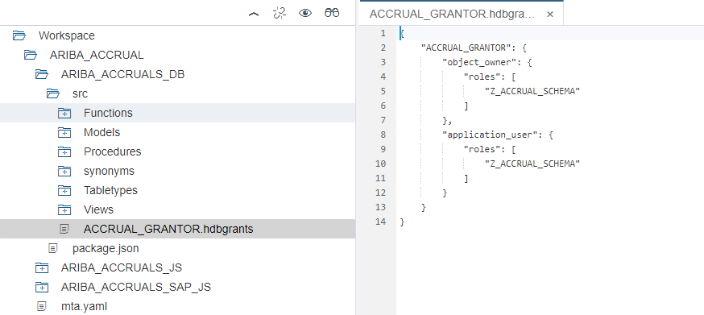

- Grantor file

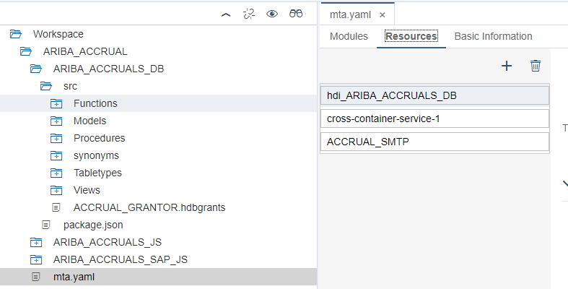

- SMTP service is created as user provided service with port 25 and host SMTPRelay.onetakeda.com
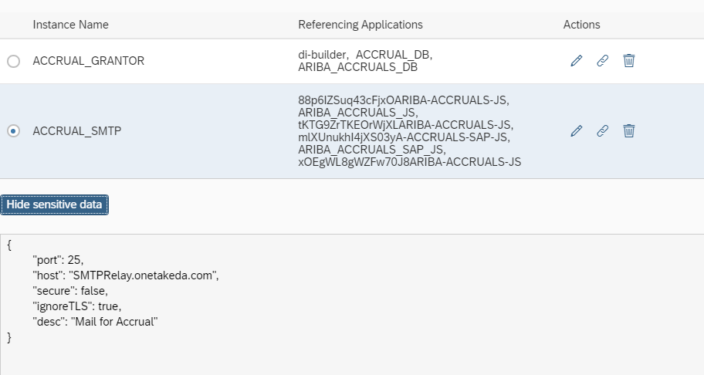

- Resources are created for the services ACCRUAL_SMTP in mta.yaml file and assigned those resources as requires in our nodejs module
- hdbgrants file is created under src folder
- Below Synonyms are created with the help of grantor service. [Note : with the help of grantor service we can get access to HANA DB ‘DH2’]

Sl. No. | Synonyms | Type
N/A | Synonyms for ECC and EDGE Custom Tables | N/A
1 | ARIBA_ACCRUAL.ARIBA_ACCRUALS_DB.synonyms::EKKO.EKKO | .hdbsynonym
2 | ARIBA_ACCRUAL.ARIBA_ACCRUALS_DB.synonyms::EKPO.EKPO | .hdbsynonym
3 | ARIBA_ACCRUAL.ARIBA_ACCRUALS_DB.synonyms::LFA1.LFA1 | .hdbsynonym
4 | ARIBA_ACCRUAL.ARIBA_ACCRUALS_DB.synonyms::EKBE.EKBE | .hdbsynonym
5 | ARIBA_ACCRUAL.ARIBA_ACCRUALS_DB.synonyms::ZT_EDGE_SERVICEPO_STATUS | .hdbsynonym
6 | ARIBA_ACCRUAL.ARIBA_ACCRUALS_DB.synonyms::T001.T001 | .hdbsynonym
7 | ARIBA_ACCRUAL.ARIBA_ACCRUALS_DB.synonyms::CSKS.CSKS | .hdbsynonym
8 | ARIBA_ACCRUAL.ARIBA_ACCRUALS_DB.synonyms::EKKN.EKKN | .hdbsynonym
9 | ARIBA_ACCRUAL.ARIBA_ACCRUALS_DB.synonyms::CSKT.CSKT | .hdbsynonym
10 | ARIBA_ACCRUAL.ARIBA_ACCRUALS_DB.synonyms::ZT_EDGE_AUDITLOG | .hdbsynonym
11 | ARIBA_ACCRUAL.ARIBA_ACCRUALS_DB.synonyms::TCURN.TCURN | .hdbsynonym
12 | ARIBA_ACCRUAL.ARIBA_ACCRUALS_DB.synonyms::TCURR.TCURR | .hdbsynonym
13 | ARIBA_ACCRUAL.ARIBA_ACCRUALS_DB.synonyms::TCURX.TCURX | .hdbsynonym
14 | ARIBA_ACCRUAL.ARIBA_ACCRUALS_DB.synonyms::TCURV.TCURV | .hdbsynonym
15 | ARIBA_ACCRUAL.ARIBA_ACCRUALS_DB.synonyms::TCURF.TCURF | .hdbsynonym
16 | ARIBA_ACCRUAL.ARIBA_ACCRUALS_DB.synonyms::ZFI_ACCRUAL_EXCL.ZFI_ACCRUAL_EXCL | .hdbsynonym
17 | ARIBA_ACCRUAL.ARIBA_ACCRUALS_DB.synonyms::CONFIG.COUNTRY | .hdbsynonym
18 | ARIBA_ACCRUAL.ARIBA_ACCRUALS_DB.synonyms::ZT_CONFIG_VALUES | .hdbsynonym
19 | ARIBA_ACCRUAL.ARIBA_ACCRUALS_DB.synonyms::DUMMY | .hdbsynonym
20 | ARIBA_ACCRUAL.ARIBA_ACCRUALS_DB.synonyms::USR01.USR01 | .hdbsynonym
21 | ARIBA_ACCRUAL.ARIBA_ACCRUALS_DB.synonyms::ADR6.ADR6 | .hdbsynonym
22 | ARIBA_ACCRUAL.ARIBA_ACCRUALS_DB.synonyms::USR21.USR21 | .hdbsynonym
23 | ARIBA_ACCRUAL.ARIBA_ACCRUALS_DB.synonyms::ADRP.ADRP | .hdbsynonym
24 | ARIBA_ACCRUAL.ARIBA_ACCRUALS_DB.synonyms::ZT_PO_THRESHOLD | .hdbsynonym
25 | ARIBA_ACCRUAL.ARIBA_ACCRUALS_DB.synonyms::ZT_CONFIG_ROLES | .hdbsynonym
26 | ARIBA_ACCRUAL.ARIBA_ACCRUALS_DB.synonyms::ZT_POST_POCHANGE_AUDIT | .hdbsynonym
27 | ARIBA_ACCRUAL.ARIBA_ACCRUALS_DB.synonyms::ZT_POLINE_AUDIT | .hdbsynonym
28 | ARIBA_ACCRUAL.ARIBA_ACCRUALS_DB.synonyms::ZT_CONFIG_HELPLINKS | hdbsynonym
29 | ARIBA_ACCRUAL.ARIBA_ACCRUALS_DB.synonyms::ZT_EDGE_SPLITFILE | hdbsynonym
30 | ARIBA_ACCRUAL.ARIBA_ACCRUALS_DB.synonyms::ZT_EMAIL_TEMPLATE_CONFIG | hdbsynonym
31 | ARIBA_ACCRUAL.ARIBA_ACCRUALS_DB.synonyms::ZT_EDGE_EXCLUSIONPO | .hdbsynonym
32 | ARIBA_ACCRUAL.ARIBA_ACCRUALS_DB.synonyms::ZT_EDGE_EXCHANGERATE | hdbsynonym
33 | ARIBA_ACCRUAL.ARIBA_ACCRUALS_DB.synonyms::ZT_CONFIG_LANGUAGES | .hdbsynonym
34 | ARIBA_ACCRUAL.ARIBA_ACCRUALS_DB.synonyms::ZT_USER_LANGUAGE | .hdbsynonym
35 | ARIBA_ACCRUAL.ARIBA_ACCRUALS_DB.synonyms:: ZT_CONFIG_VIDEOLINKS | .hdbsynonym
36 | ARIBA_ACCRUAL.ARIBA_ACCRUALS_DB.synonyms:: ZT_REC_ARIBA_STAT | .hdbsynonym
37 | ARIBA_ACCRUAL.ARIBA_ACCRUALS_DB.synonyms:: TB_PO_THRESHOLD | .hdbsynonym
 | Begin of version 7.0 (CHG0119805)
38 | ARIBA_ACCRUAL.ARIBA_ACCRUALS_DB.synonyms::SAPHANADB_ZMD_POSITN_INFO | .hdbsynonym
39 | ARIBA_ACCRUAL.ARIBA_ACCRUALS_DB.synonyms::SAPHANADB_ZMD_CONTACT_INFO | .hdbsynonym
40 | ARIBA_ACCRUAL.ARIBA_ACCRUALS_DB.synonyms::TB_PENDING_PO_DETAILS | .hdbsynonym
41 | ARIBA_ACCRUAL.ARIBA_ACCRUALS_DB.synonyms::SAPHANADB_ZMD_WORKER_NAME | .hdbsynonym
 | End of version 7.0 (CHG0119805)

- All the database artifacts are created under the folder src of DB module

Arifacts:Table Types

S.No | TableTypes | Type
1 | TT_reviewPOLinework | .hdbtabletype
2 | TT_statusPO | .hdbtabletype

Artifacts : Procedures

Sl. No. | Procedures | Details
1 | deleteConfigLanguages | Procedure to delete language details from “ZT_CONFIG_LANGUAGES” table.
2 | deleteConfigValues | Procedure to delete config details from “ZT_CONFIG_VALUES” table.
3 | deleteCountryConfig | Procedure to delete country details from “CONFIG.COUNTRY” table.
4 | deleteEmailTemplate | Procedure to delete email template details from “ZT_EMAIL_TEMPLATE_CONFIG” table.
5 | deletePoThreshold | Procedure to delete threshold details from “ZT_PO_THRESHOLD” table.
6 | deleteUserRoleConfig | Prcoedure to delete user role details from “ZT_CONFIG_ROLES“ table.
7 | getOpenPOCSV | Procedure to get all openPo’s for CSV file generation .
8 | insertConfigLanguages | Procedure to add and update language details in “ZT_CONFIG_LANGUAGES” table.
9 | insertConfigValues | Procedure to add and update config name and values in “ZT_CONFIG_VALUES” table.
10 | insertCountryConfig | Procedure to add and update country details in “CONFIG.COUNTRY” table.
11 | notifyOpenPOUsersList | Procedure to notify PO Owner,PO Preparer,Admin,Finance and TBS usesr about all open PO’s.
12 | reviewPOLine | Procedure to update Exchange Rate details in ZT_EDGE_EXCHANGERATE table.
13 | updateThresholdPOClosure | Procedure to update Eligible for Closure field in threshold tab.
14 | populateExchangeRate | Procedure to notify PO Owner .  1. TBS/Finance can review work completed for multiple line items in a PO and notify PO Owner with PO Details.
15 | updateServPOStatus | Procedure to add or update “ZT_EDGE_SERVICEPO_STATUS” table.
16 | updateUserLang | Procedure is to update and insert ZT_USER_LANGUAGE table
17 | jobSchedulerDates | Procedure to get WD-1,WD-5 and WD-10 dates
18 | discrepancyWTDAmounts | Procedure to get Discrepancy records
19 | cutOffCheck | Procedure to get flag based on cut off date and time
20 | POClosureEmail | Procedure to get PO’s which are closed
21 | insertVideoLinks.hdbprocedure | Procedure is to insert and update  ZT_CONFIG_VIDEOLINKS
22 | deleteVideoLinks.hdbprocedure | Procedure is to delete  ZT_CONFIG_VIDEOLINKS
23 | insertWebService.hdbprocedure | Procedure to insert data  ZT_REC_ARIBA_STAT
 | Begin of version 7.0 (CHG0119805)
24 | jobSchedulerWD2Date | Procedure for WD-2 date computation
25 | getEmailManagerPO | Procedure to obtain a consolidated EmailID
 | End of version 7.0 (CHG0119805)

Artifacts : Functions

S.No | Functions | Details
1 | TF_getOpenPOQueryWithEmail | Function provides Indirect Material and Indirect service PO Number,item No and PO Requestor fields.
2 | SF_accrualMethod | Scalar Function provides straight line calculation and amounts .
3 | TF_auditLog | Function returns all the log details of “ZT_EDGE_SERVICEPO_STATUS” table
4 | SF_calcSTL_wtdAmountPer | Function to calculate WTD amount and percentage.
5 | TF_checkPOExclusion | Scalar Function returns the exclusion PO lineitem details based on rule type .
6 | TF_filterPOByThreshold | Function returns PO Line item details based on threshold.
7 | TF_getExclusionPOs | Function returns Exclusion PO details for particular user(TBS/PO OWNER)
8 | TF_getOpenAllPO | Function returns all material and service Open PO’s for particular user which are greater than the threshold.
9 | TF_getOpenAllThresholdPO | Function returns all open threshold POs details .
10 | TF_getOpenPO | Function returns all open PO details for particular user .  - Gl account and cost center fields werestring aggregated .
11 | TF_getOpenPOReport | Function returns all open PO details for particular user to prepare the Report.
12 | TF_getOpenThresholdPO | Function to get threshold open PO’s based on userid and user role .
13 | TF_getPODetail | Function returns complete details of PO line item nos.
14 | TF_getPOGRValue | Function returns GR value of PO’s.
15 | TF_getPOInvoiceValue | Function returns Invoice value of PO’s.
16 | TF_getPOOwnerDash | Function to get dashboard details of material,service and threshold PO’s.
17 | TF_getUserRole | Function to get role of the user .
18 | TF_WTDAudit | Function to get total work completed information for each month .
19 | TF_UserConfigCompanyCodes | Function to get Company Codes
20 | TF_UserConfigCostCenter | Function to get Cost center details
21 | TF_getOpenThresholdPOReport | Function returns all Threshold PO details for particular user to prepare the Report.
22 | TF_UserConfigManagementUnit | Function to get Management Unit details
23 | TF_getExclusionPOReport | Function returns all Exclusion PO details for particular user to prepare the Report.
24 | SF_ConvertCurrency | Scalar Function to convert currency to required currency.
25 | SF_getExchangeRate | Scalar Function to convert currency to target currency .
26 | TF_getUserDetails | Function to get userdetails like full name ,email id and decimal format.
 | Begin of version 7.0 (CHG0119805)
27 | TF_getPendingPODetails | Function to get the pending PO’s details for Logs
28 | TF_getPendingPO | Function to get to get the pending PO’s details for csv generation
 | End of version 7.0 (CHG0119805)

Artifacts : Calculation Views

S.No | Calculation View | Details
1 | CV_accrualMethod | View to get straightline,accrual method and amount details
2 | CV_auditLog | View to get the log details of material and service PO’s.
3 | CV_getConfigLanguages | View to get language information.
4 | CV_getCountryConfig | View to the list country details.
5 | CV_getDashboard | View to display dashboard details.
6 | CV_getEmailTemplates | View for email templates .
7 | CV_getExclusionPO | View to display exclusion PO’s
8 | CV_getOpenPO | view to display all open PO’s
9 | CV_getOpenPOReport | View to display all open PO’s
10 | CV_getPO_GRValue | View to dsiplay GR values.
11 | CV_getPO_INVvalue | View to display invoice values.
12 | CV_getThresholdPO | View to display Threshold PO’s
13 | CV_getUserDetails | View to display user details
14 | CV_getUserRole | View to display user roles based on ID.
15 | CV_getUserRoleConfig | View to diaply user roles.
16 | CV_readConfigValues | View to display config details.
17 | CV_getExclusionPOReport.hdbcalculationview | View to display exclusion PO’s
18 | CV_getOpenThresholdPOReport.hdbcalculationview | View to display Threshold PO’s
19 | CV_readCountryConfig | View to display country details.
20 | CV_AllVideoLinks.hdbcalculationview | View to display the video links
21 | CV_read_PO_Rounding_Threshold.hdbcalculationview | View to display PO Rounding Threshold
 | Begin of version 7.0 (CHG0119805)
22 | CV_getPO_ManagerEmail | Fetching the Managers email then filtered out TET level 0 and 1
23 | CV_getEmailManagerPO | View to display Email manager PO
 | End of version 7.0 (CHG0119805)

File Upload on FTP server :

File Upload on FTP server
Procedure: | getOpenPOCSV
XS Service: | ARIBA_ACCURALS_SAP_JS →routeràroutes-->myNode.js

S.No | Artifact | Artifact Type | Details
1 | deleteConfigValues | .xsjs | Xsjs service to run t“e "deleteConfigValu“s " procedure and delete values.
2 | deleteCountry | .xsjs | Xsjs Service to run procedu“e "deleteCountryCon”ig" to delete country details.
3 | deleteEmailTemplate | .xsjs | Xsjs Service to r“n "deleteEmailTempl”te" Procedure to delete particular email template .
4 | deleteLanguages | .xsjs | Xsjs Service to r“n "deleteConfigLangua”es" Procedure to delete particular language details.
5 | deleteThreshold | .xsjs | Xsjs service to r“n "deletePoThresh”ld" procedure to delete threshold details.
6 | deleteUserRole | .xsjs | Xsjs services to r“n "deleteUserRoleCon”ig" procedure to delete particular user role.
7 | getAllOpenPOs | .xsjs | Xsjs Service to r“n "getAllOpen”Os" procedure to generate CSV file with all Open Pos and trigger mail.
8 | insertConfigValues | .xsjs | Xsjs service to r“n "insertConfigVal”es" procedure to create config values.
9 | insertCountry | .xsjs | Xsjs service to ”un"insertCountryCon”ig" procedure to create country details.
10 | insertEmailTemplate | .xsjs | Xsjs service to r“n "insertEmailTempl”te" procedure to create email template.
11 | insertLanguage | .xsjs | Xsjs Service to r“n "insertConfigLangua”es" procedure to create language details.
12 | insertThreshold | .xsjs | Xsjs Servcie to run “insertPoThreshold” procedure to create threshold details.
13 | insertUserRole | .xsjs | Xsjs Sercvice to r“n "insertUserRoleCon”ig" procedure to create user roles.
14 | monthlyOpenPOs | .xsjs | Xsjs Sercvice to r“n "getOpenPO”SV" procedure to trigger mail with Open PO’s.
15 | notifyOpenPO | .xsjs | Xsjs Service to r“n "notifyOpe”PO" procedure to trigger mails to all users with dashboard details.
16 | reviewPOLine | .xsjs | Xsjs Service to run “reviewPOLine” procedure to trigger mail to PO Preparer and PO Owner with Po line item.
17 | updateThresholdPOClosure.xsjs | xsjs | Xsjs Service to run “ updateThresholdPOClosure” procedure to update Eligible for closure field in threshold tab.
18 | updateServPOStatus | .xsjs | Xsjs service to r“n "updateServPOSta”us" procedure to update “ZT_EDGE_SERVICEPO_STATUS” table.
19 | cutOffCheck | xsjs | XSJS service to run cutOffCheck procedure
20 | wtdDiscrepancyFile.xsjs | xsjs | Xsjs servie to run discrepancyWTDAmounts procedure
21 | updateUserLang | Xsjs | Xsjs service to run updateUserLang procesure to update language
22 | poClosureEmail | xsjs | Xsjs service to run POClosureEmail procedure to trigger emails to UAMS team
23 | notifyTbs | xsjs | Xsjs service to trigger emails to TBS Users with pending PO Count
24 | notifyFinance | xsjs | Xsjs service to trigger emails to Finance Users with pending PO Count
25 | notifyAdmin | xsjs | Xsjs service to trigger emails to Admin Users with pending PO Count
26 | notifyPOOwners | xsjs | Xsjs service to trigger emails to PO Owners Users with pending PO Count
27 | notifyPOPreparer | xsjs | Xsjs service to trigger emaisl to PO Preparer Users with pending PO count
28 | insertVideoLinks | xsjs | Xsjs service to trigger to insert/update the data in the custom table
29 | deleteVideoLinks.xsjs | xsjs | Xsjs service to trigger to delete the data in the custom table
30 | updateServPOStatusMail.xsjs | Xsjs | Xsjs service to trigger the mail based on the custom table
 | Begin of version 7.0 (CHG0119805)
31 | notifyPOOwnerManager.xsjs | xsjs | Xsjs service to send consolidated value
32 | insertPendingPODetails.xsjs | xsjs | Xsjs service to insert data to staging table for pending PO Details
 | End of version 7.0 (CHG0119805) | N/A | N/A

Odata Artifact | Entities | DB Artifact | Details
accrualMethod.xsodata | method | CV_accrualMethod | To display accrual method,straight line and amount details.
auditLog.xsodata | audit | CV_auditLog | To display audit log details.
dashboard.xsodata | dashboardPO | CV_getDashboard | To display dashboard details.
exclusionPO.xsodata | exclusionPO | CV_getExclusionPO | To display exclusion PO’s.
openOwnerPO.xsodata | openPO | CV_getOpenPO | To display all Open PO’s details.
readConfigValues.xsodata | configValues | CV_readConfigValues | To display config values.
readConfigValues.xsodata | emailTemplate | CV_getEmailTemplates | To display email template data.
readConfigValues.xsodata | configLang | CV_getConfigLanguages | To display language details.
readCtryConfig.xsodata | ctryConfigPO | CV_readCountryConfig | To display country details.
readThreshold.xsodata | threshold | readPoThreshold | To display threshold details.
thresholdPO.xsodata | threshold | CV_getThresholdPO | To display threshold PO’s details.
userDetails.xsodata | user | CV_getUserDetails | To display user details.
userRole.xsodata | userRole | CV_getUserRoleConfig | To display user roles.
userRoleID.xsodata | role | CV_getUserRole | To display role based on user id.
videoLinks.xsodata | Video Links | CV_AllVideoLinks.hdbcalculationview | To Display the video links data

- Port 51130 (for module ARIBA_ACCRUALS_JS) is added in mta.yaml file as part of deployment.
- Project is built and deployed to XS advanced, which will generate the following local services in the environment:

          - /xsodata/dashboard.xsodata/dashboardPOParameters(IP_EMAIL='rakesh.teki@takeda.com',IP_POOWNER='X')/Results
          - /xsodata/auditLog.xsodata/auditParameters(IP_PONUM='8000059126')/Results
          - /xsodata/accrualMethod.xsodata/methodParameters
          - /xsodata/openOwnerPO.xsodata/openPOParameters(IP_PSTYPE='9',IP_EMAIL='rakesh.teki@takeda.com',IP_POOWNER='X')/Results?$format=json
          - /xsodata/exclusionPo.xsodata/exclusionPOParameters(IP_EMAIL='*',IP_POOWNER='X')/Results
          - /xsodata/readConfigValues.xsodata?$format=json
          - /xsodata/readCtryConfig.xsodata/ctryConfigPO?$format=json
          - /xsodata/thresholdPO.xsodata/thresholdParameters(IP_PSTYPE='0',IP_EMAIL=%27sweta.shrivastava@takeda.com%27)/Results?$format=json
          - /xsodata/readThreshold.xsodata/threshold
          - /xsodata/userDetails.xsodata/user?$top=100
          - /xsodata/userRoleID.xsodata/roleParameters(IP_EMAIL='sweta.shrivatsava@takeda.com')/Results
          - /xsodata/readCtryConfig.xsodata/ctryConfigPO?$format=json

XSJS Service Url’s:

The following endpoints are configured for the respective actions.

          - /xsjs/deleteConfigValues.xsjs
          - /xsjs/deleteCountry.xsjs
          - /xsjs/deleteEmailTemplate.xsjs
          - /xsjs/deleteLanguages.xsjs
          - /xsjs/deleteThreshold.xsjs
          - /xsjs/deleteUserRole.xsjs
          - /xsjs/getAllOpenPOs.xsjs
          - /xsjs/insertConfigValues.xsjs
          - /xsjs/insertCountry.xsjs
          - /xsjs/insertEmailTemplate.xsjs
          - /xsjs/insertLanguage.xsjs
          - /xsjs/insertThreshold.xsjs
          - /xsjs/insertUserRole.xsjs
          - /xsjs/monthlyOpenPOs.xsjs
          - /xsjs/notifyOpenPO.xsjs
          - /xsjs/reviewPOLine.xsjs
          - /xsjs/updateServPOStatus.xsjs
          - /xsjs/updateThresholdPOClosure.xsjs
          - xsjs/notifyAdmin.xsjs
          - xsjs/notifyFinance.xsjs
          - xsjs/notifyTbs.xsjs
          - xsjs/notifyPOOwner.xsjs
          - xsjs/notifyPOPreparer.xsjs
          - xsjs/updateUserLang.xsjs
          - xsjs/wtd DiscrepancyFile.xsjs

End of version 7.0 (CHG0052274)

Begin of version 4.0

CHG0068966: Values are populated incorrectly in Accruals Dashboard and the extract also is showing the wrong values
We are displaying GR and Invoice value up to 28th January, but during the freeze period (1-6) it should show the previous month last data i.e, 31st, January data.
Previously, we were checking, if the current date is between 1-6, then it was calculating last date of current month-1(i.e., the previous month) and in February last date is 28th, we were subtracting one month from it, then it was going to the previous month January 28th, but we need to have 31st, January.
So, now we are taking current month date and subtracting current month with 1 so it gives previous month i.e., January and in January we are taking last date i.e., is January 31st.
Changed Path: ARIBA_ACCRUALS_DB->src->Function-> TF_getPOInvValue
Changed Path: ARIBA_ACCRUALS_DB->src->Function-> TF_getPOGRValue
End of Version 4.0
Begin of Version 5.0 (CHG0070311)

CHG0070311: Bugfix - Notify ADMIN, TBS, FINANCE, POOWNER, POPREPARER jobs did not run in ACCRUALS production system on 15-Feb-2022.
Solution Implemented:
In existing XSA logic, a procedure getPendingCounts.hdbprocedure is written to get pending counts of POs for all Admin, TBS, Finance, PO Owner & PO Preparer users.
Before fetching the PO counts, a cut-off date is calculated in the same procedure. Cut-off date is the date when ACCRUALS production application becomes unfreeze i.e., 7th of every month. This date should be in ‘YYYYMMDD’ format. But, while calculating date for current month, the data format was ‘YYYYMDD’, which caused an error in the job and no emails were triggered on WD-10 day.
Hence, to fix this issue, a standard function ‘LPAD’ is used to always fetch date in ‘YYYMMDD’ format, which permanently resolves the above-mentioned issue.
Changed Path: ARIBA_ACCRUALS_DB->src->Procedures-> getPendingCounts
End of Version 5.0 (CHG0070311)
Begin of Version 7.0 (CHG0052274)

Bugfix - Subject of the Email Extract is Wrong.
Solution Implemented:
In the existing application while we are extracting Purchase Order Dashboard Extract ,During the freeze period(1st to 6th of every month) of DAS application email extract is showing the wrong subject
So, if we extract the report between (1-6th April) it has to show March in the subject of the extract mail.
Hence, to fix this issue, We have made the changes in existing getAllOpenPOs.xsjs.
File modified in edge-accruals-xsa:
Changed Path: ARIBA_ACCRUALS_JS->lib->xsjs-> getAllOpenPOs.xsjs
End of Version 7.0 (CHG0052274)
Begin of Version 9.0 (CHG0071169)

CHG0071169: Enable download of DAS reconcile data to HANA DB on monthly basis.
Solution Implemented:
As per new business requirement, implemented a solution that will insert the reconcile data into a new table named ZT_MONTHLY_RECONCILIATION in EDGE database.
In XSA, a new procedure monthly_reconciliation.hdbprocedure is created to fetch the data for exclusion, threshold & open POs on monthly basis and insert the same data to a new table.
To update existing records with ARCHIVE_FLAG = Yes and ARCHIVED_ON = CURRENT_TIMESTAMP, a new procedure monthlyReconcile_archive.hdbprocedure is newly created in XSA.
A new xsjs service “monthlyReconciliation.xsjs” is created for posting the data and on top of which a new job “monthly_reconciliation_job” is scheduled in job scheduler dashboard. This job runs on the last day of every month at 11:55 PM CET.
Similarly, a “monthlyReconcile_archive.xsjs” is created for updating archived records for previous month and a job “monthly_reconcile_archive” is scheduled to run on 2nd of every month at 11:55 PM CET for the same.
Once the data is loaded into the table, the same data will be picked up by SAP Analytic Cloud tool for further process.
Files added in edge-accruals-xsa:
ARIBA_ACCRUALS_DB -> Procedures -> monthly_reconciliation.hdbprocedure
ARIBA_ACCRUALS_JS -> lib -> xsjs -> monthlyReconciliation.xsjs
ARIBA_ACCRUALS_DB -> Procedures -> monthlyReconcile_archive.hdbprocedure
ARIBA_ACCRUALS_JS -> lib -> xsjs -> monthlyReconcile_archive.xsjs
File modified in edge-accruals-xsa:
ARIBA_ACCRUALS_DB -> synonyms -> synonym.hdbsynonym
File added in eclipse:
ACCRUALS -> Tables -> ZT_MONTHLY_RECONCILIATION.hdbtable
End Of Version 9.0 (CHG0071169)
Begin of Version 11.0 (CHG0087603/CHG0087759)

Please modify system logic to treat any Material PO that has a Service start and end date populated as a Service PO in DAS. change of logic for Material PO where Service Start and End date are populated - Brazil/China.
Solution Implemented:
SDI: Japan company code with condition has been added in EKPO table filter.
Created a Configuration name (Japan_Brazil) and values (Company Codes). Based on the configuration and the service date(zstart_date should not be initial) the PO should appear on the service and material area.
Select queries were adjusted through the above logic.
File modified in edge-accruals-xsa:
Procedures:
ARIBA_ACCRUALS_DB -> Procedures -> POClosureEmail.hdbprocedure
ARIBA_ACCRUALS_DB -> Procedures -> discrepancyWTDAmounts.hdbprocedure
ARIBA_ACCRUALS_DB -> Procedures -> getAllOpenPOs.hdbprocedure
ARIBA_ACCRUALS_DB -> Procedures -> monthly_reconciliation.hdbprocedure
ARIBA_ACCRUALS_DB -> Procedures -> notifyOpenPOUsersList_CA.hdbprocedure
Functions:
ARIBA_ACCRUALS_DB -> Functions -> TF_accuralMethod.hdbfunction
ARIBA_ACCRUALS_DB -> Functions -> TF_getOpenAllPO.hdbfunction
ARIBA_ACCRUALS_DB -> Functions -> TF_getOpenPOQuery.hdbfunction
ARIBA_ACCRUALS_DB -> Functions -> TF_getOpenPOQueryEmail_old.hdbfunction
ARIBA_ACCRUALS_DB -> Functions -> TF_getPODetail.hdbfunction
ARIBA_ACCRUALS_DB -> Functions -> TF_getPODetailQuery.hdbfunction
ARIBA_ACCRUALS_DB -> Functions -> TF_getPOOwnerDash.hdbfunction
ARIBA_ACCRUALS_DB -> Functions -> getOpenPOQueryWithEmail.hdbfunction
ARIBA_ACCRUALS_DB -> Functions -> getOpenPOQueryWithEmail_bck.hdbfunction
ARIBA_ACCRUALS_DB -> Functions -> getOPenPOQueryWithEmailbck2.hdbfunction

End Of Version 11.0 (CHG0087603/CHG0087759)
Begin of Version 12.0
CHG0087616

Purchase Orders that are in the 'Exclusion' section do not show any Invoice values, even where invoices exist in ECC.
Solution Implemented:
Added the logic of IF condition in functions.
At the input we are passing an empty value, because of this the values are not population at the output screen. Used IF Operator when the input is an empty, at this time we are using constant values. And these logics were used in below areas.
Functions:
ARIBA_ACCRUALS_DB -> Functions -> TF_getPOInvValue.hdbfunction
Values 0.00 is not showing at the output.
Solution Implemented:
Added new parameters of INVVALUE_MAPPED, GRVALUE_MAPPED in the calculation view.
Models:
ARIBA_ACCRUALS_DB -> Models -> cv_getExclusionPO.hdbcalculationview
CHG0085854

"The update made to the service completed % is not being saved when the application is being refreshed. The updates are being saved after "Mark as Reviewed" is clicked. However, when the user refreshes the screen, the amounts revert back to zero.
Changes are visible in the change log but not on the dashboard.
Solution Implemented:
Commented the logic of last person reviewed in Reviwed_by area.
Functions:
ARIBA_ACCRUALS_DB -> Functions -> TF_getOpenAllPO.hdbfunction
ARIBA_ACCRUALS_DB -> Functions -> TF_getPODetail.hdbfunction
End Of Version 12.0

Begin of Version 12.0
CHG0087840

Video Links
Solution Implemented:
Created a Custom table in HANA DB to store the data.Based on the inputs that are comes from the frontend from the user and the data will insert/update/delete in the DB. And the records that are present in the DB will be display at the Front End Application.
File modified in edge-accruals-xsa:
ARIBA_ACCRUALS_DB -> synonyms -> synonym.hdbsynonym
Table: ZT_CONFIG_VIDEOLINKS
File added in DB:
Procedures:
ARIBA_ACCRUALS_DB -> Procedures -> insertVideoLinks.hdbprocedure
ARIBA_ACCRUALS_DB -> Procedures -> deleteVideoLinks.hdbprocedure
Models:
ARIBA_ACCRUALS_DB -> Models -> CV_AllVideoLinks.hdbcalculationview
File added in XSJS and XSODATA:
ARIBA_ACCRUALS_JS -> lib -> xsjs -> deleteVideoLinks.xsjs
ARIBA_ACCRUALS_JS -> lib -> xsjs -> insertVideoLinks.xsjs
ARIBA_ACCRUALS_JS -> lib -> xsodata -> videoLinks.

CHG0080060 - facilitate better 'Committed Spend' reporting, there is a need to create a copy of the 'Eligible for Closure' email report and schedule this to run daily
Solution Implemented:
PO Closure details will send daily to some specified person. Through network drive we are sending the report. We are storing the attach file in FTP a folder from there it will send through mail from network drive.
FTP Connection:
FTP connection for dynamically we have maintained in USER PROVIDER SERIVCE in Accurals Space.
mta.yaml - Settings has been done in mta file. This is used to connect the UPS to the code.
File added in JS:
ARIBA_ACCRUALS_SAP_JS -> router -> index.js
ARIBA_ACCRUALS_SAP_JS -> router -> routes -> myNode5.js

CHG0092373 - In the main dashboard - summary of all the PO amounts per currency, material PO amounts are not populated.
Solution Implemented:
Previously we are calculating the Material PO and Service PO directly based on the pstype along with the work start date and work end date but now in the current code changes, first we are calculating the material PO count and Service PO count based on the pstype and also we are calculating the ERS count separately after that we have added the logic in the code as below for the PO summary details.
(matPOCount - ers_count) as matPOCount,
(servPOCount + ers_count) as servPOCount
File modified in edge-accruals-xsa:
ARIBA_ACCRUALS_DB -> Functions -> TF_getPOOwnerDash.hdbfunction

INC2068446 :Some of the PO lines have misaligned column information.
Solution Implemented:
Since there was a discrepancy in handling special character in excel export, we have introduced BOM component along with coma as the separator. Due to which there was a miss-alignment in few lines description. This has been corrected with this patch and now all line description are in synch with each other.
File modified in edge-accruals-xsa:
ARIBA_ACCRUALS_JS -> lib -> xsjs -> getAllOpenPOs.xsjs

RITM1318021 : Digital Accruals: Fix for the 'Price Unit' issue.
Solution Implemented:
There is a change in logic for calculating PO Values in the Digital Accruals solutions. The previous calculation for the PO Line Value for Material Purchase Orders is: (EKPO-MENGE x EKPO-NETPR) but this has been changed to (EKPO-MENGE x EKPO-NETPR) / EKPO-PEINH. This is the overall change in the logic of calculating PO Values.
File modified in edge-accruals-xsa:
ARIBA_ACCRUALS_DB -> Functions -> TF_getPOInvValue.hdbfunction

RITM1342015: Duplication of PO's due to multiple ASSET id in Single line item of PO .
Solution Implemented:
There were multiple entries for a single PO number and line item, if there were distinct Asset ID. Which was causing issue while reviewing the PO’s, since they almost looks like duplicate entries. To eliminate this scenario, we have concatenated all asset id with the same PO with “ ; ” as the separator. This eliminates the duplicate entries, and also allow us to show all the asset id associated with those PO.
File modified in edge-accruals-xsa:
ARIBA_ACCRUALS_DB -> Functions -> TF_getOpenPO.hdbfunction
ARIBA_ACCRUALS_DB -> Functions -> TF_getOpenThresholdPO.hdbfunction
ARIBA_ACCRUALS_DB -> Functions -> TF_getExclusionPOs.hdbfunction
End Of Version 12.0
Begin of Version 13.0

: RITM1391877 : Performance Issues - Column Reduction Approach - Reducing the unwanted columns at the SDI level to reduce initial load time and improve performance up to a certain level.
Solution Implemented:
We have done a full analysis on the application level, to find out what fields are used from all the tables for which we are having real time replications. After we have a consolidated list of fields which are used in the application, we have removed the remaining unnecessary fields which are not used. Hence bringing down the replication time and decreasing the response time of all different services. Changes are done at SDI level to remove unwanted columns from the virtual tables.

RITM1324833 : Schedule a daily job on the Digital Accruals system to send the ECC Posting Files to a Backup folder in ECC. This job should run at 23:45 CET each day. In addition the 'Point in Time' file also needs to be sent via email at the same time each day to a predefined email address (to be confirmed). Both these jobs should run daily, except for the final day of the month when the files should be sent to the main AL11 folder in ECC as per normal.

Solution Implemented:
For this enhancement, the ask is to place the posting file on daily basis inside the Backup folder. And the previous scheduled placement of posting file in the root location would remain as usual. Parallelly, the Point in time mails should also be triggered on daily basis to a certain email address. And at the month end the pre-defined person’s would get the point in time mails. The path of the backup file placement is provided as, “ ./ACCRUAL/Backup/ “. The job is re-scheduled to run daily instead of the last day of the month.

File modified in edge-accruals-xsa:
ARIBA_ACCRUALS_SAP_JS -> router -> routes ->myNode.js
ARIBA_ACCRUALS_SAP_JS -> router -> routes ->myNode2.js
ARIBA_ACCRUALS_SAP_JS -> router -> routes ->myNode3.js
ARIBA_ACCRUALS_SAP_JS -> router -> routes ->myNode4.js
ARIBA_ACCRUALS_JS -> lib -> xsjs -> monthlyOpenPOs.xsjs

CHG0095269 - Webservice - establish a direct API connection between Edge and Ariba for PO Eligible for Closure automatic closure.

Solution Implemented:
Whenever user He/she closes the PO’s using “Eligible Closure PO” then the system closes the PO in Ariba end by using SOAP Webservice. With the help of this Service, we will receive the Response from the Ariba whether it is success or fail. Based on that we will update the Po’s with EP Number in a custom table. And finally, we will send the Report through mail before EOD to the eligible persons that are maintained in the configurations.
File modified in edge-accruals-xsa:
ARIBA_ACCRUALS_DB -> synonyms -> synonym.hdbsynonym
ARIBA_ACCRUALS_DB -> Procedures -> insertWebService.hdbprocedure
ARIBA_ACCRUALS_JS -> lib -> xsjs -> updateServPOStatus.xsjs
ARIBA_ACCRUALS_JS -> lib -> xsjs -> updateServPOStatusMail.xsjs

INC2078352 : Authorization issues where mass number of Cost Centers to one user was not possible.

Solution Implemented:
For this enhancement, Before user storing cost centers length was 5000 characters only but now we extended the length of the cost centers up to 10000 characters.

File modified in edge-accruals-xsa:
ARIBA_ACCRUALS_DB -> Functions -> TF_UserConfigManagementUnit.hdbfunction
ARIBA_ACCRUALS_DB ->Procedures ->SP_ insertUserRoleConfig.hdbprocedure
End of version 13.0

Version 14.0 Begins(CHG0099561 & CHG0097800)

CHG0099561 : INC2383076 :- Reports on Webservice API closure shows items with dates that are before the actual report content structure.

Solution Implemented:
This issue was caused when an old PO needs to be closed again, in this case we already have the record present in our hana local table. Instead of creating a new entry it was updating the previous record, which was not updating the timestamp. So with this bug fix, we have started updating the timestamp to the current UTC timestamp. Hence solving this issue.

File modified in edge-accruals-xsa:
ARIBA_ACCRUALS_DB ->Procedures -> insertWebService.hdbprocedure

CHG0097800 : System Performance Issue.

INC2356768 :- Issue with posting files for month-end

Solution Implemented:
With the current version of code, we can place only one out of four posting files in root location at the month end. However, there was a requirement to place the posting file on backup location every day. With that requirement we can place all file at backup location but only one file is placed at root location. This has been fixed with this bug fix. There was an issue with determining the current date and last date of the month in other 3 files. Which is now corrected. Hence, solving this issue.
File modified in edge-accruals-xsa:
ARIBA_ACCRUALS_SAP_JS -> router -> routes ->myNode2.js
ARIBA_ACCRUALS_SAP_JS -> router -> routes ->myNode3.js
ARIBA_ACCRUALS_SAP_JS -> router -> routes ->myNode4.js

INC2356766 :- Issue with Webservice closing POs with NULL Values

Solution Implemented:
With implementing web service for PO closure from the application. We have kept the po closure condition as “not true”, (i.e. PO_CLOSURE!==’false’) then that particular po would be closed. However, there was a bug identified from UI/UX side that PO_CLOSURE flag is set to “NULL” from UI. Then it is satisfying this condition and getting that po closed. Which is not correct. So to correct this scenario we have removed the condition PO_CLOSURE !== ‘false’ to PO_CLOSURE === ‘true’. With this change we have rectified the bug and it is corrected.
File modified in edge-accruals-xsa:
ARIBA_ACCRUALS_JS -> lib -> xsjs -> updateServPOStatus.xsjs
End of version 14.0(CHG0099561 & CHG0097800)
Version 4.0 Begin (CHG0098341)

CHG0098341: Eligible for Closure issue (Scrollbar)
Requirement:
- Users are unable to close multiple PO’s in smart table.
- Once a PO got selected for closure that row position will become non-editable for the user, while scrolling down the PO comes to the previously selected position become non-editable.
Solution implemented: Using a new field to store the latest PO Closure flag and updating the records accordingly.
Files Modified in ARIBA_ACCRUALS_DB/src/Models
- CV_getOpenPOFinal: In This Model we have added additional column POCLOSURE_FLAG_LOCAL as output field from the service.
- CV_getThresholdPOFinal : In This Model we have added additional column POCLOSURE_FLAG_LOCAL as output field from the service.
Files Modified in ARIBA_ACCRUALS_DB/src/Functions
- TF_getOpenPOFinal: In This Function we have added additional column POCLOSURE_FLAG_LOCAL as output field from the service.
- TF_getOpenThresholdPOFinal: In This Function we have added additional column POCLOSURE_FLAG_LOCAL as output field from the service.
Version 4.0 End (CHG0098341)

Version 5.0 Begin (CHG0105586)

CHG0105586 : New Column Addition
Requirement:
- RITM1450002 - Additional column for DAS reporting using data field ZACTIVITYNBR.
Solution implemented: RITM1450002 - New Column (ZACTIVITYNBR) has been added in all the required places.
Files Modified in ARIBA_ACCRUALS_DB/src/Functions
- TF_getOpenAllPO: In this Function we have added additional column ZACTIVITYNBR.
- TF_OpenPO: In this Function we have added additional column ZACTIVITYNBR.
- TF_getOpenPOFinal: In this Function we have added additional column ZACTIVITYNBR.
- TF_getOpenThresholdPO: In this Function we have added additional column ZACTIVITYNBR.
- TF_getOpenThresholdPOFinal: In this Function we have added additional column ZACTIVITYNBR.
- TF_getOpenAllThresholdPO: In this Function we have added additional column ZACTIVITYNBR.
- TF_getPODetail: In this Function we have added additional column ZACTIVITYNBR.
- TF_getPODetailQuery: In this Function we have added additional column ZACTIVITYNBR.
- TF_getExclusionPOs: In this Function we have added additional column ZACTIVITYNBR.
- TF_getExclusionPOFinal: In this Function we have added additional column ZACTIVITYNBR.
- TF_getOpenThresholdPOReport: In this Function we have added additional column ZACTIVITYNBR.
- TF_getOpenPOReport: In this Function we have added additional column ZACTIVITYNBR.
- TF_getExclusionPOReport: In this Function we have added additional column ZACTIVITYNBR.
Files Modified in ARIBA_ACCRUALS_DB/src/Models
- CV_getOpenPO: In this Model we have added additional column ZACTIVITYNBR.
- CV_getOpenPOFinal: In this Model we have added additional column ZACTIVITYNBR.
- CV_getExclusionPO: In this Model we have added additional column ZACTIVITYNBR.
- CV_getExclusionPOFinal: In this Model we have added additional column ZACTIVITYNBR.
- CV_getThresholdPO: In this Model we have added additional column ZACTIVITYNBR.
- CV_getThresholdPOFinal: In this Model we have added additional column ZACTIVITYNBR.
- CV_getOpenThresholdPOReport: In this Model we have added additional column ZACTIVITYNBR.
- CV_getOpenPOReport: In this Model we have added additional column ZACTIVITYNBR.
- CV_getExclusionPOReport: In this Model we have added additional column ZACTIVITYNBR.
Files Modified in ARIBA_ACCRUALS_DB/src/Procedures
- getAllOpenPOs: In this Procedure we have added additional column ZACTIVITYNBR.
- getOpenPOCSV: In this Procedure we have added additional column ZACTIVITYNBR.
- monthly_reconciliation: In this Procedure we have added additional column ZACTIVITYNBR.
- monthlyPointInTime: In this Procedure we have added additional column ZACTIVITYNBR.
Files Modified in ARIBA_ACCRUALS_JS/lib/xsjs
- getAllOpenPOs: In this xsjs we have added additional column ZACTIVITYNBR.
- monthlyOpenPOs: In this xsjs we have added additional column ZACTIVITYNBR.
Files Modified in ARIBA_ACCRUALS_SAP_JS/router/routers
- myNode.js: In this we have added additional column ZACTIVITYNBR.
- myNode.2js: In this we have added additional column ZACTIVITYNBR.
- myNode.3js: In this we have added additional column ZACTIVITYNBR.
- myNode.4js: In this we have added additional column ZACTIVITYNBR.
Version 5.0 End (CHG0105586)
Version 9.0 Begin (CHG0123388)

CHG0123388: Threshold Warning Message English Translation
Requirement:
- Users should be able to view the Threshold Warning Message in their local language/s.
Solution implemented: Translations have been provided to be able to cater to the users’ system language/s.
Files Modified in EDGE-ACCRUALS-UI/Accrual_UI5/webapp/i18n
- i18n_cs.properties – Czech Translation of the Threshold Warning Message
- i18n_de.properties – German Translation of the Threshold Warning Message
- i18n_en.properties – English Translation of the Threshold Warning Message
- i18n_es.properties – Spanish Translation of the Threshold Warning Message
- i18n_fr.properties – French Translation of the Threshold Warning Message
- i18n_hu.properties – Hungarian Translation of the Threshold Warning Message
- i18n_it.properties – Italian Translation of the Threshold Warning Message
- i18n_ja.properties – Japanese Translation of the Threshold Warning Message
- i18n_pt.properties – Portuguese Translation of the Threshold Warning Message
- i18n_ru.properties – Russian Translation of the Threshold Warning Message
- i18n_zh.properties – Chinese Translation of the Threshold Warning Message
English | German | Czech | Spanish
EN | DE | CS | ES
This material purchase order cannot be closed as the goods received amount exceeds the invoiced amount by more than 10%. Please ensure the goods receipted amount is adjusted in Ariba to align with the invoiced amount before attempting to close the PO. Alternatively, this PO line can be closed directly in Ariba. | Diese Materialbestellung kann nicht abgeschlossen werden, da der Wareneingang den Rechnungsbetrag um mehr als 10 % übersteigt. Bitte stellen Sie sicher, dass der Wareneingangsbetrag in Ariba an den Rechnungsbetrag angepasst ist, bevor Sie versuchen, die PO zu schließen. Alternativ kann dieser PO/ PO-Line auch direkt in Ariba geschlossen werden. | Tuto nákupní objednávku nelze uzavřít, protože množství přijatého zboží převyšuje fakturovanou částku o více než 10 %. Před pokusem o uzavření nákupní objednávky se ujistěte, že je přijatá částka materiálu upravena v Ariba tak, aby odpovídala fakturované částce. Alternativně lze tuto linii nákupní objednávky uzavřít přímo v Aribě. | Este pedido de material no se puede cerrar porque el importe de las mercancías recibidas supera el importe facturado en más de un 10%. Asegúrese de que el importe de la recepción de mercancías esté ajustado en Ariba para que se alinearse con el importe facturado antes de intentar cerrar la orden de compra. Alternativamente, esta línea de orden de compra se puede cerrar directamente en Ariba.

French | Hungarian | Italian | Japanese
FR | HU | IT | JA
Ce PO matériel ne peut être clôturé car le montant indiqué comme reçu pour le PO dépasse de plus de 10% le montant facturé. Assurez-vous que le montant reçu indiqué dans le système Ariba soit ajusté pour refléter le montant facturé et permettre ainsi la clôture du PO. Vous pouvez également fermer le PO directement dans le système Ariba. | Ez az anyagbeszerzési rendelés nem zárható le, mivel a beérkezett áruk összege több mint 10%-kal meghaladja a számlázott összeget. Kérjük, győződjön meg arról, hogy az áruk bevételezett összege az Ariba cégnél igazodik a számlázott összeghez, mielőtt megpróbálná lezárni a beszerzési rendelést. Alternatív megoldásként ez a PO-vonal közvetlenül lezárható az Ariba-ban. | Questo ordine di acquisto materiale non può essere chiuso in quanto l'importo della merce ricevuta supera l'importo fatturato di oltre il 10%. Assicurarsi che l'importo delle merci ricevute sia regolato in Ariba in modo da allinearlo con l'importo fatturato prima di tentare di chiudere l'ordine di acquisto. In alternativa, questa riga dell’ordine di acquisto può essere chiusa direttamente in Ariba. | この商品注文書は、検収金額が請求額の10％を超えているため、クローズすることができません。つきましては、以下のどちらかの方法でご対応頂くようお願いいたします。検収金額と請求額が一致するようAribaで調整した上で、Digital Accruals Solution（DAS）で商品注文書をクローズする。Aribaで商品注文書を直接クローズする。

Portuguese | Russian | Chinese
PT | RU | ZH
A ordem de compra de material não pode ser fechada, pois o valor da mercadoria recebida excede o valor da fatura superior a 10%. Certifique-se de que o valor recebido esteja ajustado com o valor faturado antes de tentar fechar a ordem de compra no sistema Ariba, onde esta linha PO pode ser fechada diretamente. | Этот заказ на закупку материалов не может быть закрыт, так как сумма полученных товаров превышает сумму, указанную в счете-фактуре, более чем на 10%. Перед закрытием заказа на закупку скорректируйте в Ariba сумму полученного товара в соответствии с суммой, указанной в счете-фактуре. Кроме того, эту строчку заказа можно закрыть непосредственно в Ariba. | 对于物料采购订单，可以选择直接在Ariba中关闭。如果选择在DAS中关闭物料订单，当收货金额超过发票金额10%以上，则无法在DAS中关闭，请先确保在Ariba中调整至收货金额与发票金额一致，再于DAS中进行关闭。

Version 9.0 End (CHG0123388)
Begin of Version 9.0 (CHG0133736, CHG0132123, CHG0135220)

CHG0133736 – INC3139113: Problem with the VND currency, having zero decimal places when acquired in the DAS application.

Requirement: Accommodate the zero decimal places for VND currency when passing from ECC to DAS EDGE. Currently, the VND currency in ECC is set to zero decimal places, but when consumed by DAS EDGE, this causes the Purchase Order (PO) value with VND currency to be displayed incorrectly.
Solution Implemented:
To resolve the issue, we will apply the same fix used for JPY to the VND currency. Specifically, a condition will be implemented to check if the currency of the Purchase Order (PO) is either VND or JPY. If the currency is VND or JPY, the system will multiply the value by 100. This adjustment will correct the PO values accordingly.
Files modified in edge-accruals-xsa:
ARIBA_ACCRUALS_DB ->Procedures -> discrepancyWTDAmounts.hdbprocedure
ARIBA_ACCRUALS_DB ->Functions -> SF_ConvertCurrency.hdbfunction
ARIBA_ACCRUALS_DB ->Functions -> SF_accrualMethod.hdbfunction
ARIBA_ACCRUALS_DB ->Functions -> TF_getExclusionPOReport.hdbfunction
ARIBA_ACCRUALS_DB ->Functions -> TF_getExclusionPOs.hdbfunction
ARIBA_ACCRUALS_DB ->Functions -> TF_getOpenAllPO.hdbfunction
ARIBA_ACCRUALS_DB ->Functions -> TF_getOpenPO.hdbfunction
ARIBA_ACCRUALS_DB ->Functions -> TF_getOpenPOReport.hdbfunction
ARIBA_ACCRUALS_DB ->Functions -> TF_getOpenThresholdPO.hdbfunction
ARIBA_ACCRUALS_DB ->Functions -> TF_getOpenThresholdPOReport.hdbfunction
ARIBA_ACCRUALS_DB ->Functions -> TF_getPODetailQuery.hdbfunction
ARIBA_ACCRUALS_DB ->Functions -> TF_getPOGRValue.hdbfunction
ARIBA_ACCRUALS_DB ->Functions -> TF_getPOInvValue.hdbfunction
ARIBA_ACCRUALS_DB ->Functions -> getOpenPOQueryWithEmail.hdbfunction

CHG01312123 – RITM2138379: Business request to adjust DAS Email Notification for PO Owner/Preparer and TBS/Admin/Finance users from 10, 5, 2 days before Month End Closing to 10, 5, 1 days before Month End Closing.

Requirement: Notification email for PO Owner/Preparer and TBS/Admin/Finance users should be sent out on 10, 5, 1 days before the Month End Closing.

Solution Implemented: Update the code in procedure jobSchedulerDates to send out emails from 10, 5, 2 days before Month End Closing to 10, 5, 1 days.
Files modified in edge-accruals-xsa:
ARIBA_ACCRUALS_DB ->Procedures -> jobSchedulerDates .hdbprocedure

CHG0135220 - RITM2192804: Decrease improvisation of dialog boxes upon marking as reviewed the POs.

Requirement: The steps when reviewing Purchase orders must be reduced
Solution Implemented: Created a new function and revised the message in the pop-up as requested by the user.

Files modified in edge-accruals-ui

Accrual_UI5->webapp->controller->TBS.controller.js
Accrual_UI5->webapp->controller->Business.controller.js
Accrual_UI5->webapp->i18n->i18n.properties

End of Version 9.0 (CHG0133736, CHG0132123, CHG0135220)
Begin of Version 10.0 (CHG0148052)

CHG0148052 - Upgrade nodejs version and convert xsjs files into async for DAS.

.github->CODEOWNERS
.github->workflows->build-deploy.yml
.gitignore
.prettierrc
.vscode->launch.json
.vscode->settings.json
ARIBA_ACCRUALS_DB->package.json
ARIBA_ACCRUALS_JS->lib->index.xsjs
ARIBA_ACCRUALS_JS->lib->xsjs->cutOffCheck.xsjs
ARIBA_ACCRUALS_JS->lib->xsjs->dailypoClosureEmail.xsjs
ARIBA_ACCRUALS_JS->lib->xsjs->deleteConfigValues.xsjs
ARIBA_ACCRUALS_JS->lib->xsjs->deleteCountry.xsjs
ARIBA_ACCRUALS_JS->lib->xsjs->deleteEmailTemplate.xsjs
ARIBA_ACCRUALS_JS->lib->xsjs->deleteHelpLinks.xsjs
ARIBA_ACCRUALS_JS->lib->xsjs->deleteLanguages.xsjs
ARIBA_ACCRUALS_JS->lib->xsjs->deleteThreshold.xsjs
ARIBA_ACCRUALS_JS->lib->xsjs->deleteUserRole.xsjs
ARIBA_ACCRUALS_JS->lib->xsjs->deleteVideoLinks.xsjs
ARIBA_ACCRUALS_JS->lib->xsjs->exchangeRate.xsjs
ARIBA_ACCRUALS_JS->lib->xsjs->exclusionPO.xsjs
ARIBA_ACCRUALS_JS->lib->xsjs->getAllOpenPOs.xsjs
ARIBA_ACCRUALS_JS->lib->xsjs->insertConfigValues.xsjs
ARIBA_ACCRUALS_JS->lib->xsjs->insertCountry.xsjs
ARIBA_ACCRUALS_JS->lib->xsjs->insertEmailTemplate.xsjs
ARIBA_ACCRUALS_JS->lib->xsjs->insertHelpLinks.xsjs
ARIBA_ACCRUALS_JS->lib->xsjs->insertLanguage.xsjs
ARIBA_ACCRUALS_JS->lib->xsjs->insertPendingPODetails.xsjs
ARIBA_ACCRUALS_JS->lib->xsjs->insertThreshold.xsjs
ARIBA_ACCRUALS_JS->lib->xsjs->insertUserRole.xsjs
ARIBA_ACCRUALS_JS->lib->xsjs->insertVideoLinks.xsjs
ARIBA_ACCRUALS_JS->lib->xsjs->monthlyOpenPOs.xsjs
ARIBA_ACCRUALS_JS->lib->xsjs->monthlyReconcile_archive.xsjs
ARIBA_ACCRUALS_JS->lib->xsjs->monthlyReconciliation.xsjs
ARIBA_ACCRUALS_JS->lib->xsjs->notifyAdmin.xsjs
ARIBA_ACCRUALS_JS->lib->xsjs->notifyFinance.xsjs
ARIBA_ACCRUALS_JS->lib->xsjs->notifyOpenPO.xsjs
ARIBA_ACCRUALS_JS->lib->xsjs->notifyPOOwner.xsjs
ARIBA_ACCRUALS_JS->lib->xsjs->notifyPOOwnerManager.xsjs
ARIBA_ACCRUALS_JS->lib->xsjs->notifyPOPreparer.xsjs
ARIBA_ACCRUALS_JS->lib->xsjs->notifyTbs.xsjs
ARIBA_ACCRUALS_JS->lib->xsjs->poClosureEmail.xsjs
ARIBA_ACCRUALS_JS->lib->xsjs->reviewPOLine.xsjs
ARIBA_ACCRUALS_JS->lib->xsjs->updatePOClosure.xsjs
ARIBA_ACCRUALS_JS->lib->xsjs->updateServPOStatus.xsjs
ARIBA_ACCRUALS_JS->lib->xsjs->updateServPOStatusMail.xsjs
ARIBA_ACCRUALS_JS->lib->xsjs->updateThresholdPOClosure.xsjs
ARIBA_ACCRUALS_JS->lib->xsjs->updateUserLang.xsjs
ARIBA_ACCRUALS_JS->lib->xsjs->wtdDiscrepancyFile.xsjs
ARIBA_ACCRUALS_JS->package.json
ARIBA_ACCRUALS_JS->server.js
ARIBA_ACCRUALS_JS->test->test.http
ARIBA_ACCRUALS_JS->testrun.js
ARIBA_ACCRUALS_SAP_JS->package.json

End of Version 10.0 (CHG0148052)

Begin of Version 11.0 (CHG0156477)

CHG0156477- Bug Fix: to resolve DAS closing issue connection to Ariba
Requirement: Ensure that closure information is successfully transmitted from DAS to Ariba via API when a Purchase Order (PO) is marked as reviewed and the "Eligible for closure" checkbox is selected. This action must trigger an immediate update across all integrated systems—DAS, Ariba, and ECC—resulting in the PO being effectively closed in each system.
Solution implemented: Following the upgrade to the latest version of NJS (v20.12), the functionality of the web.WebRequest web service was impacted. As a result, the support team modified the integration approach by replacing web.WebRequest with axios for sending data to Ariba.
The axios library is fully supported in the updated NJS version and replicates the previous functionality effectively. This change resolves the connectivity issue between DAS and Ariba, ensuring that closure information is now successfully transmitted to the interfaced system.
Files modified in edge-accruals-xsa:
ARIBA_ACCRUALS_JS->lib->xsjs->updateServPOStatus.xsjs

End of Version 11.0 (CHG0156477)

Begin of Version 12.0 (CHG0164446)

CHG0164446 - Add a quick filter option to the column settings in the DAS table.

Requirement: Business requested to add quick filter option to column settings
Solution Implemented: Enabled the ShowFilterMenuEntry property by setting it to true for all columns across all SmartTables

Files modified in edge-accruals-ui

Accrual_UI5->webapp->controller->TBS.controller.js
Accrual_UI5->webapp->controller->Business.controller.js

End of Version 12.0 (CHG0164446)

Begin of Version 13.0 (CHG0170932)

CHG0170932 - Dynamic dates for email notifications in DAS EDGE
Requirement: The business has requested an update to the logic governing email notification dates for TBS, Admin, Finance, PO Owner, PO Preparer, and Manager escalation.
Currently, the notification schedule follows a logic based on workdays (-1, -2 for manager escalation, -5, and -10). This will be changed to a configurable schedule, with notifications to be sent on the 15th, 20th, 24th (manager escalation), and 26th of each month, regardless of whether these dates fall at weekends.
Additionally, the enhancement will be designed to be configurable for easier maintainability. The email body of the notifications will also be updated as part of this enhancement.
Solution Implemented: Created a configuration entry in the Configuration Tile under “Configuration Values” for the following :1ST_REVIEW_NOTIFICATION_DATE, 2ND_REVIEW_NOTIFICATION_DATE, MANAGER_REMINDER_DATE, 3RD_REVIEW_NOTIFICATION_DATE. This ensures job schedule notification maintainability. Adjusted the logic for the email notification services to pull these dates dynamically. Updated the email notification templates via the Configuration Tile under the “Email Template” tab
Files modified in edge-accruals-xsa:
ARIBA_ACCRUALS_DB ->src->Procedures->jobSchedulerDates .hdbprocedure
ARIBA_ACCRUALS_DB ->src->Procedures->jobSchedulerWD2Dates.hdbprocedure

End of Version 13.0 (CHG0170932)
Begin of Version 14.0 (CHG0176051)

CHG0176051- PO lines are not successfully closing even though they have been marked as eligible for closure
Requirement: A defect in the code causes PO lines to not close when user selects a PO line to be closed in an alternating manner. This triggers the bug, resulting in the assignment of an incorrect PR/EP Number to the PO lines. Due to this incorrect assignment, the PO lines fail to close as expected.
Solution Implemented: The issue has been resolved by sorting the payload into ascending order, ensuring the correct assignment of PR/EP Number and addressing the problem that prevented the PO lines from closing.
Files modified in edge-accruals-xsa:
ARIBA_ACCRUALS_JS -> lib -> xsjs -> updateServPOStatus.xsjs

End of Version 14.0 (CHG0176051)
Begin of Version 15.0 (CHG0181951, CHG0181679)

CHG0181951- Enhancement - Invoice amount field replace with 'REFWR' field from EKBE instead of 'WRBTR' field.
Requirement: The business has requested to change the field where the invoice amount is fetched. From ‘WRBTR’ to ‘REFWR’ of the same table EKBE.
Solution Implemented: The column in the EKBE replication task is first added through the configuration. After the new column “REFWR” is available, the table function is updated to reference this new field.
Specifically, the invoice amount field is changed from WRBTR to REFWR.
Files modified in edge-accruals-xsa:
ARIBA_ACCRUALS_DB/src/Functions/TF_getPOInvValue.hdbfunction

CHG0181679- Enhancement - Add the percentage splitting in Dashboard per line item
Requirement: The business has requested the addition of a new column, “Split Accounting %”, to the Dashboard across all tabs: POs Over $50K, POs Under $50K, and For Information Only.
This column will capture the split percentage from the EKKN table, using the VPROZ field. It should be positioned in the rightmost position of the table.
The Split Accounting % column should be included in all files sent in ‘Email Excel Report’. The column shall appear in the rightmost position of the file as well.
When multiple values are present, the split percentages should be separated by semicolons and sorted according to the Cost Center.
Solution Implemented: Changes in the backend by adding the field in the table functions all the way to the calculation views dependencies. The front end then gets the new column from the backend and displays the column in the user interface.
Files modified in edge-accruals-xsa:
ARIBA_ACCRUALS_DB/src/Functions/TF_getExclusionPOFinal.hdbfunction
ARIBA_ACCRUALS_DB/src/Functions/TF_getExclusionPOs.hdbfunction
ARIBA_ACCRUALS_DB/src/Functions/TF_getOpenPO.hdbfunction
ARIBA_ACCRUALS_DB/src/Functions/TF_getOpenPOFinal.hdbfunction
ARIBA_ACCRUALS_DB/src/Functions/TF_getOpenThresholdPO.hdbfunction
ARIBA_ACCRUALS_DB/src/Functions/TF_getOpenThresholdPOFinal.hdbfunction
ARIBA_ACCRUALS_DB/src/Models/CV_getExclusionPO.hdbcalculationview
ARIBA_ACCRUALS_DB/src/Models/CV_getExclusionPOFinal.hdbcalculationview
ARIBA_ACCRUALS_DB/src/Models/CV_getOpenPO.hdbcalculationview
ARIBA_ACCRUALS_DB/src/Models/CV_getOpenPOFinal.hdbcalculationview
ARIBA_ACCRUALS_DB/src/Models/CV_getThresholdPO.hdbcalculationview
ARIBA_ACCRUALS_DB/src/Models/CV_getThresholdPOFinal.hdbcalculationview
ARIBA_ACCRUALS_DB/src/Procedures/getAllOpenPOs.hdbprocedure
ARIBA_ACCRUALS_JS/lib/xsjs/getAllOpenPOs.xsjs

Files modified in edge-accruals-ui:
Accrual_UI5/webapp/fragment/actUpon.fragment.xml
Accrual_UI5/webapp/fragment/actUponTBS.fragment.xml
Accrual_UI5/webapp/fragment/infoTab.fragment.xml
Accrual_UI5/webapp/fragment/thresholdTBS.fragment.xml
Accrual_UI5/webapp/fragment/thresholdTab.fragment.xml
Accrual_UI5/webapp/i18n/i18n.properties
End of Version 15.0 (CHG0181951, CHG0181679)

Begin of Version 16.0 (CHG0188041, CHG0189963)

CHG0188041- Enhancement - SAP RISE SFTP and Replication tasks changes
Requirement: The business transition to the SAP RISE environment impacted the application’s SFTP server and replication jobs. The SFTP configuration required updates due to changes in the host, password, and server. While the SFTP settings are typically maintained in SAP HANA Cockpit, this case required a code-level change because the host value was hard-coded. Additionally, the replication jobs needed to be updated by recreating them to point to a new remote source, moving from ECC_ACCRUALS to ECC_ACCRUALS_RISE.
Solution Implemented: The SFTP configuration was updated to support the new RISE server by removing hard-coded host values and instead retrieving the host dynamically from SAP HANA Cockpit variables. This ensures better flexibility and maintainability going forward.
For the replication setup, the jobs were recreated using the new remote source ECC_ACCRUALS_RISE, while keeping the configuration identical to the previous setup to ensure continuity and consistency of data replication. Additionally, certain HANA objects were updated to handle not only whitespace (' ') values but also blank (') values to ensure proper data handling.
Files modified in edge-accruals-xsa:
ARIBA_ACCRUALS_SAP_JS/router/routes/myNode.js
ARIBA_ACCRUALS_SAP_JS/router/routes/myNode2.js
ARIBA_ACCRUALS_SAP_JS/router/routes/myNode3.js
ARIBA_ACCRUALS_SAP_JS/router/routes/myNode4.js
ARIBA_ACCRUALS_DB/src/Functions/TF_checkPOExcl_Mod.hdbfunction
ARIBA_ACCRUALS_DB/src/Functions/TF_getOpenAllPO.hdbfunction
ARIBA_ACCRUALS_DB/src/Functions/TF_getPODetailQuery.hdbfunction
ARIBA_ACCRUALS_DB/src/Functions/getOpenPOQueryWithEmail.hdbfunction
ARIBA_ACCRUALS_DB/src/Procedures/discrepancyWTDAmounts.hdbprocedure
Files modified in SAP HANA Web-based development workbench: Editor
ADR6.hdbreptask
ADRP.hdbreptask
CSKS.hdbreptask
CSKT.hdbreptask
EKBE.hdbreptask
EKKN.hdbreptask
EKKO.hdbreptask
EKPO.hdbreptask
LFA1.hdbreptask
T001.hdbreptask
TCURF.hdbreptask
TCURN.hdbreptask
TCURR.hdbreptask
TCURV.hdbreptask
TCURX.hdbreptask
USR01.hdbreptask
USR02.hdbreptask
USR21.hdbreptask
ZFI ACCRUAL_EXCL.hdbreptask

CHG0189963- Enhancement - Removal of POs under Russia Company Codes 1101 and 1105 from DAS
Requirement: The business requested the complete removal of Purchase Orders (POs) under Russia company codes 1101 and 1105.
Solution Implemented: To prevent POs under company codes 1101 and 1105 from being replicated into DAS, we removed the BUKRS (Company Code) filter from the EKPO and EKKO replication tasks.
Files modified in SAP HANA Web-based development workbench: Editor
EKKO.hdbreptask
EKPO.hdbreptask
End of Version 16.0 (CHG0188041, CHG0189963)
Begin of Version 17.0 (CHG0191904)

CHG0191904- Bugfix - Numeric overflow issue in Posting, Monthly Reconciliation, and Monthly Point-in-Time background jobs

Requirement: Prevent the numeric overflow issue by simplifying the calculation. This way when the HANA evaluates the arithmetic expression it will not exceed the maximum precision supported by the datatype. This will eliminate the numeric overflow errors in posting, monthly reconciliation, and monthly point in time jobs.
Solution Implemented: The calculation was simplified to avoid multiplying by a large quantity value when it is not required. Since the condition already ensures the quantity equals 1, the calculation was updated to multiply by 1 instead. This change prevents large intermediate calculations that exceed numeric limits and cause job failure.
Files modified in edge-accruals-xsa:
ARIBA_ACCRUALS_DB/src/Procedures/getOpenPOCSV.hdbprocedure
ARIBA_ACCRUALS_DB/src/Procedures/monthly_reconciliation.hdbprocedure
ARIBA_ACCRUALS_DB/src/Procedures/monthlyPointInTime.hdbprocedure

End of Version 17.0 (CHG0191904)
Begin of Version 18.0 (CHG0189716)

3.5.37 CHG0189716- Enhancement - Move Synchronous jobs to Asynchronous job for DAS to optimize job logging.
Requirement: Prevent the ESOCKETTIMEDOUT in DAS job logs.
Solution Implemented: Consolidate all Synchronous job and other related files to upgrade to Asynchronous job. The main goal of this enhancement is to optimize the logging of the background jobs by enabling it to display appropriate Early Response message, Success message and Error Message. This will eliminate and prevent the ESOCKETTIMEDOUT error
Files modified in edge-accruals-xsa:
ARIBA_ACCRUALS_JS/lib/xsjs/exchangeRate.xsjs
ARIBA_ACCRUALS_JS/lib/xsjs/exclusionPO.xsjs
ARIBA_ACCRUALS_JS/lib/xsjs/insertPendingPODetails.xsjs
ARIBA_ACCRUALS_JS/lib/xsjs/monthlyOpenPOs.xsjs
ARIBA_ACCRUALS_JS/lib/xsjs/monthlyReconcile_archive.xsjs
ARIBA_ACCRUALS_JS/lib/xsjs/monthlyReconciliation.xsjs
ARIBA_ACCRUALS_JS/lib/xsjs/notifyAdmin.xsjs
ARIBA_ACCRUALS_JS/lib/xsjs/notifyFinance.xsjs
ARIBA_ACCRUALS_JS/lib/xsjs/notifyOpenPO.xsjs
ARIBA_ACCRUALS_JS/lib/xsjs/notifyPOOwner.xsjs
ARIBA_ACCRUALS_JS/lib/xsjs/notifyPOOwnerManager.xsjs
ARIBA_ACCRUALS_JS/lib/xsjs/notifyPOPreparer.xsjs
ARIBA_ACCRUALS_JS/lib/xsjs/notifyTbs.xsjs
ARIBA_ACCRUALS_JS/lib/xsjs/poClosureEmail.xsjs
ARIBA_ACCRUALS_JS/lib/xsjs/updatePOClosure.xsjs
ARIBA_ACCRUALS_JS/lib/xsjs/updateServPOStatusMail.xsjs
ARIBA_ACCRUALS_JS/lib/xsjs/wtdDiscrepancyFile.xsjs
ARIBA_ACCRUALS_JS/lib/xsjslib/handlers.xsjslib
ARIBA_ACCRUALS_SAP_JS/package.json
ARIBA_ACCRUALS_SAP_JS/router/routes/myNode.js
ARIBA_ACCRUALS_SAP_JS/router/routes/myNode2.js
ARIBA_ACCRUALS_SAP_JS/router/routes/myNode3.js
ARIBA_ACCRUALS_SAP_JS/router/routes/myNode4.js
ARIBA_ACCRUALS_SAP_JS/router/routes/myNode5.js
ARIBA_ACCRUALS_SAP_JS/router/routes/utils/constants.js
ARIBA_ACCRUALS_SAP_JS/router/routes/utils/handlers.js
End of Version 18.0 (CHG0189716)

Detailed Enhancement Design Specifications
Enhancement Type | N/A
Enhancement Framework | N/A
Badi | N/A
User Exit | N/A
Routine/formula | N/A
Search Help Exit | N/A
Screen Exit | N/A
Table/Structure Exit | N/A

Enhancement Framework
Source Code Enhancement | Enhancement Spot: | N/A
Source Code Enhancement | Implicit Enhancement: | N/A
Source Code Enhancement | Explicit Enhancement: | N/A
Source Code Enhancement | Source Code Plug-Ins: | N/A
FunctionGroup Enhancement: | N/A
Class Enhancement: | N/A
WebDypro Enhancement: | N/A

BADI Information
Name of the BADI Definition | N/A
Name of the BADI Implementation | N/A
Name of the BADI Method | N/A
Development Package | N/A

User Exit Information
Name of the User Exit | N/A
Name of the Main Program | N/A
Functional Module Name | N/A
Project Name if any | N/A

Routine / Formulas
Routine/Formulas | N/A
Routine/Formulas no: | N/A
Routine/Formulas description: | N/A
Application Type: | N/A
Standard Include Name | N/A

Search Help Exit
Elementary Search Help  (if applicable): | N/A
Collective Search Help  (if applicable): | N/A

Screen Exit
Screen Name | N/A | Screen No | N/A
Screen Descriptions | N/A | PF Key Def | N/A

Table/Structure Enhancement
Name of the table/structure | ZEDGE_ACCRUALS_PO_CHANGE_IN
Descriptions: | ACCRUALS: PO Change Input parameters
Table Type: | Structure
Package Name: | ZEDGE_ACCRUALS
Client Dependent: | N
Append structure name: | N/A

Name of the table/structure | ZEDGE_ACCRUALS_RETURN_OUT
Descriptions: | Return - EDGE Accruals
Table Type: | Structure
Package Name: | ZEDGE_ACCRUALS
Client Dependent: | N
Append structure name: | N/A

Any Additional Enhancement
Name of The Enhancement |  |  | ZCL_Z_EDGE_ACCRUALS_DPC_EXT
Descriptions: |  |  | DPC Extension class
Package Name: |  |  | ZEDGE_ACCRUALS
Application Type: |  |  | Class
Method Name | Descriptions | Type |  | Details
IWBEP/IF_MGW_APPL_SRV_RUNTIME~CREATE_DEEP_ENTITY | This method is invoked via service Url from Gateway | Redefined method |  | If the entity PODataSet, then call the  custom_create_deep_entity

Name of The Enhancement |  |  | ZCL_Z_EDGE_ACCRUALS_DPC_EXT
Descriptions: |  |  | DPC Extension class
Package Name: |  |  | ZEDGE_ACCRUALS
Application Type: |  |  | Class
Method Name | Descriptions | Type |  | Details
CUSTOM_CREATE_DEEP_ENTITY | This method is invoked from IWBEP/IF_MGW_APPL_SRV_RUNTIME~CREATE_DEEP_ENTITY | Custom Method |  | This method calls the custom function module: ZEDGE_ACCRUALS_POST_PO_CHANGE

Detailed Form Design Specifications
Form Type: | Fiori – Accrual
Development Type: | New | Pre-printed Form: |  | N/A
Form Name / Original Form Name: | EDGE |  | N/A
Form Description: | N/A
Print Program /Original Program Name: | N/A |  | N/A
Interface / Original Interface (If Adobe Form): | N/A |  | N/A
Application Type: | Custom | Package Name: |  | com.takeda
Transaction Code: | N/A | Output Type: |  | HTML
Bar Codes (field names): | N/A | Paper Size: |  | HTML
List of Language translation constraints: | ENGLISH
Output Destination (check all that apply) | N/A
Number of forms to print per run: | N/A
IMG Configuration, if any: | N/A
Menu Path to Generate Form: | N/A

UI fields mapped to PO Owner page:
The order of the fields is provided by business.

Section | Type | Value
Header Info | N/A | Accrual, Takeda Logo
Fields | Table Fields | - PO Number  - Line Item  - Supplier Name  - Supplier Code  - PO Line Description  - PO Value  - Service Start Date  - Service End Date  - Services Completed Amount  - % of Services Completed  - Document Currency  - Invoiced Amount to date  - Status  - Amount to be accrued  - Straight Line Method  - Accrual Method  - Reviewed By  - PO Owner  - PO Preparer  - Audit log  - PO Details  - PO Creation Date  - EP Number  - Last Update On

UI fields mapped to TBS page
Section | Type | Value
Header Info | N/A | Accrual, Takeda Logo
Fields | Table Fields | - PO Number  - Line Item  - Supplier Name  - Supplier Code  - PO Line Description  - Eligible for Closure  - PO Value  - PO Value (USD)  - Service Start Date  - Service End Date  - Services Completed Amount  - % of Services Completed  - Services Completed Amount (USD)  - Document Currency  - Invoiced Amount to date  - Invoiced Amount to date (USD)  - Status  - Amount to be accrued  - Amount to be accrued (USD)  - Straight Line Method  - Accrual Method  - Reviewed By  - PO Owner  - PO Preparer  - Audit log  - PO Details  - PO Creation Date  - EP Number  - Lat Updated On  - Asset Id  - Cost Center  - GL Account  - Internal Order  - Management Unit  - Order Quantity  - Profit Center  - Purchasing Unit  - Purchasing Organisation  - Region

Windows Attributes

S.no | Window Name | Window Type | Window Size | Fields Detail for Window
 |  |  |  | Descriptions | Value
N/A | N/A | N/A | N/A | N/A | N/A

Form Output Layout
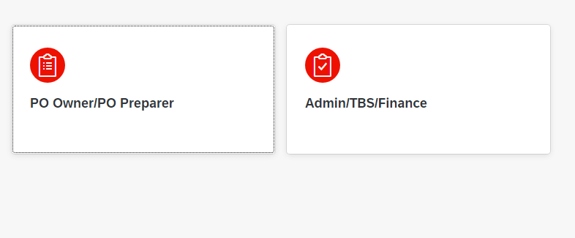
Figure 11: Main Page
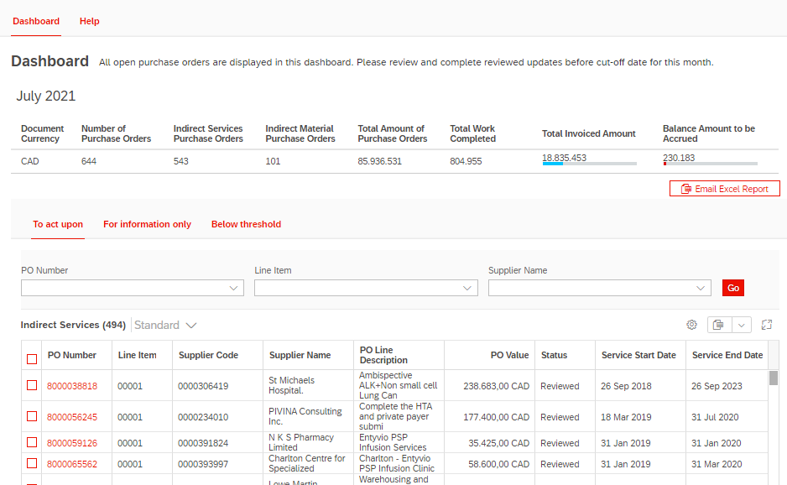
Figure 12: Indirect services of TBS Page
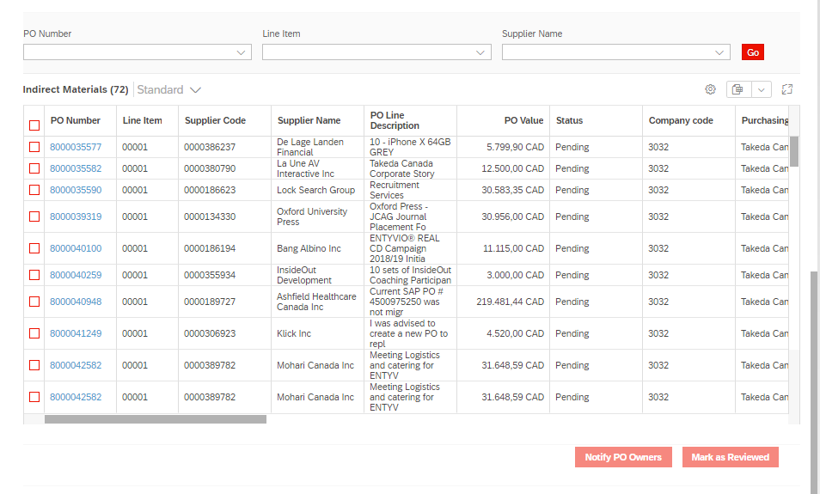
Figure 13: Indirect Materials of TBS view
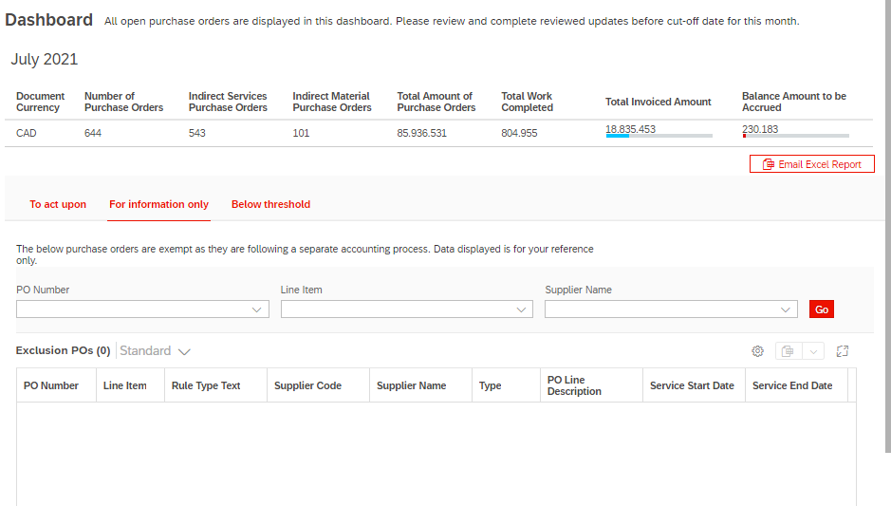
Figure 14: Exclusion POs of TBS Page
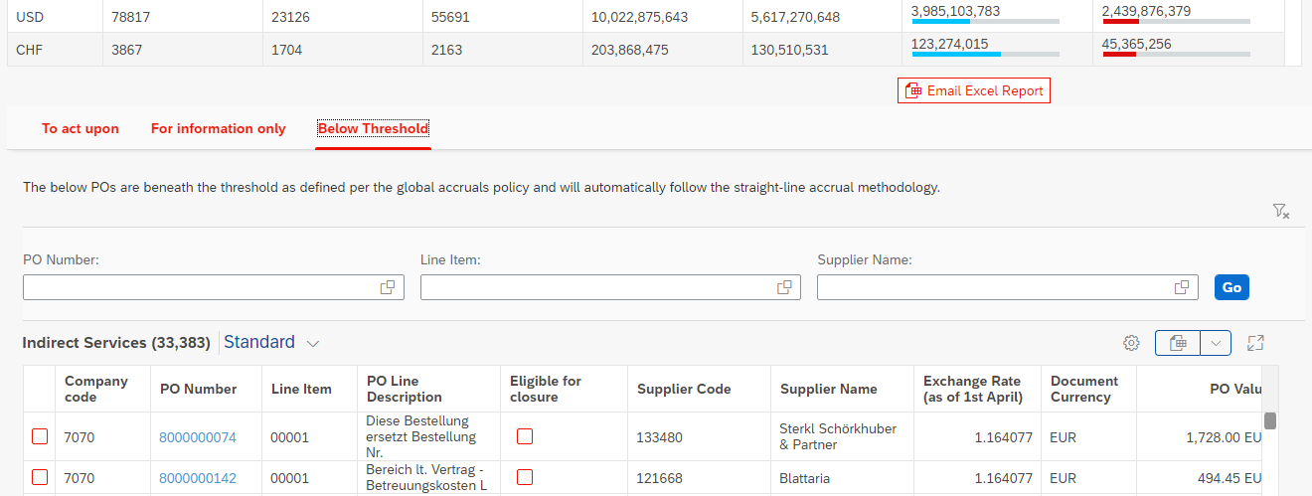
Figure 15: : Indirect Services of Below threshold POs of TBS page
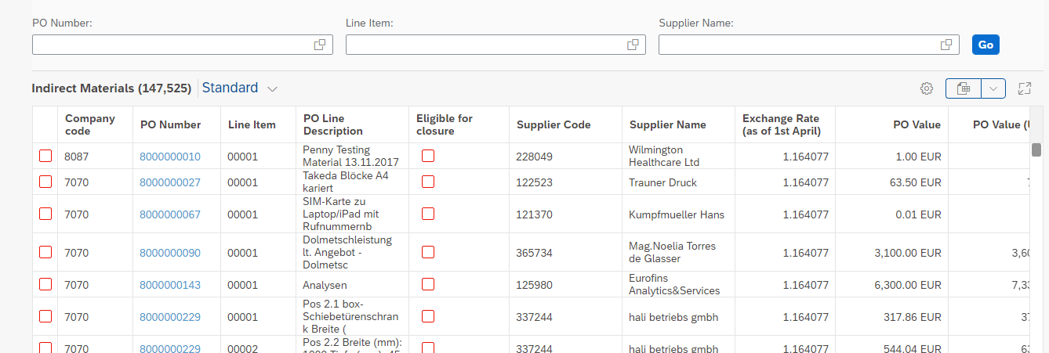
Figure 16: Indirect Materials of Below threshold POs of TBS page

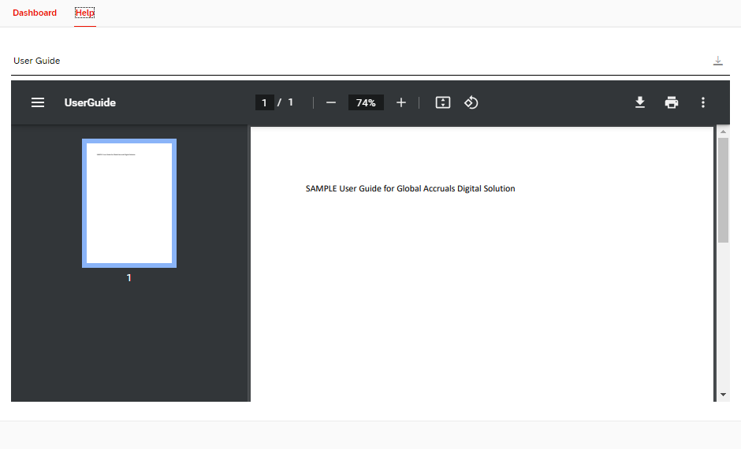
Figure 17: Help tab of TBS Page
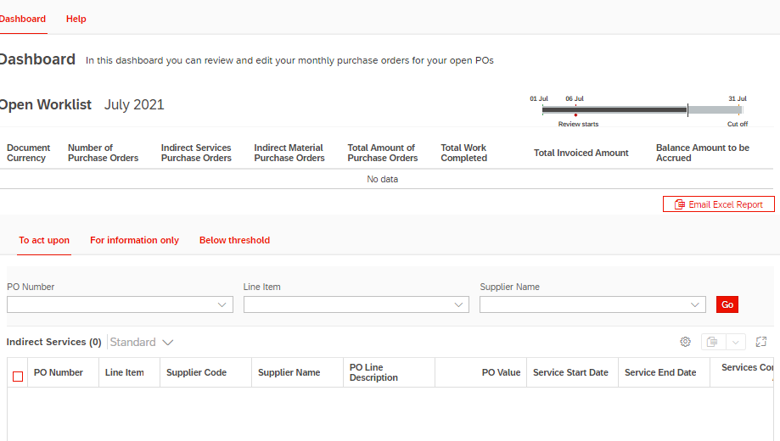
Figure 18: Dashboard and indirect services of PO Owner Page
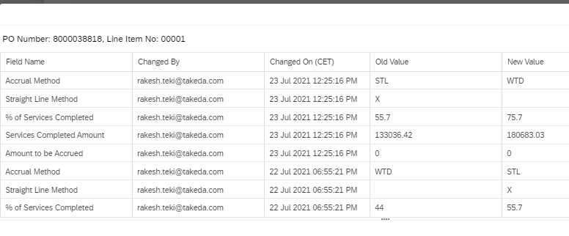
Figure 19: Audit log

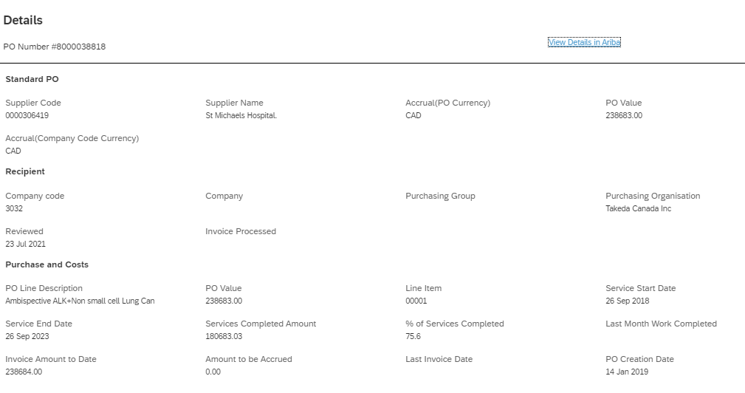
Figure 20: Details Screen

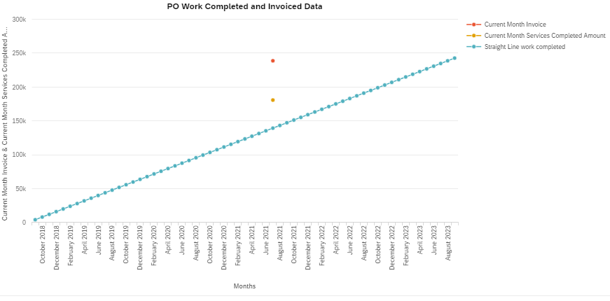

Figure 21: Line chart

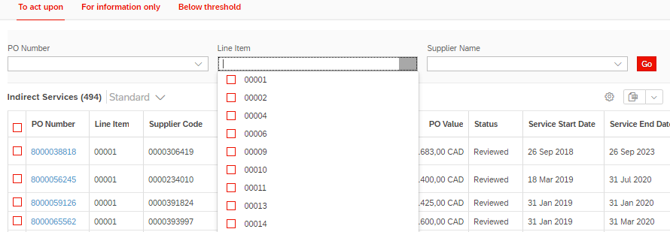
Figure 22: Smart filter bar

Additional Information
N/A

Parallel Processing
N/A

Error /Exception Handling Method
The following errors are displayed on the UI
Condition | Message
Enters wrong format for Services Completed Amount | Enter amount in xxx,xxx.xx format
Enters invalid Amount | Enter a valid amount
Enters Services Completed Amount more than PO Value | Amount should not be more than PO Value
Enters Services Completed Amount in Negative | Services Completed Amount should not be Negative
Enters % Services Completed more than 100 | Percentage should not be more than 100
Enters % Services Completed in Negative | Percentage should not be in Negative
Services Completed Amount or % Services Completed data not available | Below POs have empty Services Completed Amount or % of Services Completed
BAPI Posting Error: | All the SAP Standard error messages are displayed on the EDGE application.
HANA DB Error | All the HANA standard error messages are displayed on the EDGE application.

Post Execution Notification Details:
N/A

Begin of version 3.0

Process Log Details:
The processing logs are maintained at different locations based on where the program is executed.
HANA XSA: The logs are maintained at the SAP BTP platform, since it is hosted on the cloud platform.
SAP UI5: The logs are maintained at the console of the browser and on the SAP BTP Platform, since it is hosted on the cloud platform.
SAP Gateway: The logs are maintained in the transaction code: /iwfnd/error_log.
End of Version 3.0

Scheduling Considerations
            - Point in time email is scheduled to trigger an email to SOX team at 23:59 CET every month end.
            - CSV file is posted to SAP AL11 application server at 23:59 CET every month end.
            - Based on the split files table and the corresponding company codes maintained, a separate file will be generated and placed on the AL11.
            - A notification email is sent to PO Owners and preparers with a list of pending POs at the intervals of cutoff -15 days, cutoff-10 days and cut off -2 days.
Begin version 3.0
            - Exchange rate table is scheduled yearly once (procedure: populateExchangeRate).
            - Exclusion table is scheduled to be loaded every 5 mins ( pre-decided ).
End of Version 3.0

Backup / Recovery
N/A

Security Profile & Authorization
All the Takeda users assigned to the generic OKTA role: Okta-All-Takeda-Users. If the users are PO Owners / Preparers, then users will be able to access the Open Purchase orders assigned to them, else the empty tables will be displayed on the application.

RUN support team are assigned to both the Okta-All-Takeda-Users and OKTA-ACCRUAL-ADMIN in order to access the “Configuration” tile in the Digital Accruals Solution.

Authorization Object /Field name | Type | Protection rule
N/A | N/A | N/A

Considerations for Informal Testing

Test Considerations | Scope of Testing (Inside SAP (IS) / Outside SAP (OS) / Both (BO))
N/A | N/A

Transport Request List
Object name | Type | Transport Request Number
ZEDGE_ACCRUALS | Workbench | ME1K9A3DXD
ZEDGE_ACCRUALS ( Function Group) | Workbench | ME1K9A3DXD
ZCL_Z_EDGE_ACCRUALS_DPC | Workbench | ME1K9A3DXD
ZCL_Z_EDGE_ACCRUALS_DPC_EXT | Workbench | ME1K9A3DXD
ZCL_Z_EDGE_ACCRUALS_MPC | Workbench | ME1K9A3DXD
ZCL_Z_EDGE_ACCRUALS_MPC_EXT | Workbench | ME1K9A3DXD
Z_EDGE_ACCRUALS_MDL | Workbench | ME1K9A3DXD
Z_EDGE_ACCRUALS( SEGW Project) | Workbench | ME1K9A3DXD
Z_EDGE_ACCRUALS_SRV | Workbench | ME1K9A3DXD
ZEDGE_ACCRUALS_PO_CHANGE_IN | Workbench | ME1K9A3DXD
ZEDGE_ACCRUALS_RETURN_OUT | Workbench | ME1K9A3DXD
ZEDGE_TT_ACCRUALS_PO_CHANGE_IN | Workbench | ME1K9A3DXD
ZEDGE_TT_ACCRUALS_RETURN_OUT | Workbench | ME1K9A3DXD
ZEDGE_ACCRUALS | Workbench | MS2K901754
Z_EDGE_ACCRUALS_MDL_0001_BE | Workbench | MS2K901754
Z_EDGE_ACCRUALS_SRV_0001 | Workbench | MS2K901754

Pull Request Link
No. | Change Request Number |  |  |  |  |  |  | Pull Request Link
1 | CHG0156477 |  |  |  |  |  |  | https://github.com/oneTakeda/edge-accurals-xsa/pull/440
Begin of Version 12.0 (CHG0164446)
2 | CHG0164446 |  |  |  |  |  |  | https://github.com/oneTakeda/edge-accurals-ui/pull/653
End of Version 12.0 (CHG0164446)
Begin of Version 13.0 (CHG0170932)
3 |  | CHG0170932 |  |  |  |  |  |  | https://github.com/oneTakeda/edge-accurals-xsa/pull/448
End of Version 13.0 (CHG0170932)
Begin of Version 14.0 (CHG0176051)
4 | CHG0176051 |  |  |  |  |  | https://github.com/oneTakeda/edge-accurals-xsa/pull/479
End of Version 14.0 (CHG0176051)
Begin of Version 15.0 (CHG0181951, CHG0181679)
5 |  |  |  | CHG0181951, CHG0181679 |  |  |  |  |  | https://github.com/oneTakeda/edge-accurals-xsa/pull/500  https://github.com/oneTakeda/edge-accurals-ui/pull/691
End of Version 15.0 (CHG0176051, CHG0181679)
Begin of Version 16.0 (CHG0188041)
6 |  |  |  |  | CHG0188041 |  |  |  |  |  | https://github.com/oneTakeda/edge-accurals-xsa/pull/518
End of Version 16.0 (CHG0188041)
Begin of Version 17.0 (CHG0191904)
7 |  |  |  |  |  | CHG0191904 |  |  |  |  |  | https://github.com/oneTakeda/edge-accurals-xsa/pull/523
End of Version 17.0 (CHG0191904)
Begin of Version 18.0 (CHG0189716)
8 |  |  | CHG0189716 |  |  |  |  |  |  |  |  |  | https://github.com/oneTakeda/edge-accurals-xsa/pull/538
End of Version 18.0 (CHG0189716)

Glossary
Abbr. /Term/Definition | Description
DAS | Digital Accruals Solution

Appendices / Attachments

Appendix A
N/A

